Infection Prevention and Control (IPC): Respiratory Hygiene
Key Stage 3

Lesson 5: Respiratory Hygiene
In this interesting experiment, students learn how easily microbes can be spread through coughs and sneezes by recreating a giant sneeze.

Learning Outcomes

All students will:
- Understand that sometimes microbes can make us ill.
- Understand that prevention of infection, where possible, is better than cure.
- Understand not to spread their harmful microbes to others.
- Understand that infection can spread through sneezing and coughing.
- Understand that covering your mouth and nose with a tissue or your sleeve (not your hands) when you cough, or sneeze helps prevent the spread of infection

Most students will:
- Understand that coughing or sneezing in your hand can still spread infection.

Curriculum Links

PHSE/RHSE
- Health and prevention

Science
- Working scientifically
- Scientific attitudes
- Experimental skills and investigations

English
- Reading
- Writing

Lesson 5: Respiratory Hygiene

Resources Required

Main Activity: Snot Gun

Per student
- Copy of SW1
- Paper disk (10cm)

Per group
- Measuring tape
- Spray bottle
- Water
- Food dye (optional)
- Large tissue
- Gloves
- Mask

Extension Activity: Respiratory Hygiene Quiz

Per group
- Copy of SW2
- Copy of SH1

Supporting Materials
- TS1 Snot Gun Teacher Answer Sheet
- SH1 Respiratory Hygiene Poster
- SW1 Snot Gun Student Worksheet
- SW2 Respiratory Hygiene Quiz

Advanced Preparation
- Copy SW1 for each student.
- Copy of TS1 teachers answers.
- Fill one spray bottle per group with water and food colouring. A different colour for each part of the experiment prevents mixing up results. 4. Create a large tissue from a section of kitchen roll.
. Lesson 5: Respiratory Hygiene

Key Words
Aerosol
Contamination
Experiment,
Infection Prevention
Transmission

Modifications
If there is an outbreak of respiratory illness and mask wearing is recommended, you can include a step to show how a mask can block the microbes from a sneeze/cough. Always include tissue as a step and re-enforce the message to catch it, bin it, kill it and wash hands afterwards. This activity can be simplified for a larger or mixed group demonstration. See the spreading bug section of the ‘Antibiotic Guardian Youth Badge’ lesson plans for ideas www.e-bug.eu.
Health & Safety
Students may be required to wear aprons and gloves.
Ensure that the food colouring is diluted.
Ensure that all spray bottles have been thoroughly cleaned and rinsed prior to use.
Students may need to wear safety goggles.
In the event of an infectious disease outbreak, you may need to modify this activity to ensure social distancing or other criteria according to your school’s policy and government guidance.
For safe microbiological practices in the classroom consult CLEAPPS www.cleapps.org.uk
Weblinks
e-bug.eu/eng/KS3/lesson/ Respiratory-Hygiene

Introduction
- Explain to students that many diseases are airborne and spread in tiny droplets of water, which are coughed and sneezed into the air by people.
- Tell students that the diseases that spread in this way range from viral diseases like colds and flu to rarer, more serious infections like meningitis or tuberculosis (TB) which are caused by bacteria and can result in death.
- Continue to discuss colds and flu, explaining that they are caused by a virus and not bacteria and, as such, cannot be cured by antibiotics.
- Explain that it is very important for everyone’s health that people cover their mouth and nose when they cough and sneeze as this can reduce the spread of infection. You may wish to discuss basic respiratory hygiene practices using SH1 Respiratory Hygiene Poster.Explain to students that they are going to carry out an activity to help understand the best to wash their hands to remove any of the harmful microbes.

Activity

Main Activity: Snot Gun
- Divide the class into groups of 8 – 10 students.
- Provide each student in the class with a circular disk of paper. Ask them to draw a face and write their name on the paper. Tell the class that these disks are going to represent real people. Explain to the class what they are about to do (see below) and ask them to fill out the hypothesis section of SW1 prior to the activity (answers provided on TS1).
- Explain to the class that the ‘people’ are in a crowded place, which could be a school bus. Each student should place their disk in one of the positions as if they are on a bus. It is important that the central positions are roughly aligned at set distances. These disks will represent how far the sneeze has travelled and who it has affected en route. The other disks should be placed at varying distances away from each side of the central line these disks will represent how wide the sneeze has travelled and how many people it has affected en route. Write the distance on each disk.
- Nominate a student as the sneezer and provide them with the spray bottle of coloured water (you may wish to use coloured water to make the activity more visually interesting). Explain to the class that this person has a new strain of the flu and it is very contagious. Ask the student to hold the spray bottle facing forward and give it a firm tight squeeze – this represents the person sneezing.
- Students should look at the ‘people’, how many people did the sneeze contaminate?
- Ask students to collect the ‘people’ and draw a circle around each drop of water, they should then count how many drops of water were on each sheet. Explain to the students that each drop of water represents a droplet of snot from a sneeze and that each droplet may contain thousands of bacteria or viruses.
- Repeat the experiment holding a gloved hand over the nozzle of the spray bottle. Repeat a third time using a piece of kitchen roll, this represents a tissue covering your sneeze.
- Each student should complete and record their results on a graph.

Discussion
Discuss with students the experiment, the hypothesis and their results. Were they surprised by the results in the activity?
Discuss in detail what this experiment has taught the students about the transmission of microbes. How many students would have been infected by a sneeze?
Would there be a change in the results if the experiment was carried out outside on a windy day?
Ask students to remember the gloved hand and notice that it was very wet with the spray ‘microbes’. Ask them to imagine that this was someone’s hand after sneezing on it and how many things or people they would have touched when their hand was covered in infectious microbes. Highlight that while sneezing onto your hand is good and stops the germs spreading far, it is important to wash hands immediately after sneezing into them or to preferably sneeze into a tissue and throw it away and wash your hands after.
Note: Microbes also spread through coughing, it is just as important to cover our mouths with a tissue when coughing.

Fascinating Fact
Lower respiratory infections remain the world’s most deadly communicable (infectious) disease, ranked as the 4th leading cause of death. In 2019 it claimed 2.6 million lives.

Extension Activities

Spread of Infection on a Cruise Discussion
This activity can be used to demonstrate to students how infectious agents can easily spread globally, and that methods of prevention can be better than a cure. In groups or as a class discussion explain:
- They are going to predict how many people can become infected and how far influenza can travel in a week by one infected person.
- Tell the class that they are on a Mediterranean cruise that will call at ports in Spain, France, Italy, Malta and Greece. At each port-of-call passengers can get off for shore excursions. On the cruise there are:
  - A family of 4 on their way back to Australia.
  - 12 passengers planning an onward journey from Greece to Turkey.
  - 4 passengers planning an interrailing excursion through Hungary, Czech Republic and Germany.
  - The remaining passengers plan to return to the USA
- On this cruise one man has a new strain of the influenza virus and it is very contagious.
  - Hypothesise and consider how many people will he infect and how far will this virus travel in 24 hours, and in 1 week?
  - What could have been done to prevent the infection travelling so far?

Respiratory Hygiene Best Practice
Discussion in groups, individually or as a class discussion explain:
- Three school friends, Sara, Elisa and Chloe, have all caught a cold and are coughing a lot. As you can see from the picture below, each student has adopted a different way of covering their coughs and sneezes. One is sneezing into a tissue, one into their elbow, and one on their hand.
- Ask students to discuss the advantages and disadvantages of each method in the context of:
  - Their daily life
  - Reducing the spread of infection.

Respiratory Hygiene Quiz
Provide SW2 to groups of 4 - 5 students. This can be used before and after the lesson to test student’s knowledge. The group with the most points wins the quiz.
Students can also create some simple rules or messages to reduce the spread of coughs, colds and flu in their school, for example:
- Coughs and sneezes spread diseases
- Catch it, bin it, kill it
- Cover my coughs and sneezes with a tissue or cough/sneeze into the crook of my elbow or sleeve (not my hand).
- Wash my hands after a cough or a sneeze or use hand sanitiser

Germ Defence
The website germdefence.org can be used as a tool to help students reduce the likelihood of getting colds, flu and stomach upsets, and from transmitting them on to other people. Students follow simple steps and can print or download a summary of the information they have reviewed.

TS1 – Snot Gun Experiment Teacher Answer Sheet

Snot Gun Experiment: Teacher Answer Sheet
Questions
- Which disk do you think will be most affected by the sneeze?
> The paper disks directly in front of and to the sides of the sneezer will be the most affected
- Which people do you think will be least affected by the sneeze?
> The person behind the sneezer and those furthest away
- What do you think will happen when you place a gloved hand over the sneeze?
> The sneeze will not travel to as many people but the microbes will be found on the hand
- What do you think will happen when you place a tissue over the sneeze?
> All the microbes will be trapped in the tissue
Results
- What was the furthest distance the sneeze travelled?
 | Distance travelled | Number of people contaminated
Sneeze alone
Gloved hand
Tissue
This will vary depending on the type of spray bottle used, but in general the sneeze alone will infect more people and travel the furthest. The sneeze in the tissue should affect the least.

- Did any of the sneezes contaminate any of the people on the side lines? If so, how many?
Sneeze alone
Gloved hand
Tissue
As above

- How many ‘microbes’ landed on the person behind the sneezer?
- ___________________________________________________
Conclusions
- Based on this experiment what have you learnt about microbial transmission?
> Microbes can pass very easily from person to person through sneezing and touch.
- If we don’t wash our hands after sneezing into them, what might happen?
> We can still transfer the harmful microbes found in a sneeze to other people when we touch them
- Which method is best for preventing the spread of infection, sneezing into your hand or sneezing into a tissue? Why?
> Sneezing into a tissue; this causes the microbes to get trapped and we can then throw the tissue away
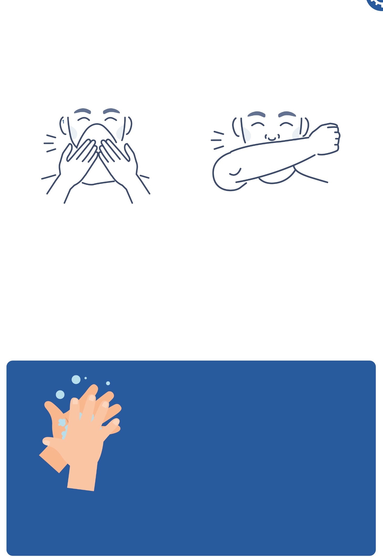

SH1 - Respiratory Hygiene Poster

Cover your coughs and sneezes
1

Use a tissue if you have one
If you have no tissue use your sleeve

2
Wash your hands for 20 seconds with soap and water.
To help keep time - sing ‘Happy Birthday’ twice

SW1 - Snot Gun Student Worksheet

Snot Gun Experiment: Student Worksheet
Questions
- Which disk do you think will be most affected by the sneeze?
____________________________________________________________
- Which people do you think will be least affected by the sneeze?
____________________________________________________________
- What do you think will happen when you place a gloved hand over the sneeze?
____________________________________________________________
- What do you think will happen when you place a tissue over the sneeze?
____________________________________________________________
Results
- What was the furthest distance the sneeze travelled?
 | Distance travelled | Number of people contaminated
Sneeze alone
Gloved hand
Tissue

- Did any of the sneezes contaminate any of the people on the side lines? If so, how many?

Sneeze alone
Gloved hand
Tissue

- How many ‘microbes’ landed on the person behind the sneezer?
_________________________________________________________
Conclusions
- Based on this experiment what have you learnt about microbial transmission?
_________________________________________________________
- If we don’t wash our hands after sneezing into them, what might happen?
_________________________________________________________
- Which method is best for preventing the spread of infection, sneezing into your hand or sneezing into a tissue? Why?
_________________________________________________________

SW2 - Respiratory Hygiene Quiz

Quiz: Respiratory Hygiene
Please tick as many answers as appropriate
How can you spread microbes to others? (3 points)
- Touching
- Sleeping
- Sneezing
- Coughing
After we sneeze into our hands, we should: (2 points)
- Wash our hands
- Dry our hands on our clothes
- Take antibiotics
- None of the above is necessary
If you do not have a tissue available, the next best option is to sneeze: (1 point)
- Into your hands
- Into your sleeve
- Into an empty space
- Onto your desk
The best way to stop microbes from spreading is: (2 points)
- To use your hand to cover your sneeze
- To use a tissue to cover your sneeze
- To use a sleeve if you haven’t got a tissue
- To drink plenty of fluids
What should you do with a tissue after sneezing into it? (1 point)
- Put it in your pocket for next time
- Put it straight in the bin
- Put it up your sleeve for next time
- Any of the above
What might happen if we don’t wash our hands after sneezing into them? (1 point)
- Nothing
- Transfer harmful microbes to other people
- Help protect our microbes

