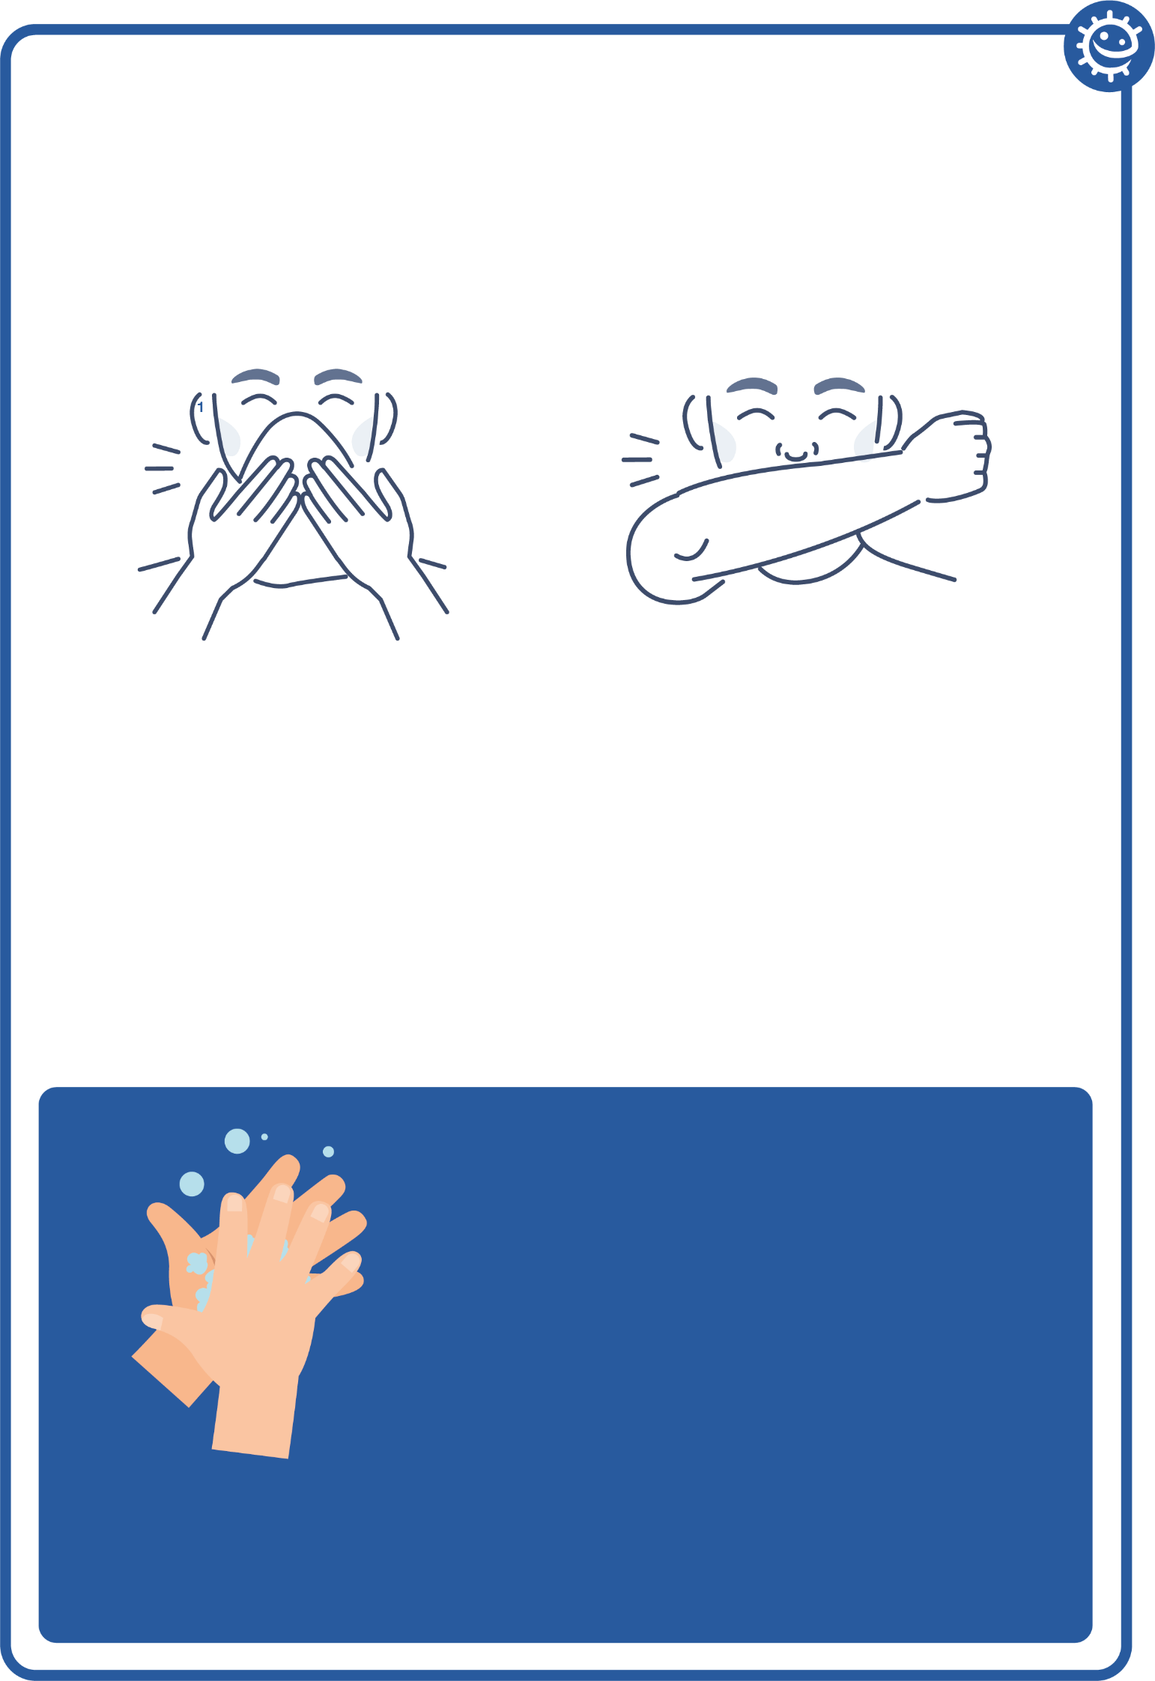



## SH1 - Respiratory Hygiene Poster

### Cover your coughs and sneezes

1

Use a tissue if you have one

If you have no tissue use your sleeve

2

Wash your hands for 20 seconds with soap and water.

To help keep time - sing ‘Happy Birthday’ twice