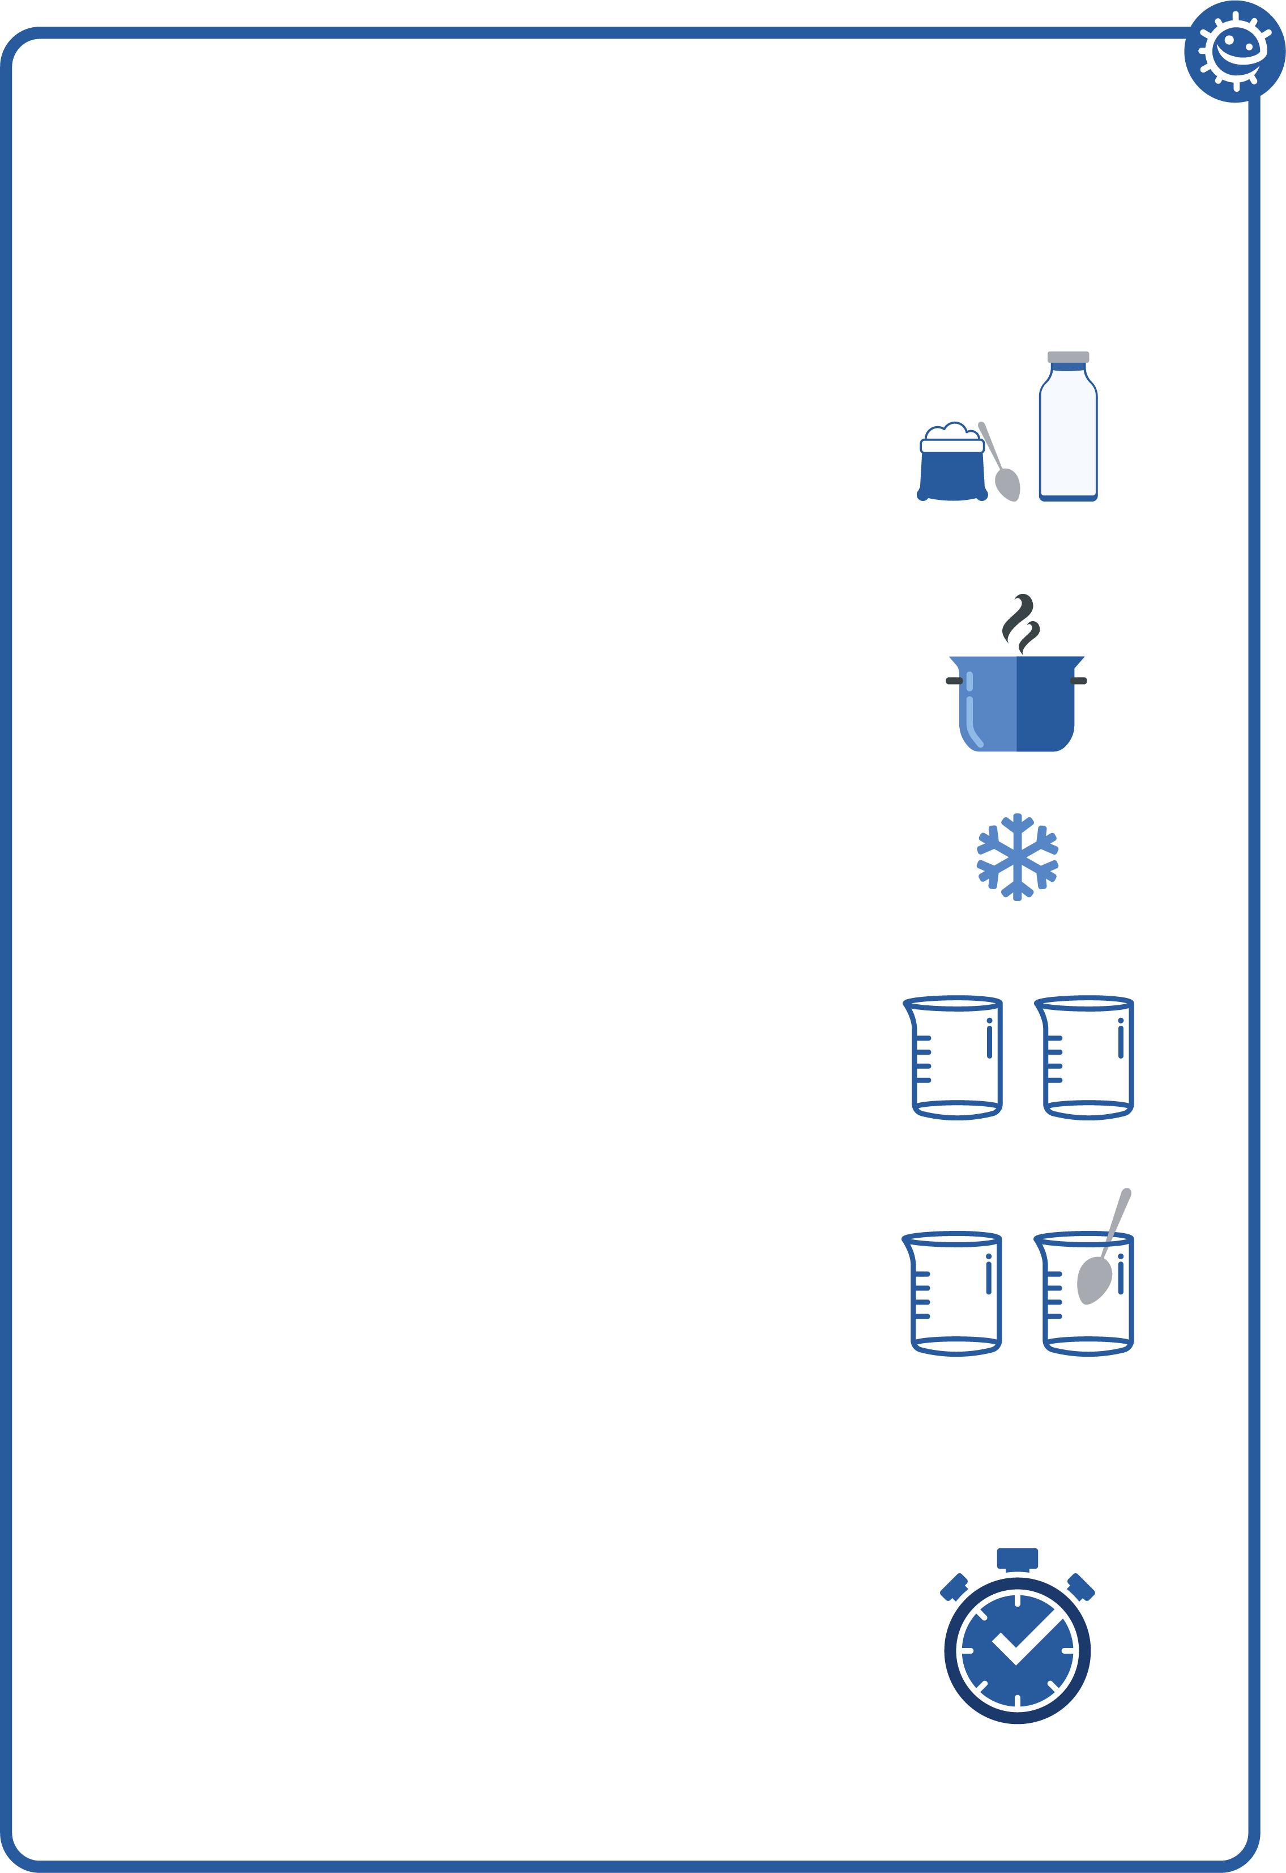

## SH1 - How to Make Yoghurt Instructions

### How to Make Yoghurt

Experiment

1. Add two tablespoons of powdered, skimmed milk to 500ml (one pint) of whole milk.
2. Bring the mixture to a boil over medium heat for 30 seconds, stirring constantly to kill any unwanted bacteria present. Take care it does not overflow!
3. Cool to 46-60°C.
4. Divide the cooled mixture into 2 sterile beakers and label test 1 and test 2.  
   Test 1 : add 1-2 teaspoons of live yoghurt  
   Test 2 : add 1-2 teaspoons of sterile yoghurt
5. Stir both mixtures well using a spoon previously sterilised by standing it in boiling water.
6. Cover each container with aluminium foil.
7. Incubate the mixtures at 32-43°C in a hot water bath, for 9-15 hours until desired firmness is reached.