SW1 – Yoghurt Experiment Worksheet

Yoghurt Experiment Worksheet
Test 1 - Yoghurt | Before Incubation | After Incubation
What was the consistency of the mixture?
What did the mixture smell like?
What was the colour of the mixture?
Test 2 – Sterile Yoghurt | Before Incubation | After Incubation
What was the consistency of the mixture?
What did the mixture smell like?
What was the colour of the mixture?
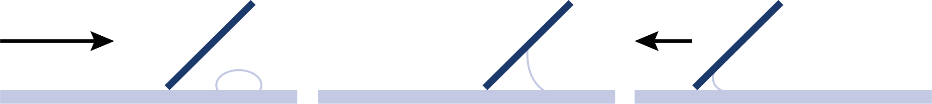
How did the mixture change during fermentation?
________________________________________________________________________________________________________________________________

Test 3
How long did it take to make the yoghurt when the mixture was incubated at:
20°C - ____________
40°C - ____________
SW2 - Microscopic Yoghurt Observation Sheet
How to Make Yoghurt
Procedure
Test 1
- Place a small drop of yoghurt onto one side of a glass microscope slide.
- Taking a second clean slide, streak the yoghurt across the length of the slide creating a thin smear.
- Leave the slide to air dry and then pass once through a Bunsen flame in order to heat fix the smear.
- Cover the smear with a few drops of Methylene Blue and leave for 2 minutes.
- Wash off any excess stain by running under a slow running tap.
- Cover smear with a cover slip and examine the slide under a high powered microscope.
- Record your observations below.

Test 2
- Repeat steps 1-7 above using sterile yoghurt instead of live culture yoghurt.
How to prepare a smear:
Observations
What did you see in the yoghurt smear?
__________________________________________________________________________________________________________________
What did you see in the sterile yoghurt smear?
__________________________________________________________________________________________________________________
What, in your opinion, caused the difference?
__________________________________________________________________________________________________________________
Yoghurt
1. Approach
2. Adhesion
3. Advancement

SW1 – Yoghurt Experiment: Conclusions

Yoghurt Experiment
Conclusions
- What caused the change from milk to yoghurt?
__________________________________________________________________________________________

- What is this process called?
_____________________________________________
- Explain the difference in results in test 1 and test 2.
__________________________________________________________________________________________
- What is the type and name of microbes which can be used to make yoghurt?
_____________________________________________
- Why did it take longer to make yoghurt at 20°C than at 40°C?
_______________________________________________________________________________________________________________________________________
- A sterile spoon is used to stir the mixture (step 5) before incubating, what do you think might happen if a dirty spoon was used?
__________________________________________________________________________________________

