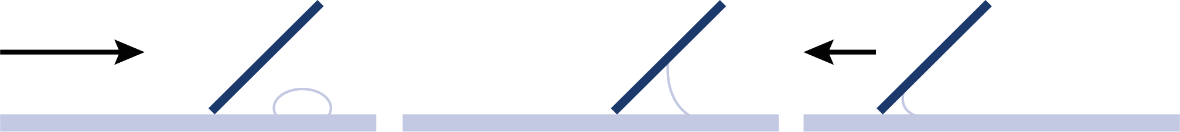



## SW2 - Microscopic Yoghurt Observation Sheet

### How to Make Yoghurt

Procedure

Test 1

1. Place a small drop of yoghurt onto one side of a glass microscope slide.
2. Taking a second clean slide, streak the yoghurt across the length of the slide creating a thin smear.
3. Leave the slide to air dry and then pass once through a Bunsen flame in order to heat fix the smear.
4. Cover the smear with a few drops of Methylene Blue and leave for 2 minutes.
5. Wash off any excess stain by running under a slow running tap.
6. Cover smear with a cover slip and examine the slide under a high powered microscope.
7. Record your observations below.

Test 2

1. Repeat steps 1-7 above using sterile yoghurt instead of live culture yoghurt.

How to prepare a smear:

Yoghurt

1. Approach

2. Adhesion

3. Advancement

Observations

What did you see in the yoghurt smear?

__________________________________________________________________________________________________________________

What did you see in the sterile yoghurt smear?  
__________________________________________________________________________________________________________________

What, in your opinion, caused the difference?  
__________________________________________________________________________________________________________________