

## SW2 - World Map Activity

Russia

Far East

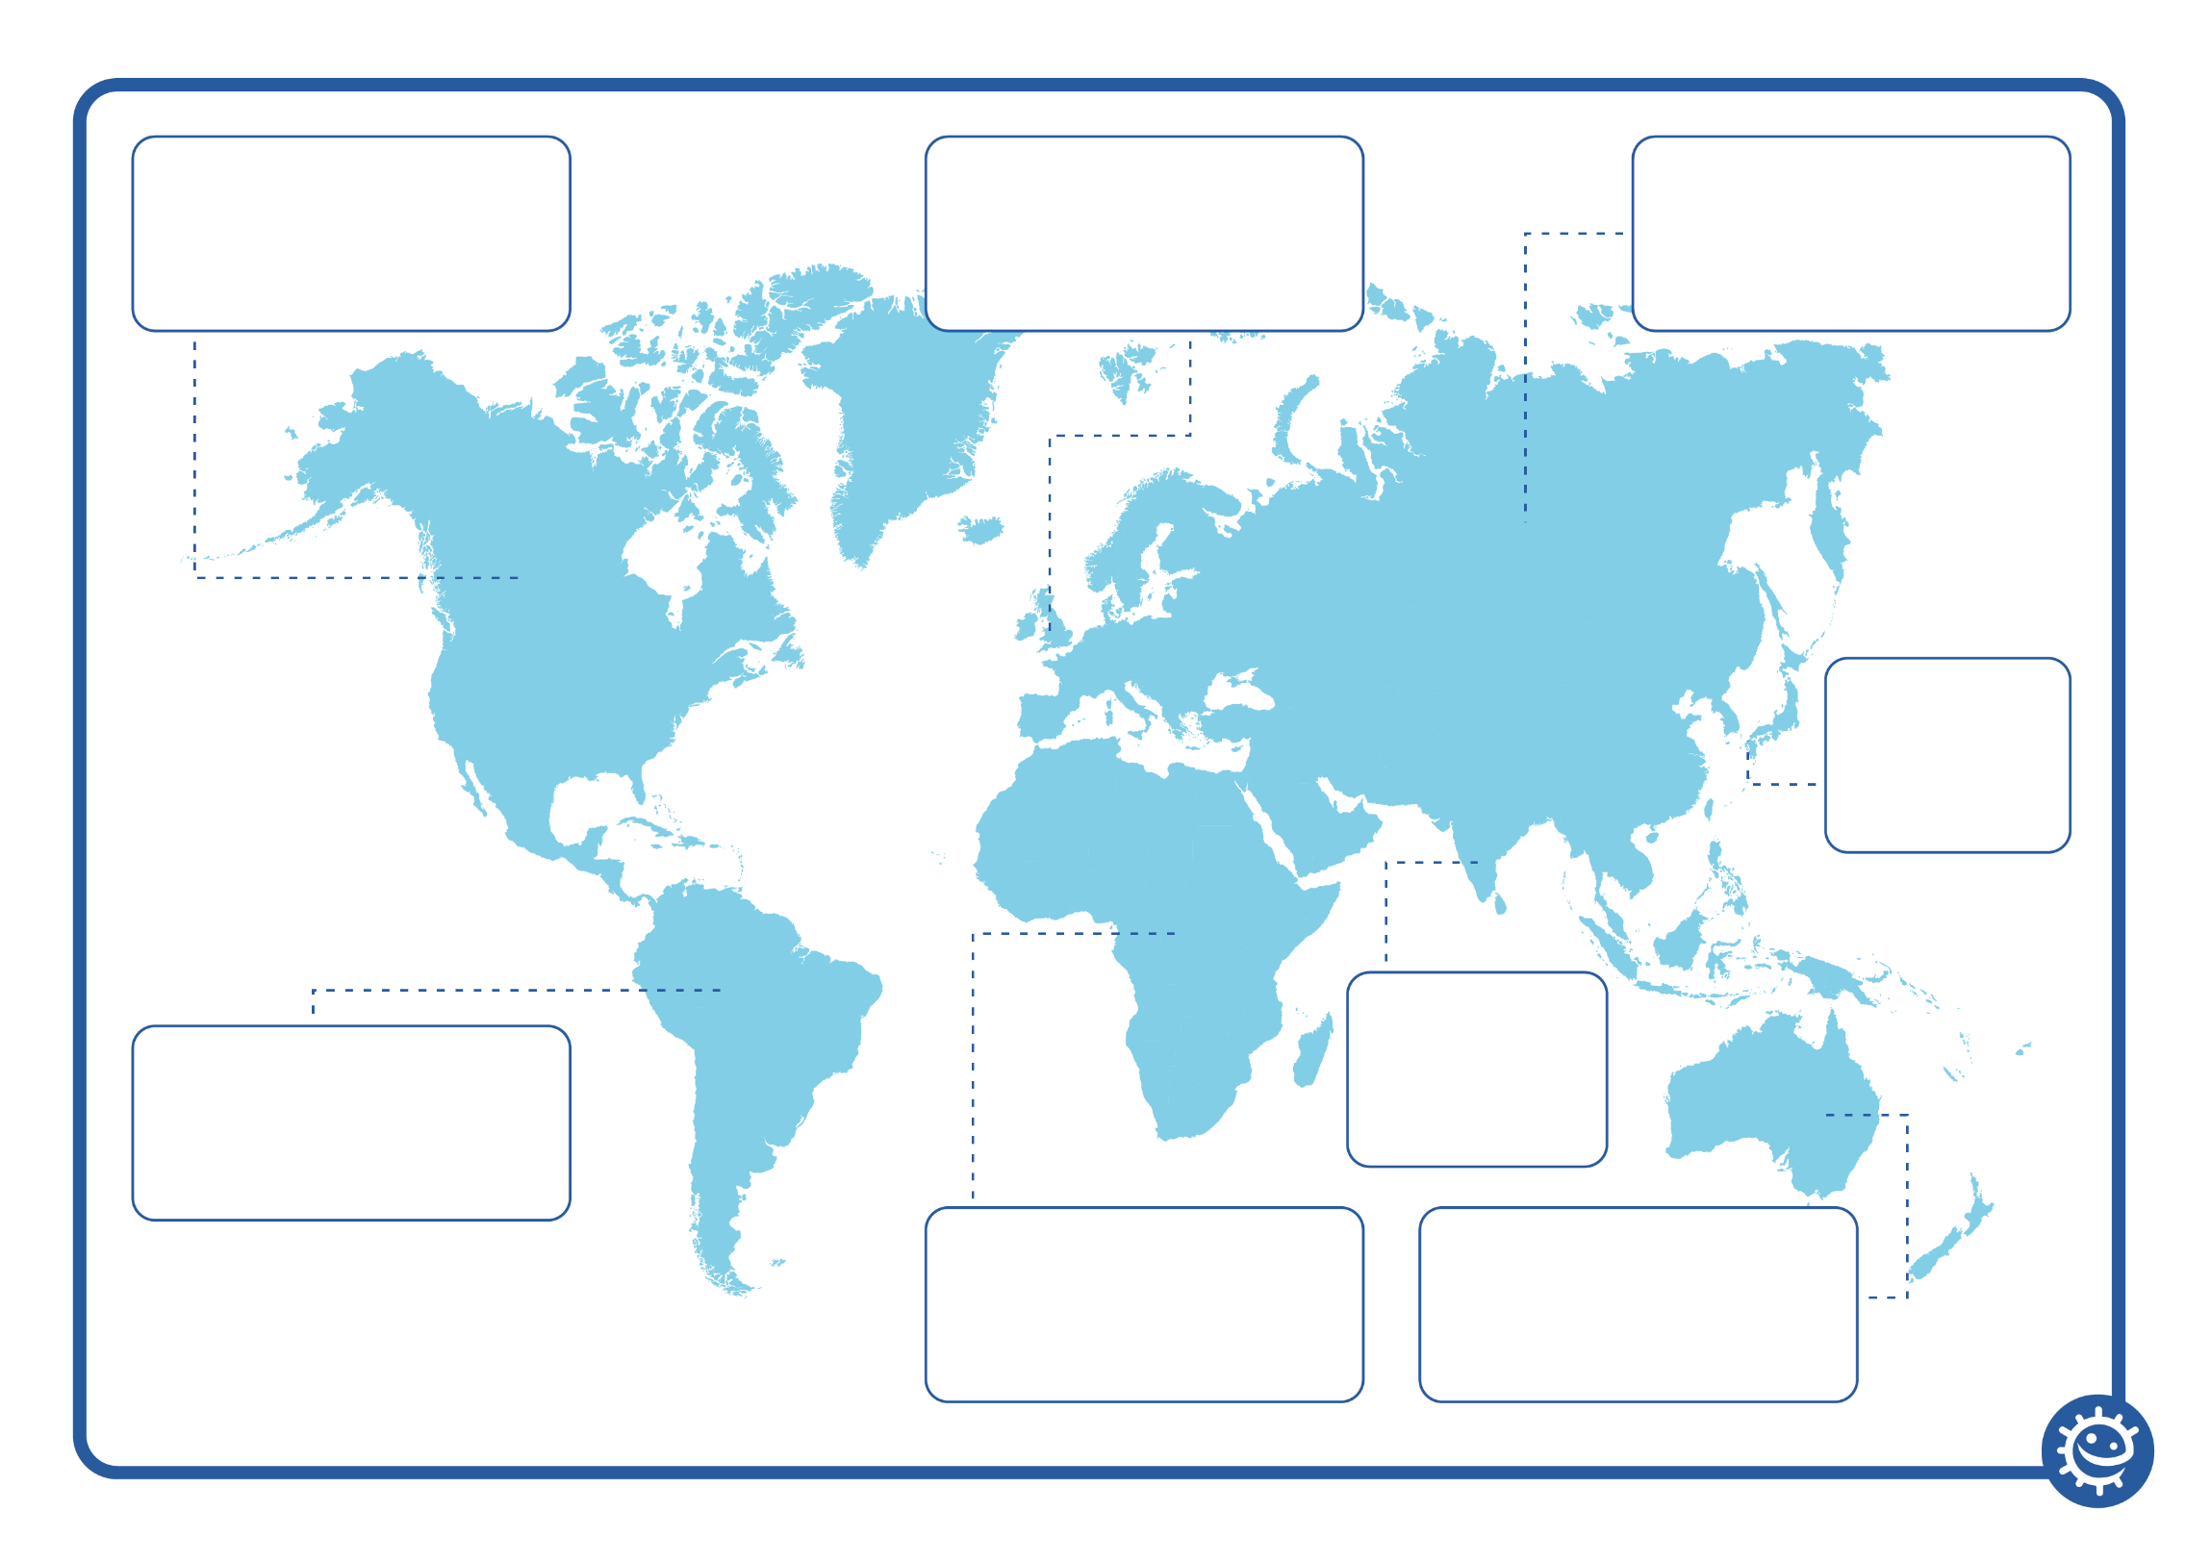

Asia

Australia

Western Europe

Africa

Canada

S. America