Treatment of Infection: Antibiotic Use and Antimicrobial Resistance
Key Stage 4

Lesson 8: Antibiotic Use and Antimicrobial Resistance
Introductory lesson to antibiotics and their use. This lesson introduces students to the growing global public health threat of antimicrobial resistance (AMR) through an agar plate experiment.

Learning Outcomes:

All students will:
- Understand that antibiotics do not work on viruses, as bacteria and viruses have different structures.
- Understand that bacteria are continually adapting to develop ways of not being killed by antibiotics, this is called antibiotic resistance.
- Understand that taking antibiotics also affects your useful bacteria, not just the ones causing an infection.
- Understand that antibiotic resistant bacteria can be carried by healthy or ill people and passed onto others without knowing.
- Understand that antibiotic resistance spreads between different bacteria within our body.
- Understand that controlling antibiotic resistance is everyone’s responsibility including you

Curriculum Links

PHSE/RHSE
- Health and prevention

Science
- Scientific thinking
- Experimental skills and strategies
- Analysis and evaluation

English
- Reading
- Writing

Art & Design
- Graphic communication
Lesson 8: Antibiotic Use and Antimicrobial Resistance

Resources Required

Main Activity: Agar Experiment

Per student
- Copy of SW1
- Copy of SW2
- Copy of SW3
- Gloves

Per class/group
- Copy of TS2
- Petri dishes
- Base Agar
- Hot plate
- Phenol Red*
- Wax Crayon/marker
- Disposable droppers
- Hydrochloric acid
- Cork borer
- Test tubes
- Test tube rack

Activity 2: Antibiotics ‘Right’ or ‘Wrong’?

Per student
- Copy of SW4

Additional Supporting Materials:
- Copy of TS1
- Copy of SH1

Supporting Materials
- TS1 Agar experiment Advanced Preparation
- TS2 Teacher Answer Sheet
- SH1 Antibiotic Sensitivity Test Results
- SW1 Agar Experiment worksheet
- SW2 Agar Experiment Conclusions
- SW3 Differentiated Agar Experiment Conclusions
- SW4 Antibiotics Right or Wrong

Advanced Preparation
- Follow instructions in TS1 to prepare for the Agar experiment
- Print off SW1 and SW2 or SW3 (differentiated version adaptable for students of different abilities) for each student in advance
- Antibiotic videos: Introduction to Antibiotics antibioticguardian.com OR https://youtu.be/HN5ultN7JaM
- Antibiotics Animation e-bug.eu/eng/KS4/lesson/ Antibiotic-AntimicrobialResistance Copy SW1 and SW2 for each student.

Lesson 8: Antibiotic Use and Antimicrobial Resistance

Key Words
Antibiotic
Antimicrobial resistance
Immune system
Infection
Medicine
Natural selection
Stewardship
Health & Safety
For safe microbiological practices in the classroom consult CLEAPPS
www.cleapps.org.uk

Weblinks
e-bug.eu/eng/KS4/lesson/ Antibiotic-Antimicrobial-Resistance

Introduction
- Explain that students are going to learn about how antibiotics work to kill bacteria and how the bacteria are fighting back and becoming resistant to the antibiotics. Antibiotic resistance is becoming a global health threat and it can affect everyone – antibiotic resistant bacteria can easily spread from person to person. It is everyone’s responsibility to ensure antibiotics are used correctly.
- Show the students the 2-minute Introduction to Antibiotics Video.
- Next, watch the e-Bug animation. Throughout the animation there are choice points to allow teachers to pause and discuss the content with the students.
- Highlight that the discovery of new antibiotics has slowed down and explain that many pharmaceutical companies are no longer spending money to develop new antibiotics, despite the increasing problem of resistance.

Activity

Main Activity: Agar Experiment
- This activity should be carried out in small groups (3 - 5 students).
- A workbench should be set up for each group containing:
  - 4 agar culture plates with indicator, each labelled with a patient’s name.
  - 4 test tube racks, each containing 5 antibiotic solutions (refer to guidance in TS1), each next to its corresponding agar plate.
- Provide students with a copy of SW1 and SW2 or SW3 (differentiated version) to record their results.
- Explain that Eva is working in a hospital lab and it is her job to grow microbial cultures from swabs taken from patients at a doctor’s surgery. Eva then tests whether the microbes are killed by a range of antibiotics. The results help the doctor decide what microbe is causing the illness and which antibiotics, if any, to prescribe.
- Highlight that the red colour represents the microbes growing in the agar; it may help here to show them an agar plate with no indicator (yellow), i.e. no growth.
- Place plates on a sheet of white paper. Students should label each bore hole and drop antibiotics, one drop at a time, into the appropriately labelled hole until the hole is filled with the antibiotic.
- Replace the lid of the Petri dish and leave for 5 minutes.
- After 5 minutes, students should measure the size of the decolourised zone (inhibition) if present. You may wish to show students SH1 for an illustration of the expected results.
- Students should complete their worksheets (SW1, 2 or 3) in groups and discuss with the teacher.

Activity 2 - Antibiotics ‘Right’ or ‘Wrong’?
Use the ‘right or wrong’ worksheet provided to learn about how to take antibiotics correctly. Provide each student a copy of the worksheet (SW4). For each statement, discuss with the group whether they are right or wrong and reasons why, as provided below.
Statement 1: Wrong
Most common infections that cause coughing and sneezing are caused by viruses, and will get better by themselves with bed rest and fluid intake. Antibiotics are not effective against viruses.
Statement 2: Right
Antibiotics should be taken exactly as advised by your healthcare professional.
Statement 3: Wrong
You must not use other people’s or any leftover antibiotics.
Statement 4: Right
Most common infections that cause coughing and sneezing are caused by viruses, and will get better by themselves with bed rest and fluid intake. Antibiotics are not effective against viruses.
Statement 5: Wrong
Antibiotics can help severe bacterial infections such as pneumonia or kidney/ urine infections.
Statement 6: Wrong
Antibiotics should be taken exactly as advised by your healthcare professional.
Statement 7: Wrong
Antibiotics are not effective against headaches or viruses, such as the one that causes flu.
Statement 8: Right
If you over-use antibiotics they might not work when you really need them for a severe infection.

Discussion
Discuss the questions on the student’s worksheet (SW2/3) with the class:
Antibiotics don’t cure the cold or flu, what should the doctor recommend or prescribe to a patient to get better?
Answer: Antibiotics can only treat bacterial infections and the flu is caused by a virus. Coughs and colds are caused by viruses and in many cases the body’s own natural defences will fight these infections. Other medicines from the pharmacist help with the symptoms of coughs and colds. Doctors can prescribe pain killers to help reduce the pain and fever associated with the infection.
Differentiated answer: b
What would happen if a patient was prescribed an antibiotic to treat a bacterial infection, but the bacteria was resistant to that antibiotic?
Answer: Nothing, the antibiotic would not be able to kill the bacteria causing the illness therefore the patient would not get any better.
Differentiated answer: a
If you had some Penicillin left over in your cupboard from a previous sore throat, would you take them later to treat a cut on your leg that got infected? Explain your answer.
Answer: No, you should never use other people’s antibiotics or antibiotics which have been prescribed for a previous infection. There are many different types of antibiotics which treat different bacterial infections. Doctors prescribe specific antibiotics for specific illnesses and at a dose suitable for that patient. Taking someone else’s antibiotics may mean your infection does not get better.
Differentiated answer: a
A patient doesn’t want to take the prescribed antibiotic for their wound infection. They say: ‘I took more than half of those pills the doc gave me before and the infection went away for a while but came back worse!’ Can you explain why this happened?
Answer: It is very important to finish a course of prescribed antibiotics, not just stop half way through. Failure to finish the course may result in not all the bacteria being killed and possibly becoming resistant to that antibiotic in future.
Differentiated answer: c

Discuss with the class:
1. Their understanding of antibiotic resistance.
2. Ask what resistant bacteria they have heard of? Describe Methicillin-resistant Staphylococcus aureus and tuberculosis as two examples:
- Methicillin-resistant Staphylococcus aureus (MRSA) is a bacterial strain that is resistant to beta-lactam antibiotics, flucloxacillin and cephalosporins. MRSA infections can be very difficult to treat. MRSA infections are more common in people in hospitals or care settings, but they can also occur in the community. MRSA rates have fallen in the last few years, due to increased awareness, efforts to tackle infection control in hospitals e.g. thorough hand washing and swabbing patients, and reduction of broad-spectrum antibiotic use. In 2006, 1.8% of hospital patients were reported to have MRSA and this fell to 0.1% in 2012.
The figure above shows the downward trend in rates of MRSA bacteraemia (bacteria in blood) from 8.8 reported cases per 100,000 population in 2007/8 to 1.6 reported cases per 100,000 in 2013/14. This data is taken from the Public Health England Annual Epidemiology Commentary 2013/14.
- Some antibiotic resistant strains of tuberculosis (TB) are known as Multi-drug-resistant tuberculosis (MDR-TB). These strains are resistant to the two most commonly used antibiotics to treat TB. As of 2013, 3.6% of new tuberculosis cases are caused by MDR-TB. The WHO estimates that there were almost 0.5 million new MDR-TB cases in the world in 2012. MDR-TB can have a mortality rate of up to 80% and the drugs used to treat MDR-TB are more expensive than those used to treat TB and they can have more adverse side effects. To treat TB well you need to take 2, 3 or 4 antibiotics at once. Not taking them correctly (due to lack of funding for treatment or counterfeit antibiotics) has led to increased resistance, so it has now become a major problem.

Extension Activities

Extension Activity: Essay Writing
- Ask the students to write an essay based on the message from the e-Bug antibiotics animation and the common misconceptions they have learnt about during the lesson.
- They should consider the following points:
  - What are the most common misconceptions around antibiotics and why might there be such widespread misunderstanding?
  - How would tackling common misconceptions around antibiotics help to slow or prevent the rise of resistance?
  - What methods or approaches should be used to tackle misconceptions?
  - Personal, family or friends’ experiences of antibiotics can also be included, such as why antibiotics were taken and if the user thought they may have been unnecessary. What would have helped in this situation?

Learning Consolidation
Check for understanding by asking students if the following statements are true or false.
- Antibiotics do not work on viruses, as bacteria and viruses have different structures.
Answer: True

- Bacteria are continually adapting to develop ways of not being killed by antibiotics, this is called antibiotic adaptation.
Answer: False, it is called antibiotic resistance.

- Antibiotic resistant bacteria can be carried by healthy or ill people and can be passed on silently to others.
Answer: True

TS1 - Agar Experiment Advanced Preparation
Advanced Preparation
The following preparation is for 1 group of 5 students
For a visual of workbench set up visit www.e-bug.eu
Materials Required
- Petri dishes
- Hydrochloric acid
- Wax Crayon/marker
- Base Agar
- 20 Test tubes
- Disposable droppers
- Hot plate
- 5 Test tube racks
- Cork borer
- Phenol Red
Agar Plate Preparation
- Make up 100ml of base agar following the manufacturer’s instructions.
- When cooled slightly, but not solid, pour 1 agar plate (to demonstrate no growth). When complete add enough (~10 drops) 2 – 4% Phenol Red to turn the agar a deep red/dark orange and mix well.
- Pour approx 20ml into each petri dish and leave to cool.
- When solidified, make 5 evenly spaced bore holes in each agar plate.
- Label each Petri dish with Patient A, B, C and D
Antibiotic (test-tube) Preparation
Patient | Penicillin | Meticillin | Erythromycin | Vancomycin | Amoxicillin
A | Water | Water | Water | Water | Water
B | 10%HCl | 5% HCl | 1% HCl | 0.05% HCl | 5% HCl
C | Water | Water | 1% HCl | 0.05% HCl | Water
D | Water | 0.05% HCl | 0.05% HCl | 0.05% HCl | Water
1. Set up a test tube rack of 5 test tubes for each patient. Label each test tube with one of the following labels
a. Penicillin b. Meticillin c. Oxacillin d. Vancomycin e. Amoxicillin
2. Transfer 5ml of the following solutions into the appropriately labelled test tube
NB: It is extremely important to have the correct concentrations of HCl (antibiotics) for each patient.
3. Set up a work bench for the group as follows:
- Place the appropriate patient’s agar plate next to each corresponding rack of test tubes at 4 stations across the bench
- A dropper for each test tube
- A ruler with mm markings
- It may be easier for students if they place each patient’s agar plate on a piece of white paper and label the paper next to each bore hole with the antibiotic name.
Patient | Penicillin | Meticillin | Erythromycin | Vancomycin | Amoxicillin | Diagnosis
A | No | No | No | No | No | Influenza
B | Yes | Yes | Yes | Yes | Yes | Strep Throat
D | No | Yes | Yes | Yes | No | Staphylococcus wound infection
C | No | No | No | Yes | No | MRSA

TS2 - Agar Experiment Teacher Answer Sheet
Agar Experiment Teacher Answer Sheet
Plate Results
Plate Results Explained
Yes means Sensitive – no zone of growth visible
No means Not sensitive – no zone visible
Patient A:
Influenza is caused by a virus as such none of the antibiotics will have an effect as antibiotics can only be used on bacterial infections.
Patient B:
Sore throat infections are quite common and generally get better on their own. In sever cases, most antibiotics will treat this infection. Penicillin is the antibiotic of choice for this infection as the group of bacteria responsible (Streptococcus) have yet to develop a mechanism of resistance. Antibiotics should not be given unnecessarily for mild sore throats as 80% of sore throats are due to viruses and other bacteria can develop resistance during treatment.

TS2 - Agar Experiment Teacher Answer Sheet
Agar Experiment Teacher Answer Sheet
Plate Results Explained
Patient C:
Methicillin Resistant Staphylococcus aureus (MRSA) infections are becoming increasingly difficult to treat. These S.aureus bacteria have developed resistance to Methicillin, the previous antibiotic of choice. Vancomycin in one of the last lines of defence against these potentially fatal bacteria however some organisms have been detected with also show resistance to this.
Patient D:
Penicillin was the first antibiotic discovered and produced, unfortunately many people viewed it as a ‘wonder drug’ and used it to treat many common infections. This resulted in the majority of Staphylococcal bacteria quickly developing resistance to this antibiotic. As ampicillin is a derivative of penicillin, Staphylococcus bacteria are resistant to this as well. Methicillin is the drug of choice for this sensitive Staphylococcus infection.

SH1 - Antibiotic Sensitivity Test Results
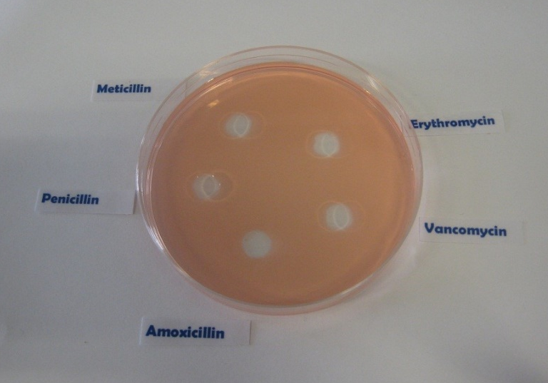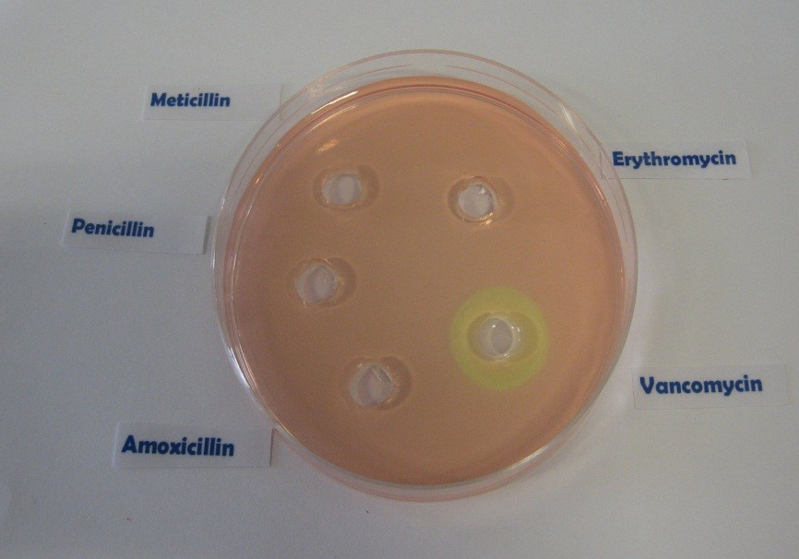
Patient B
Patient D
Antibiotic Sensitivity Test Results
Patient A
Patient C

SW1 - Agar Experiment Worksheet - Section A
Agar Experiment Worksheet: Results
Eva is on a summer work placement at the local hospital laboratory.
It is her job to read the test results and fill in the paperwork. Eva has missed up some of the test results.
Her results sheet shows the following:
Patient | Peni-cillin | Meti-cillin | Erythro-mycin | Vanco-mycin | Amoxi-cillin | Diagnosis
 | No | No | No | No | No | Influenza
 | Yes | Yes | Yes | Yes | Yes | Strep throat
 | No | Yes | Yes | Yes | No | Staphylococcus wound infection
 | No | No | No |  | No | MRSA
Yes means Sensitive – no zone of growth visible
No means Not sensitive – no zone visible
She has cultured the infectious organism isolated from each of the patients on agar plates and identified the diagnosis.
Can you repeat the antibiotic sensitivity test and match the patient to the results.

SW1 - Agar Experiment Conclusions Worksheet- Section B
Agar Experiment Student Worksheet: Results
In the results section below, record the results of your sensitivity test and identify which antibiotic you would recommend the doctor to prescribe.
Flu  (Influenza virus) | Zone of Inhibition  Size (mm)
Penicillin
Methicillin
Erythromycin
Vancomycin
Amoxicillin
Strep Throat  (Streptococcus) | Zone of Inhibition  Size (mm)
Penicillin
Methicillin
Erythromycin
Vancomycin
Amoxicillin
Patient A___________________
Patient B___________________
Staph Wound  Infection  (Staphylococcus aureus) | Zone of Inhibition  Size (mm)
Penicillin
Methicillin
Erythromycin
Vancomycin
Amoxicillin
Recommended antibiotic
_________________________
Recommended antibiotic
_________________________

Patient C___________________
Patient D___________________
MRSA  (Methicillin  Resistant  Staphylococcus aureus) | Zone of Inhibition  Size (mm)
Penicillin
Methicillin
Erythromycin
Vancomycin
Amoxicillin
Recommended antibiotic
_________________________
Recommended antibiotic
_________________________

SW2 - Agar Experiment Conclusions Worksheet
Agar Experiment Student
Worksheet: Conclusions
- Antibiotics don’t cure the cold or flu, what should the doctor recommend or prescribe to patient A to get better?
________________________________________________________________________________________________________________________________________________________________________________________________________
- Methicillin used to be used to treat a Staphylococcal infection, what would happen to Patient C’s infection if they had been prescribed Methicillin?
________________________________________________________________________________________________________________________________________________________________________________________________________
- If you had some amoxicillin left over in your cupboard from a previous chest infection, would you take them later to treat a cut on your leg that got infected? Explain your answer.
________________________________________________________________________________________________________________________________________________________________________________________________________
- Patient D doesn’t want to take the prescribed flucloxacillin for their wound infection.
“I took more than half of those pills the doc gave me before and it went away for a while but came back worse.”
Can you explain why this happened?
__________________________________________________________________________________________________________________________________________________________________________________________________________________________________________________________

SW3 - Differentiated Agar Experiment Conclusions Worksheet
Agar Experiment Student
Worksheet: Conclusions
- Antibiotics don’t cure the cold or flu, what should the doctor recommend or prescribe to patient A to get better?
A) Antibiotics can be used to treat viral infections, the doctor should prescribe antibiotics.
B) Antibiotics can only be used to treat bacterial infections; the cold or flu is caused by a virus. The doctor should prescribe medicines to help with the symptoms.
C) The doctor should prescribe antifungals.

- Methicillin used to be used to treat a Staphylococcal infection, what would happen to Patient C’s infection if they had been prescribed Methicillin?
A) Nothing. MRSA is resistant to antibiotics.
B) Patient C would have gotten better; their infection would have gone away.

- If you had some amoxicillin left over in your cupboard from a previous chest infection, would you take them later to treat a cut on your leg that got infected? Explain your answer.
A) No, you should never use other people’s antibiotics or antibiotics which have been prescribed for a previous infection. There are many different types of antibiotics which treat different bacterial infections. Doctors prescribe specific antibiotics for specific illnesses and at a dose suitable for that patient. Taking someone else’s antibiotics may mean your infection does not get better.
B) No, you should get some new medicine.
C) Yes.

- Patient D doesn’t want to take the prescribed flucloxacillin for their wound infection.
“I took more than half of those pills the doc gave me before and it went away for a while but came back worse.”
Can you explain why this happened?
A) Patient D should not have taken their medicine.
B) Patient D should only have taken one pill.
C) It is very important to finish a course of prescribed antibiotics, not just stop halfway through. Failure to finish the course may result in not all the bacteria being killed and possibly becoming resistant to that antibiotic in future.

SW4 Antibiotics Right or Wrong?
Antibiotics Right or Wrong?
Discuss which of these statements are right or wrong.
1 He was coughing and sneezing everywhere. You would have thought the doctor would have given him antibiotics!
2 My doctor told me to take my antibiotics for 5 days so that is what I did.
3 When my friend was ill, I gave her my old antibiotics. I like helping my friends.
4 Antibiotics don’t help coughs and colds; you just need bed rest, lots of fluids and eat healthily.
5 All drugs are bad for you. I can’t see the point in taking antibiotics.
6 My doctor gave me
antibiotics to take for 10 days but I feel better after 3 days so I’m going to stop taking them.
7 My headache and flu symptoms are really getting me down. I think I need antibiotics!
8 I don’t take antibiotics unless I really need them as they might not work in the future.

