An international educational resource covering the world of microbes and disease.
Lesson plans, worksheets and activities.
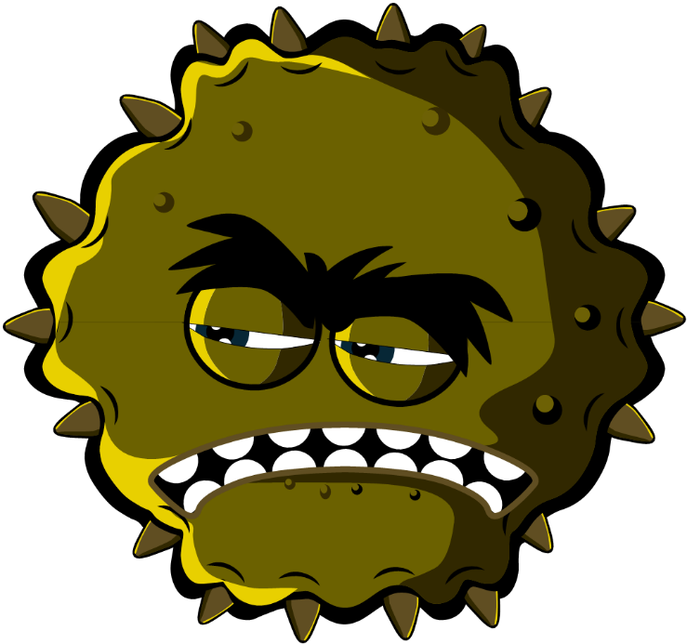

Key Stage 4 (14-16 years)

Welcome to e-Bug

e-Bug has been designed to bring the world of microbes and antibiotics to life for children in the school environment. It is a curriculum supplement series (Early Years, Key Stage 1, 2, 3 and 4) that complies with the Department for Education educational standards for junior and senior schools.
This resource has been created by the UK Health Security Agency (formerly Public Health England) in collaboration with 17 EU partner countries to foster an interest in science and to improve young people’s knowledge and understanding about microbes, infection prevention and control, and prudent antibiotic use, thereby empowering them to be proactive in looking after their own health. Lesson plans can be used in sequence or as individual activities designed to fit into 50-minute classroom slots. These tools can be used freely by educators and may be copied for classroom use but may not be sold.
Over 27 international countries are involved in the e-Bug project, and the resources have been evaluated with more than 3000 children in England, France and the Czech Republic. The e-Bug pack is supported by a website from which all the pack resources, videos, images and additional activities can be downloaded (www.e-bug.eu).

We would like to thank everyone involved in the development of this resource which will help the next generation of adults to use antibiotics more wisely. We would especially like to thank the teachers and students across the UK, and Europe who participated in focus groups and the evaluation process and helped ensure that these materials are not only fun and exciting but also effective. We do hope you enjoy using e-Bug and will find this an invaluable addition to your classroom. If you would like to keep up to date with our latest resources, or the research and development that we undertake please register for our quarterly newsletter at: www.e-bug.eu/uk-newsletter

As educators, your feedback is invaluable to us. Your comments will help the e-Bug resource grow and evolve. Please send any comments, queries and suggestions to: Primary Care and Interventions Unit UK Health Security Agency Twyver House, Bruton Way Gloucestershire GL1 1DQ

Or alternatively visit the e-Bug website and contact us at www.e-bug.eu/uk-contact-us

The e-Bug Team

Each section of the pack contains detailed lesson plans, student worksheets and handouts some of which are available in MS PowerPoint format for whiteboard use:
- Creative inquiry-based activities to promote active learning
- Highlighted learning outcomes which deepen students’ understanding of the importance of microbes, their spread, treatment and prevention
- Activities that encourage students to take more responsibility for their own health
- Activities that highlight the importance of responsible antibiotic use

Teacher Refresher Information
Key Stage 4
Optional background information on each of the pack topics are included to help you plan your lessons and introduce the topic to students.

Introduction to Microbes
Micro-organisms are living organisms too small to be seen with the naked eye; they are microscopic. Micro-organisms are found almost everywhere on Earth and can be both useful and harmful to humans. It is important to clarify that microbes are not innately “useful” or “harmful”. Rather, that some microbes can be useful to humans whilst others can be harmful depending on the situation. For example, the mould Aspergillus is used to help make chocolate, however, can cause harm to humans if inhaled into the lungs. Although extremely small, microbes come in many different shapes and sizes. The three groups of microbes covered in this resource are viruses, bacteria and fungi.
Viruses are the smallest of the three and are generally harmful to humans. Viruses cannot survive by themselves. They require a ‘host’ cell in which to live and reproduce. Once inside the host cell, they rapidly multiply destroying the cell in the process. There are over 250 different kinds of virus causing the common cold. One of the most common of these is Rhinovirus.
Bacteria are single celled organisms that, under the right conditions, can multiply exponentially, on average once every 20 minutes. During their normal growth, some produce substances (toxins) which can be harmful to humans and cause disease (Staphylococcus aureus). Some bacteria are completely harmless and can be extremely useful (such as Lactobacillus in the food industry), or even necessary for human life (such as Rhizobacterium, which is involved in plant growth). When bacteria are harmless, they are called non-pathogenic, while bacteria that cause harm are known as pathogenic. Over 70% of bacteria are non-pathogenic (harmless) micro-organisms.
Bacteria can be divided into three groups by their shapes – cocci (balls), bacilli (rods) and spirals. Cocci can also be broken down into three shapes -clusters, chains or groups of two. Scientists can use these shapes to help identify the microbes and tell which infection a patient has.
Fungi are generally multi-cellular organisms that can be both useful and harmful to humans. Fungi obtain their food by either decomposing dead organic matter or by living as parasites on a host. Fungi range in size from being microscopic to very large and include mould, mushrooms and mildew. While fungi can be harmful by causing an infection or being poisonous to eat; others can be useful or harmless e.g. Penicillium produces the antibiotic penicillin and Agaricus bisporus can be eaten (the common button mushroom). Fungi spread through the air in small hard seed-like spores. When these spores land on bread or fruit, they can open and grow under the right conditions (such as dampness).

Useful microbes
One of the main ways in which bacteria are beneficial is in the food industry. The natural by-products created during normal microbial growth can be used to make many of the food products we eat.
Fermentation is a process by which bacteria break down complex sugars into simple compounds like carbon dioxide and alcohol. Optional background information on each of the pack topics are included to help you plan your lessons and introduce the topic to students.
There are different types of fermentation, acetic acid fermentation produces vinegar and lactic acid fermentation produces yoghurt and cheese. Some fungi are also used to make blue cheese. The yeast, Saccharomyces cerevisiae, is used to make bread and dough products through fermentation. Wine and beer are also produced in the same manner although alcohol is produced following fermentation when the microbes are grown without oxygen. The chocolate industry also relies on bacteria and fungi. These organisms produce acid through fermentation which eats away at the hard pod and makes it easier to get at the cacao beans.
When the bacteria Streptococcus thermophilus or Lactobacillus bulgaricus are added to milk they consume the sugars during fermentation, turning it into yoghurt. So much acid is produced in fermented milk products that few potentially harmful microbes can survive there.
Lactobacillus bacteria are generally referred to as useful or ‘friendly’ bacteria. They help us digest food and have been termed probiotic bacteria that we find in our yoghurts and probiotic drinks. Although even ‘friendly bacteria’ can cause infection in people who are immunocompromised.

Harmful Microbes
Some microbes can be harmful to humans and can cause disease: the Influenza virus causes the “flu” (short for “Influenza”), Campylobacter bacteria can cause food poisoning and the dermatophyte fungi, such as Trichophyton, can cause diseases such as athlete’s foot and ringworm. Microbes like these are known as pathogens. Each pathogenic microbe can make us ill in different ways.
Bacterial toxins can damage tissues and organs and make us very unwell, fortunately this is rare.
Viruses need to live within a cell in order to survive. Once inside a cell, they multiply until fully grown and leave the host cell. Dermatophytes generally prefer to grow or colonise under the skin. The products they produce while feeding cause swelling and itching.
Someone who is ill because of a harmful disease-causing microbe is said to be infected. Many harmful microbes can pass from one person to another by a number of different routes – air, touch, water, food, aerosols (such as sneezes and water vapour), animals, etc. Diseases caused by such microbes are said to be infectious diseases.
In some cases, infectious diseases can spread in communities or large areas, this is called an epidemic. When the disease spreads to over an entire country or around the world this is known as a pandemic. The COVID-19 pandemic started when a new virus SARS-CoV-2 caused the disease COVID-19, infecting a population in China. Because this virus was very infectious, and global travel is so commonplace, it was able to spread quickly and infect people all over the world.
It is important to remember that not all microbes are harmful, and some microbes are only harmful when taken out of their normal environment. For example, Salmonella and Campylobacter live in the gut of chickens usually without causing them any harm. However, when they enter the human gut, the toxins they release through their normal growth can make us very ill.
Our bodies have also adapted to help us get rid of these infections; this may be in the form of
- Fever: Microbes prefer to live at normal body temperature at 37ºC. A fever or increase in body temperature is one of the body’s immune responses to eliminate the perceived threat (microbe) inside the body.
- Swelling: A cut on the hand may result in swelling; this is our body responding in a similar way to a fever only in a more localised way.
- Rash: This is our body’s reaction to microbial toxins.

Hand and Respiratory Hygiene

Why is hand hygiene so important?
Hand hygiene is possibly the single most effective way of reducing and preventing the spread of infection and is an important behavioural intervention to instil and reinforce from a young age. Schools and community groups are a relatively crowded and closed environment where microbes can spread easily and rapidly from child-to-child via direct contact or via surfaces. Some of these microbes can be harmful and cause illnesses. Washing our hands with soap and water at key moments removes any harmful microbes we pick up on our hands from our surroundings e.g. home, school, garden, animals, pets, food. Effective hand washing has been shown to reduce absenteeism rates in schools.

Why is soap needed for effective hand washing?
Our hands are naturally covered by useful bacteria – Staphylococcus is a common example (ball shaped bacteria arranged in clusters). Our skin naturally secrete oil called ‘sebum’ which helps to keep it moist and keeps our skin microbiome (micro-organisms that live on our skin) healthy. This oil, however, is also a perfect place for potentially harmful microbes to grow and multiply as the sebum helps microbes ‘stick’ to our skin.
Soap is required to break up the oils on the surface of the hands and should be applied well to all surfaces of the hand, producing a lather which helps to lift the dirt and microbes. It is important to rinse our hands to help remove the dirt and microbes. Where possible liquid soap should be used instead of bars of soap, especially if used by multiple people. If soap is unavailable, hand sanitisers, with at least 60% alcohol can also be effective as long as there is no visible dirt/ other substance on hands (these need washing with soap and water). Sanitiser should be applied to all parts of the hands and rubbed until dry (about 20 seconds - the length of the happy birthday song twice). Hand sanitisers with ingredients like alcohol work by destroying microbes as they dry, but don’t kill all types of harmful microbes and don’t remove visible dirt or other substances from our skin. Therefore, hand sanitisers should not be generally used after using the toilet.

When are the key moments for hand washing?
- Before, during and after preparing food
- Before eating or handling ready to eat food
- After using the toilet or changing a soiled nappy/underwear
- After exposure to animals or animal waste
- After coughing, sneezing or blowing your nose
- If you are ill or have been around ill people
- When you get home or go into another place like work, school, or another household (especially in an outbreak situation)
Colds and flus are the most common illnesses in the classroom and perhaps one of the most contagious. COVID-19 is a respiratory illness that is transmitted in a similar way to colds and flus. The most common mode of transmission for respiratory tract infections (RTIs) is through close contact with respiratory droplets in the air from coughs and sneezes or through contact with contaminated surfaces. Most droplets are heavy and only fall within 1m – to 1.5m of people. However, there are smaller droplets that last in the air for longer (airborne) and travel further. Examples: the common cold (droplet) and measles (airborne). Microbes can also be spread more directly, through person-to-person contact and contact with contaminated surfaces or objects. The virus can be spread by getting into the non-infected person’s nose or eyes because they touch their face with contaminated hands.
Sneezing is a way in which our body tries to get rid of any harmful microbes and particles we might inhale from getting deeper into our respiratory tract. The harmful microbes and dust get caught on the nose hair and tickle our nose. The nose sends a message to the brain which then sends a message back to your nose, mouth, lungs and chest telling them to blow the irritation away. In the case of colds and flu, millions of viral particles rush out and contaminate the surfaces on which they land; this could be our food or hands. While a sneeze can travel at 100mph through the air and spread cold/flu virus over 20 feet away from the infected person, particles from a cough can travel up to 3 metres in a matter of seconds and could linger in the air for more than a minute.
Good respiratory hygiene is especially important in the approach to the winter cold/ flu season each year, and when there is an outbreak of some kinds of infection. Common symptoms of RTIs include a headache, sore throat and fever, and sometimes a runny or blocked nose. These infections can also cause sneezing and/or coughing, loss of taste or smell, and rarely nausea/vomiting or diarrhoea.
To prevent the spread of harmful microbes from coughs or sneezes:
- Catch it: cover your mouth and nose with a tissue. If you don’t have a tissue, cover with your upper sleeve or elbow (not your hands).
- Bin it: throw away the used tissue at once to avoid spreading infection to surfaces, or other people.
- Kill it: wash your hands well with soap and water, or hand sanitiser if soap and water are not available, immediately after having binned the tissue.
Another way of preventing the spread of respiratory illness is learning how to successfully practice good respiratory hygiene when we cough or sneeze. It is a natural reflex to put our hands towards our faces when we sneeze, but it is important to replace this action with new habits of respiratory hygiene to reduce the spread of infection. We can prevent some of these infections (like the flu and COVID-19) by getting vaccinations. Check this ECDC infographic [www.ecdc.europa.eu/en/ seasonal-influenza/prevention-and-control/ vaccination-infographic] on why a different flu vaccine is needed each year.
Where there is an outbreak of infection it is important that you wash your hands more often and for 20 seconds and follow key guidance on respiratory hygiene. You may also be asked to wear a facemask and keep a certain distance from people.

Food Hygiene and Safety
harmful microbes, but it is harmful microbes that can be associated with foodborne illness or ‘food poisoning’. The top five foodborne microbes in Europe account for about 70% of the health burdens related to foodborne illness and these include; Norovirus, Toxoplasma Gondii, Campylobacter jejuni, Campylobacter coli, Salmonella enterica and Listeria monocytogenes. Other microbes such as Bacillus cereus and Escherichia coli have also been associated with serious cases of foodborne illness. These microbes can be found in raw meats, in eggs without a British Lion mark or equivalent quality marking outside of the UK, some dairy products, on the surface of fruits and vegetables, in dried food like pasta and rice, or in ready to eat foods such as sandwiches and desserts. Symptoms can include diarrhoea, stomach cramps, fever and vomiting and some foodborne illness may even result in death – though this is rare. The symptoms of foodborne illness usually start within a few days of eating the food that caused the infection and can usually be treated at home with rest and fluids.
Saccharomyces cerevisiae is used to make bread and beer. Lactobacilli bacteria are used in yoghurt and cheese making. Food spoilage is the deterioration of the colour, texture and flavour of food. It can be caused by many things, including microbes. For example, the fungus Rhizopus stolonifer causes bread mould. Microbes that cause foodborne illness may or may not cause food spoilage.
There are important steps you can take to prevent foodborne illness and spoilage that apply at all stages in the journey of food, from the shop to our plates:
- Keep clean; maintaining hand and surface hygiene is the best way for avoiding foodborne microbes entering our food. Tools, equipment and surfaces should be regularly cleaned to remove harmful microbes.
- Maintain the cold chain; keeping food in the fridge or freezer slows the growth of bacteria but does not stop it. To keep food safe for longer, care should be taken to minimise the time food spends outside of the fridge or freezer, this includes leftovers which should be stored in the fridge soon after cooling. Refrigerators should be kept ≤4°C.
- Prevent cross-contamination; preventing harmful microbes found on food from spreading to other foods (for example via our hands or kitchen utensils) and causing illness when those foods are eaten. This can include taking care not to wash chicken or other meats as this can splash microbes around the kitchen.
- Cook food such as meat thoroughly; one way of checking is to cut the thickest part of the meat, check that none of the meat is pink and that any juices run clear. A temperature probe can also be used; the temperature should reach one of the following combinations to make sure it has been cooked properly:
  - 60°C for 45 minutes
  - 65°C for 10 minutes
  - 70°C for 2 minutes
  - 75°C for 30 seconds
  - 80°C for 6 seconds
Labels placed on foods are used to determine when it is safe to eat the food, or when the quality of the food is at its best. ‘Use by’ refers to when the food is still safe to eat. Food should not be consumed after this date. ‘Best before’ refers to when the food will be at its best quality, but it is worth noting that consumption after this date should still be safe.
Detailed background information and training to support educators has been developed and can be found at e-bug.eu/eng/KS4/ lessons/Food-Hygiene.

Sexually Transmitted Infections
STIs are contracted by having close sexual contact with someone who is already infected. Some STIs can be treated and cured with antibiotic medicine whereas others cannot. Many symptoms of incurable STIs can be treated to make them easier to live with. There are over 25 different STIs.
Bacterial STIs are caused when bacteria are spread through vaginal, oral or anal sexual contact with an infected person. These infections include chlamydia, gonorrhoea and syphilis and are generally cured through antibiotic therapy.
Viral infections can be spread via the same routes as bacterial infections but can also be spread through direct contact with infected skin or bodily fluids such as blood, semen or saliva from an infected person entering into the bloodstream of an uninfected person. Viral infections include genital warts, hepatitis B, herpes and HIV which although they can be treated, are NOT curable.
Although most STIs are generally transmitted through sexual encounters, some of these infections can be transmitted in other ways as well as sexually. For example, hepatitis B, C and HIV can be spread to others by sharing needles and syringes or are transferred from mother to unborn baby during pregnancy and childbirth. HIV can also be spread through breast milk. It is important to note that an HIV positive person who is on treatment and their viral load is undetectable cannot transmit HIV to another person.
Details on the most common STIs are available in a MS PowerPoint presentation at e-bug.eu/eng/KS4/lesson/STIs. It is important to note that people can have an STI but have NO obvious symptoms; they themselves may not know they are infected.
Anyone can contract an STI. Most people who contract an STI do not know that the person they have sexual contact with is infected. When discussing sexual health with students, it is important everyone feels comfortable, safe, and heard. Here are some ground rules to follow:
- No one (teacher or student) will have to answer a personal question
- No one will be forced to take part in a discussion
- Only the correct names for body parts will be used (you may wish to ask pupils to use the correct word if they can but if not, to use the word they know and then provide them with the more appropriate word)
- Meanings of words will be explained in a sensible and factual way
- Others (as agreed by class)

Chlamydia
Chlamydia is a sexually transmitted infection (STI) caused by bacteria called Chlamydia trachomatis. The highest incidence of chlamydia is amongst 16-24-year olds. Of this group approximately one in ten is thought to be infected. About 70% of females and 50% of males with chlamydia don’t experience any symptoms at all which means that many infected people don’t realise they carry the infection. For women who do experience symptoms these might include abnormal discharge, pain and/or bleeding during sex and pain when urinating. In men these include a cloudy or watery discharge from the tip of the penis, pain when urinating and testicular pain.
Diagnosis can be made using a sample of urine (males and females) or vaginal swab (females only). Infection is treatable with a one-week course of antibiotics. Untreated chlamydia is a well-established cause of pelvic inflammatory disease (serious inflammation of the ovaries and fallopian tubes), ectopic pregnancy (when a foetus grows in a fallopian tube) and infertility in women. In men infection can cause prostate and testicular problems, and a growing body of evidence also links chlamydia to infertility in men.
Although chlamydia is a serious and growing public health problem, there are a number of characteristics of this infection which may mean that young people may not find it particularly threatening.
In making a decision about whether to use condoms, young people most likely weigh up the consequences. Some of these will be positive such as protecting against STIs but there are likely to be many more negative ones (such as “it interrupts the mood”). Often the negative consequences can outweigh the positive ones, so that motivations to use condoms are not particularly strong.
To counteract this and bolster intentions to use condoms, it is very important that young people have accurate perceptions of the threat caused by STIs. This lesson has been designed to encourage strong and realistic perceptions of the threat caused by chlamydia and to provide students with the opportunity to explore the issues around negotiating safer sex.

Vaccinations
Vaccinations have been one of the most effective methods to prevent disease and have helped to lower mortality associated with infectious diseases worldwide. They are designed to prevent disease, rather than treat a disease once you have caught it.

How Vaccines Provide Immunity
A vaccine is usually made from weak or inactive versions of the same microbes that make us ill. In some cases, the vaccines are made from cells which are similar to, but not exact copies of, the microbe cells that make us ill. Some diseases are caused by a toxin the microbe produces so some vaccines contain a substance that is similar to the toxin known as a toxoid. Examples are: Cholera and Diphtheria.
When the vaccine is introduced into the body the immune system attacks it as if harmful microbes were attacking the body. The white blood cells (WBC) create lots of antibodies to attach to the antigens on the surface of the vaccine. Because the vaccine is an extremely weakened version of the microbe the WBCs successfully eliminate all the microbial cells in the vaccine and the vaccine will not make you ill. By successfully eliminating all the vaccine antigens, the immune system remembers how to combat those microbes. The next time microbes carrying the same antigen enter the body, the immune system is ready to fight it before it has a chance to make you ill.
In some cases, the immune system needs reminding and this is why some vaccinations require booster jabs. Some microbes such as the influenza virus are tricky and change their antigens. This means that the immune system is no longer equipped to fight them. For this reason, we have annual flu vaccinations.
The live viruses in the flu vaccine that is given to school aged children are cold adapted so that they cannot replicate efficiently at body temperature (37⁰C). This means that the vaccine viruses will not replicate in the lungs but will reproduce at the cooler temperatures found in the nose. This allows the child to produce localised antibodies in the lining of the airways which then protect against infection if they encounter flu virus (which enters the body via the nose and mouth).
These localised antibodies are not produced in response to the inactivated flu vaccine. In addition to localised antibodies in the nose, antibodies are also produced in the blood (systemic antibodies). The use of vaccines has meant that some previously common diseases, e.g. smallpox, have now been eradicated. The re-emergence of other diseases in a population, e.g. measles, may be due to not vaccinating a large enough proportion of the population. Epidemics can be prevented by vaccinating a large enough part of the population leading to herd immunity.

Herd Immunity
Herd Immunity is a type of immunity which occurs when the vaccination of a portion of a population (or herd) provides protection to unvaccinated individuals. If enough of a population is vaccinated, unvaccinated individuals are less likely to come into contact with the disease due to its decreased prevalence. It is important to maintain herd immunity as some people are unable to have vaccinations. Individuals who may not be able to have a vaccine include those who are immuno-compromised, individuals with allergies to the components of vaccines and very young children.

Routine and Other Vaccinations
Countries have routine vaccinations for diseases that are considered to be high risk in that country. Some vaccines contain antigens for more than one disease. Examples of these include the polio, diphtheria and tetanus vaccine, and MMR (measles, mumps and rubella). In some cases, one pathogen can cause more than one disease. Human papillomavirus also known as HPV, is an infection caused by Human papillomavirus that can cause genital warts and if left unmonitored in women, can lead to cervical cancer. The HPV vaccination can prevent cervical cancer in women, and also protects against genital warts. International travel is increasingly popular, and it is important for students to understand that travel to different regions comes with increased risk of infection. Increased risk can be due to poor sanitation or hygiene, or higher occurrence of different infections in those countries, for example rabies, meningitis or Japanese encephalitis. Students can visit the e-Bug website for more information, their travel vaccination practitioner at their GP surgery, or visit [www.fitfortravel.nhs.uk]. Travel vaccinations are important and in some cases are required for entry into a country. An example includes the proof of vaccination against meningitis for entry into Saudi Arabia for the Hajj pilgrimage.

COVID-19
COVID-19 is the name of the disease caused by the coronavirus known as SARS-CoV-2 that causes illness in people by affecting their lungs and therefore their breathing. Most people infected with the COVID-19 virus will experience mild to moderate respiratory illness and recover without requiring special treatment. Older people, and those with underlying medical problems like cardiovascular disease, diabetes, chronic respiratory disease, and cancer are more likely to develop serious illness.
The best way to prevent and slow down transmission is to be well informed about the SARS-CoV-2 virus, the COVID-19 disease it causes, how it spreads and to have the vaccine if it is offered to you as part of a vaccination programme. You can also protect yourself and others from infection by washing your hands or using an alcohol-based rub frequently, not touching your face, wearing a face mask, and practicing social distancing.
At the time of writing this e-Bug pack (July 2021), several COVID-19 vaccines have been developed to help manage the outbreak, for example the Oxford/AstraZeneca vaccine that was tested on over 11,000 people, and the Pfizer/BioNTech vaccine that was tested on 43,500 people. While development of these vaccines was fast, no parts of the process were skipped and the vaccines met the rigorous standards set by the Medicines and Healthcare products Regulatory Agency (MHRA), who make sure that all medicines used in the UK are safe. COVID-19 vaccines have played a significant role in slowing the spread of infection and preventing deaths.

Antibiotic Use and Antimicrobial Resistance
In some cases, the immune system needs help. Antimicrobials are medicines used to kill or slow the growth of microbes. Antimicrobials can be grouped according to the micro-organisms they act primarily against. Antibiotics are used to treat bacterial infections such as meningitis, tuberculosis and pneumonia. They do not work on viruses, so antibiotics cannot treat viral infections such as colds and flu. Antibiotics work by targeting structures unique to bacteria; thereby they do not cause damage to human cells and they do not kill viruses.
Antibiotics are either bactericidal, meaning they kill the bacteria, or they are bacteriostatic, meaning they slow the growth of bacteria. Penicillin is an example of a bactericidal antibiotic, which targets the peptidoglycan layer in the cell wall leading to cell death. Bacteriostatic antibiotics interfere with processes the bacteria need to multiply, such as protein production, DNA replication or metabolism.
Antibiotics can be narrow spectrum, affecting only one or two species of bacteria, or broad spectrum, affecting many different species of bacteria in the body, including useful bacteria in the gut. As a result of killing many bacteria in the gut, broad spectrum antibiotics are more likely to cause diarrhoea.
Bacteria are continually adapting to develop ways of not being killed by antibiotics. This is called antibiotic resistance. Resistance develops due to mutations in the bacterial DNA. The genes for antibiotic resistance can spread between different bacteria in our bodies through horizontal gene transfer, which includes transformation, transduction and conjugation. Resistance genes can also spread by vertical gene transfer when genetic material in chromosomes is passed from parent to offspring during reproduction.
Antibiotic resistant bacteria can be carried by healthy or ill people and can spread to others just as other types of microbes would, for example by shaking hands or touching all types of surfaces on animals, vegetables or food where bacteria are present.
Antibiotic resistance arises in bacteria found in the body, animals or the environment, due to the overuse and misuse of antibiotics. The more often a person takes antibiotics, the more likely they are to develop antibiotic resistant bacteria in their body. To prevent resistance, antibiotics should only be taken as prescribed by a doctor or nurse. The important points to remember are:
- Antibiotics do not need to be taken for colds and flu or most coughs, sore throats, ear infections or sinusitis as these usually get better on their own.
- It is important to take the antibiotic exactly as instructed and complete the course of antibiotics, to decrease the risk of emergence of resistance.
- Antibiotics are personal and prescribed for individuals and for a particular infection. They should not be shared or taken for a different illness.

All lesson plans and supporting materials contained in this pack are available to download as modifiable templates from the e-Bug website. Answers are available at the end of this booklet.

Micro-organisms: Introduction to Microbes
Key Stage 4

Lesson 1: Introduction to Microbes
Students are introduced to the exciting world of microbes. In this lesson they will learn about bacteria, viruses and fungi, their different shapes and the fact
that they are found everywhere.

Learning Outcomes

All students will:
- Understand that useful bacteria are found in our body.
- Understand that microbes come in different sizes.
- Understand the key differences between the three main types of microbe

Most students will:
- Understand using a variety of scientific concepts and models, how to develop scientific explanations.

Curriculum Links

PHSE/RHSE
- Health and prevention

Science
- Scientific thinking
- Analysis and evaluation
- Experimental skills and strategies

Biology
- Development of medicines
- Cells
- Health and disease

English
- Reading
- Writing

Art and design
- Graphic communication

Lesson 1: Introduction to Microbes

Resources Required

Introduction

Per student
- Copy of SH1

Main Activity: Microbe Mayhem

Per group
- Copy of SH2
- Copy of SH3
- Copy of SH4
- Copy of SH5

Extension Activity: Posters

Per student
- Pens/pencils
- Paper

Alternative Main Activity: Peer Education

Per group
- Groups of 3 or 4 students

Supporting Materials
- SH1 How Big is a Microbe?
- SH2 Microbe Mayhem
- SH3 Microbe Mayhem
- SH4 Microbe Mayhem
- SH5 Microbe Mayhem
- SW1 Quiz

Advanced Preparation
Cut out and laminate a set of playing cards (SH2 – SH5) for each group.
Lesson 1: Introduction to Microbes

Key Words
Bacteria
Cell
Fungi
Microbe
Microscope
Pathogen
Virus

Health & Safety
For safe microbiological practices in the classroom consult CLEAPSS
www.cleapss.org.uk

Weblinks
e-bug.eu/eng/KS4/lesson/ Introduction-to-Microbes

Introduction
- Begin the lesson by asking students what they already know about microbes. Most students will already know that microbes can cause illness but may not know that microbes can also be good for us. Ask the class where they would look if they wanted to find microbes. Do they think microbes are important to us?
- Explain that microbes are the smallest living creatures on Earth and that the word micro-organism literally translates into micro: small and organism: life. Microbes are so small they cannot be seen without the use of a microscope. Antonie van Leeuwenhoek created the first microscope in 1676. He used it to examine various items around his home and termed the living creatures (bacteria) he found on scrapings from his teeth ‘animalcules’.
- Show the class that there are three different types of microbe: bacteria, viruses and fungi. Use SH1 to demonstrate how these three microbes vary in shape and structure.
- Highlight to the class that microbes can be found EVERYWHERE – floating around in the air we breathe, on the food we eat, in the water we drink and on the surface of and in our bodies. Emphasise that although there are harmful microbes that can make us ill, there are many more useful microbes that we can use.
- Emphasise that although microbes cause disease, there are also useful microbes. Ask students to identify some benefits of useful microbes. If they cannot, provide examples for them e.g. Lactobacillus in yoghurt, probiotic bacteria in our gut which aid digestion and the fungus Penicillium which produces the antibiotic Penicillin.

Activity

Main Activity: Microbe Mayhem
In this activity groups of 3-4 students play a card game which helps them remember some of the technical words relating to microbes as well as familiarising students with a variety of microbial names, the differences in size, capability of causing harm and if antibiotic resistance occurs. Microbe size and number of species are correct at the time of resource development; however as new microbes are continuously being discovered and reclassified, these numbers may be subject to change.
The remaining numbers presented are only to be used as a guide and are illustrative only. There are no formulae to create these, and they may also be subject to change i.e., bacterial species may develop resistance to more antibiotics resulting in them having a higher number being more dangerous to humans.
Hand out a set of Microbe Mayhem playing cards SH2 - SH5 to each group. Let the students know that ‘nm’ on the playing cards stands for nanometres. There are ten million nanometres in a centimetre.

Game rules
- The dealer should shuffle the cards well and deal all the cards face down to each player. Each player holds their cards face up so that they can see the top card only.
- The player to the dealer’s left starts by reading out the name of the microbe on the top card and chooses an item to read (e.g. Size 50). In a clockwise direction, the other players then read out the same item. The player with the highest value wins, taking the other players top cards and placing them to the bottom of their pile. reads out the name of the microbe on their next card and selects the item to compare.
- If two or more players have the same top value, then all the cards are placed in the middle and the same player chooses again from the next card. The winner then takes the cards in the middle. The person with all the cards at the end is the winner.

Alternative Main Activity: Peer Education
Divide the class into groups of 3 – 4 students. Explain to the students that they will be creating a presentation to teach a group of their younger peers about microbes. Allow the students to choose the level at which they want their presentation to be aimed – EY, KS1, KS2 or KS3.
Ask student to design an engaging presentation to teach their younger peers the following:
- What are microbes?
- Where are microbes found?
- Microbial shapes and structures
- Microbes that are good or bad for humans
Suggest to students that their presentations should include amazing microbe facts, interactive elements or activities and they should make the presentation visually engaging for a younger audience.

Extension Activities
Divide the class into groups of 3 – 4 students. Each group should research and create a poster to reinforce learning on one of the following topics:
- Choose a specific type of bacterium, virus or fungus e.g., Salmonella, Influenza A or Penicillium. The poster should include:
  - Structure of that microbe
  - The different places they can be found
  - How they affect humans in either a good or bad way
  - Any specific growth requirements of that group of microbes
OR
- A timeline poster on the history of microbes. This poster may include:
  - 1676: van Leeuwenhoek discovers ‘animalcules’ using homemade microscope
  - 1796: Jenner discovers smallpox vaccination
  - 1850: Semmelweis advocated washing hands to stop the spread of disease
  - 1861: Pasteur publishes germ theory: the concept that germs cause disease
  - 1892: Ivanovski discovers viruses
  - 1905: Koch awarded Nobel Prize in Medicine for his work understanding tuberculosis and its causes
  - 1929: Fleming discovers antibiotics

Learning Consolidation
Check for understanding by asking students if the following statements are true or false.
- There are two main types of microbes: bacteria and fungi?
Answer: False, there are three main types: bacteria, viruses and fungi.
- Bacteria have three main shapes, cocci (balls), bacilli (rods) and spirals.
Answer: True.
- Microbes are only in the food we eat.
Answer: False, there are microbes everywhere, floating around in the air we breathe, on the food we eat, in the water we drink and on the surface of and in our bodies, even inside volcanoes.
- Microbes can be useful, harmful or both.
Answer: True

SH1 - How Big is a Microbe?
Viruses
Glycoproteins
Nucleic acid
Capsid
Viruses are NOT free living – they MUST live inside another living cell/organism
Capsid
Double lipid layer holding the cells
genetic material.
Glycoproteins
These serve 2 purposes:
- Anchor the virus to the host cell.
- Transport genetic material from the
virus to the host cell.
Nucleic acid
Either DNA or RNA material, but viruses rarely contain both. Most viruses contain RNA material.
Bacteria
Chromosome
Cytoplasm
Cell membrane
Cell wall
Bacteria are free living and are found everywhere
Chromosome:
Genetic material (DNA) of the cell.
Cell wall:
The cell wall is made of peptidoglycan and maintains the overall shape of a bacterial cell.
Cell membrane:
Lining the inside of the cell wall providing a boundary for the contents of the cell and a barrier to substances entering and leaving.
Cytoplasm:
Jelly like substance inside of the cell
holding the contents.
Fungi
Sporangi-ophore
Sporangia
Rhizoids
Sporangia:
Spore producing body.
Sporangiophore:
Filamentous stalk on which the
sporangium forms.
Rhizoids:
The sub-surface hyphae are specialized for food absorption.
Microbe size
Viruses 1x
Fungi 100x
Bacteria 20x
Max size (nm)
1,000
Number of species
Danger to humans
Usefulness to humans
Antibiotic resistance
21
50
75
50
Streptococcus
Strep-Toe-Coccus
Bacterium
Many Streptococcus species are harmless to humans and are the normal flora of the mouth and hands. However, Group A Streptococcus bacteria cause about 15% of sore throats.
Treponema
Trep-O-Nee-Ma
Bacterium
Syphilis is an extremely contagious disease, caused by Treponema bacteria. In severe cases syphilis can lead to brain damage or death. Syphilis can be cured with antibiotics however resistant strains are becoming more frequent.
Max size (nm)
2,000
Number of species
Danger to humans
Usefulness to humans
Antibiotic resistance
3
115
8
50

Chlamydia
Clam-id-E-A
Bacterium
Chlamydia is a sexually transmitted infection (STI) that is caused by the bacteria Chlamydia trachomatis. Although symptoms are generally mild i.e., discharge from the penis or vagina, it can lead to infertility.
Max size (nm)
1,000
Number of species
Danger to humans
Usefulness to humans
Antibiotic resistance
3
37
1
70
Escherichia coli
Esh-Er-lc-E-Ah
Bacterium
Many strains of E. coli are harmless, and huge numbers are present in the human and animal gut. In some cases, however, E. coli cause both urinary infections and food poisoning.
Max size (nm)
2,000
Number of species
Danger to humans
Usefulness to humans
Antibiotic resistance
7
70
184
80
Max size (nm)
90
Number of species
Danger to humans
Usefulness to humans
Antibiotic resistance
1
146
12
n/a
Influenza A
In-Flu-En-Za A
Virus
The flu is an infection caused by Orthomyxoviridae. Every year 5 – 40% of the population get the flu but most people recover completely in a couple of weeks.
Simplex Virus
Sim-Plex Virus
Herpes simplex is one of the oldest known sexually transmitted infections. In many cases, Herpes infections produce no symptoms, but scab-like symptoms do occur in about one third of people infected.
Max size (nm)
200
Number of species
Danger to humans
Usefulness to humans
Antibiotic resistance
2
64
2
n/a

Tobamovirus
Tob-A-Mo-Virus
Virus
Tobamovirus are a group of viruses that infect plants, the most common being tobacco mosaic virus, which infects tobacco and other plants. This virus has been very useful in scientific research.
Max size (nm)
18
Number of species
Danger to humans
Usefulness to humans
Antibiotic resistance
125
12
34
n/a
Lyssavirus
Lice-A-Virus
Virus
The Lyssavirus infect both plants and animals. The most common Lyssavirus is the Rabies virus and is usually associated with dogs. Rabies results in over 55,000 deaths worldwide every year but can be prevented by vaccination.
Max size (nm)
180
Number of species
Danger to humans
Usefulness to humans
Antibiotic resistance
10
74
5
n/a
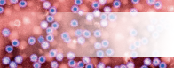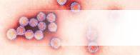
Max size (nm)
35
Number of species
Danger to humans
Usefulness to humans
Antibiotic resistance
8
25
0
n/a
Norovirus
Nor-o-virus
Virus
The flu is an infection caused by Orthomyxoviridae. Every year 5 – 40% of the population get the flu but most people recover completely in a couple of weeks.
Papillomavirus
Pap-ill-O-Ma-virus
Virus
Herpes simplex is one of the oldest known sexually transmitted infections. In many cases, Herpes infections produce no symptoms, but scab-like symptoms do occur in about one third of people infected.
Max size (nm)
55
Number of species
Danger to humans
Usefulness to humans
Antibiotic resistance
170
130
0
n/a

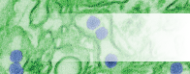
Varicellovirus
Var-E-Cell-O-Virus
Virus
Tobamovirus are a group of viruses that infect plants, the most common being tobacco mosaic virus, which infects tobacco and other plants. This virus has been very useful in scientific research.
Max size (nm)
200
Number of species
Danger to humans
Usefulness to humans
Antibiotic resistance
2
21
7
n/a
Zika
Zee-ka
Virus
The Lyssavirus infect both plants and animals. The most common Lyssavirus is the Rabies virus and is usually associated with dogs. Rabies results in over 55,000 deaths worldwide every year but can be prevented by vaccination.
Max size (nm)
40
Number of species
Danger to humans
Usefulness to humans
Antibiotic resistance
1
98
0
n/a
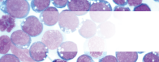
Max size (nm)
4,000
Number of species
Danger to humans
Usefulness to humans
Antibiotic resistance
5
150
0
100
Mycobacterium
My–co–back–tear–e–um
Bacteria
Tuberculosis (TB) is caused by the bacterium Mycobacterium tuberculosis and is one of the top 10 causes of death worldwide. Although treatable with antibiotics, many strains of TB are becoming resistant to multiple antibiotics.
Lymphocryptovirus
Lim-Foe-Cryp-Toe Virus
Virus
The Epstein-Barr virus, a type of Lymphocryptovirus, causes an illness known as the Kissing Disease or Glandular fever. Symptoms include sore throats and extreme tiredness. Transmission requires close contact such as kissing.
Max size (nm)
110
Number of species
Danger to humans
Usefulness to humans
Antibiotic resistance
7
37
2
n/a

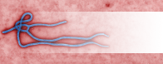
Neisseria
Nai–sheer–e-a
Bacterium
Neisseria meningitidis is a bacterium that can cause meningitis, a life-threatening disease. A vaccine is available to protect against the 4 main types of this bacteria A, C, W and Y.
Max size (nm)
800
Number of species
Danger to humans
Usefulness to humans
Antibiotic resistance
13
120
0
20
Filovirus
File-o-vi-rus
Virus
Filovirus causes a disease more commonly known as Ebola. It is one of the more dangerous viruses known to humans. 25 – 90% of victims died from the disease before the development and approval of a vaccine in 2019.
Max size (nm)
1,500
Number of species
Danger to humans
Usefulness to humans
Antibiotic resistance
1
200
0
n/a
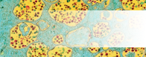
Max size (nm)
25
Number of species
Danger to humans
Usefulness to humans
Antibiotic resistance
2
28
14
n/a
Rhinovirus
Rhino-virus
Virus
There are over 250 different kinds of cold viruses, but Rhinovirus is by far the most common. Rhinovirus can survive three hours outside someone’s nose. If it gets on your fingers and you rub your nose, you’ve caught it!
HIV
HIV
Virus
The human immunodeficiency virus (HIV) is a sexually transmitted infection (STI) which leads to acquired immunodeficiency syndrome (AIDS). Individuals with this condition are more at risk of infection and cancer.
Max size (nm)
120
Number of species
Danger to humans
Usefulness to humans
Antibiotic resistance
2
150
0
n/a
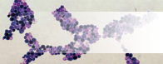
Max size (nm)
1,000
Number of species
Danger to humans
Usefulness to humans
Antibiotic resistance
19
1
184
n/a
Saccharomyces
Sac-A-Row-My-Sees
Fungus
For at least 6,000 years, Saccharomyces cerevisiae (Brewers yeast) has been used to make beer and bread! It is also used to make wine and it is widely used in biomedical research. One yeast cell can turn into 1,000,000 in only six hours.
Candida
Can-Did-a
Fungus
Candida is naturally found living in the human mouth and gastrointestinal tract. Under normal circumstances these fungi live in 80% of the human population with no harmful effects, although overgrowth results in candidiasis (Thrush).
Max size (nm)
10,000
Number of species
Danger to humans
Usefulness to humans
Antibiotic resistance
44
74
175
n/a

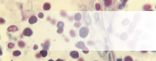
Penicillium
Pen-Ee-Sil-Ee-Um
Fungus
Penicillium is a fungus that naturally produces the antibiotic penicillin. Since this discovery, the antibiotic has been mass produced to fight bacterial infections. Unfortunately, due to its overuse many bacterial species have become resistant to this antibiotic.
Max size (nm)
332,000
Number of species
Danger to humans
Usefulness to humans
Antibiotic resistance
16
64
198
n/a
Cryptococcus
Cryp-Toe-Coccus
Fungus
Cryptococcus is a fungus which grows as a yeast. It is known for causing a severe form of meningitis in people with HIV/AIDS. The majority of Cryptococci live in the soil and are not harmful to humans.
Max size (nm)
7,500
Number of species
Danger to humans
Usefulness to humans
Antibiotic resistance
37
98
37
n/a
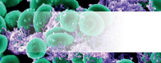
Max size (nm)
1,000
Number of species
Danger to humans
Usefulness to humans
Antibiotic resistance
19
174
20
90
Staphylococcus
Staff-ill-O-coccus
Bacterium
Methicillin resistant Staphylococcus aureus (MRSA) are a type of Staphylococcus aureus that have mutated to become resistant to most antibiotics. They can cause severe infection in humans.
Lactobacillus
Lac-Toe-Ba-Sil-Us
Bacterium
Lactobacilli are very common and usually harmless to humans; they make up a small portion of the gut flora. These bacteria have been extensively used in the food industry - in yoghurt and cheese making.
Max size (nm)
1,500
Number of species
Danger to humans
Usefulness to humans
Antibiotic resistance
125
0
195
10

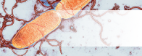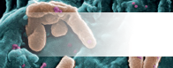
Salmonella
Sam-on-ella
Bacterium
Salmonella is most commonly known for causing food poisoning. Symptoms range from vomiting to diarrhoea. Salmonella is becoming resistant to antibiotics with an estimated 6,200 resistant cases per year in the US.
Max size (nm)
1,000
Number of species
Danger to humans
Usefulness to humans
Antibiotic resistance
3
89
15
60
Pseudomonas
Sued-O-Moan-Us
Bacterium
Pseudomonas are one of the most common microbes found in almost all environments. Although some may cause disease in humans, other species are involved in decomposition. Some Pseudomonas species are becoming resistant to multiple antibiotic treatment.
Max size (nm)
5,000
Number of species
Danger to humans
Usefulness to humans
Antibiotic resistance
126
50
150
90
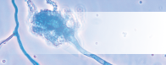
Max size (nm)
72,000
Number of species
Danger to humans
Usefulness to humans
Antibiotic resistance
2
83
2
n/a
Stachybotrys
Stack-Ee-Bo-Trys
Fungus
Stratchybotrys (or straw mould) is a black toxic fungus that although itself is not pathogenic, it does produce a number of toxins that can cause rashes or life-threatening reactions for those with respiratory problems.
Aspergillus
Ass-Per-Gill-Us
Fungus
Aspergillus is both beneficial and harmful to humans. Many are used in industry and medicine. It accounts for over 99% of global citric acid production and is a component of medications which manufacturers claim can decrease flatulence!
Max size (nm)
101,000,000
Number of species
Danger to humans
Usefulness to humans
Antibiotic resistance
200
47
124
n/a

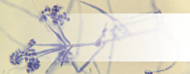
Tinea
Tin-Ea-A
Fungus
Although a variety of fungi can cause foot rashes, Tinea cause the itchy, cracked skin between toes known as Athlete’s foot, which is the most common fungal skin infection. Athlete’s foot affects nearly 70% of the population.
Max size (nm)
110,000
Number of species
Danger to humans
Usefulness to humans
Antibiotic resistance
12
43
14
n/a
Verticillium
Ver-Tee-Sil-Ee-Um
Fungus
Verticillium is a widely distributed fungus that inhabits decaying vegetation and soil. Some may be pathogenic to insects, plants, and other fungi but very rarely cause human disease.
Max size (nm)
8,500,000
Number of species
Danger to humans
Usefulness to humans
Antibiotic resistance
4
1
18
n/a

Micro-organisms: Useful Microbes
Key Stage 4

Lesson 2: Useful Microbes
The story of insulin helps students learn how microbes can be useful.

Learning Outcomes

All students will:
- Understand that some microbes can keep us healthy.
- Understand that some microbes can be useful.
- Understand that we need bacterial colonisation to live a healthy life.
- Understand that we need to protect our normal microbial flora.
- Begin to explore scientific research.

Most students will:
- Understand that microbes are important in decomposition and nutrient recycling.

Curriculum Links

PHSE/RHSE
- Health and prevention

Science
- Scientific thinking
- Analysis and evaluation
- Experimental skills and strategies
- Genetic engineering
- Role in biotechnology

Biology
- Development of medicines
- Cells
- Health and disease

English
- Reading
- Writing

Lesson 2 Useful Microbes

Resources Required

Main Activity: The Story of Insulin

Per student / per group
- Devices with internet access or biology textbooks

Optional Extension Activity for Upper KS4: Useful Microbes Presentation

Per student / per group
- Devices with internet access or biology textbooks

Extension Activity: Useful Microbes and their Properties

Per student
- Copy of SW1
- Devices with internet access

Additional Supporting Materials:
- TS1 Useful Microbes and Their Properties Sheet

Supporting Materials
- TS1 Useful Microbes and their properties teacher sheet
- SW1 Useful Microbes and their properties worksheet

Lesson 2: Useful Microbes

Key Words
Fermentation
Genetic modification
Insulin
Microbiome
Health & Safety
For safe microbiological practices in the classroom consult CLEAPSS
www.cleapss.org.uk

Weblinks
e-bug.eu/eng/KS4/lesson/ Useful-Microbes

Introduction
- . Begin the lesson by explaining that there are millions of different species of microbes and that most of these are completely harmless to humans; some are actually very good for us. Ask the class if they know of any ways in which we use microbes to our advantage. Examples may include Penicillium (fungus) to make antibiotics; some microbes break down dead animals and plant material to make compost; some microbes help us digest foods and some are even used to turn milk into yoghurt, cheese and butter.
- Remind the class that bacteria and fungi, like us, are alive – they need a food source to grow and multiply. They vary in their food requirements but generally anything we consider food can be used as food by many microbes. Microbes also produce waste products and it is these waste products that can either be beneficial or harmful to humans. Ask students if they have ever seen milk turn sour; although this may be seen as a problem to us, industry uses this process (fermentation) in making yoghurt.
- Explain that fermentation is a chemical change/process by which bacteria ‘eat’ sugars and produce acids and gas as waste. We use this process in the food industry to create wine, beer, bread, yoghurt and many more foodstuffs. When making yoghurt, the bacteria added to milk consume the milk sugars, and through fermentation convert these sugars to lactic acid which causes the milk to thicken into a yoghurt.
- Explain to the class that in this lesson they will be investigating other useful microbes.

Activity

Main Activity: Microbes in industry, the story of insulin (non-lab activity)
- Explain to the class: Insulin is a hormone (protein) that is produced in the pancreas and released when we have consumed carbohydrate or sugar. We need some sugar in our blood to feed our cells with energy, but too much can be dangerous. Insulin is the hormone that communicates with our liver, telling it to convert excess sugar into glycogen which is stored in the liver and muscles.
- People with type 1 diabetes do not produce enough insulin to regulate the levels of sugar in the blood; this can lead to hyperglycaemia. An insulin injection after a meal helps people with type 1 diabetes regulate their blood sugar.
- Ask the class: does anyone know where this insulin comes from? Today much of the insulin we use comes from genetically modified microbes.
- Tell the students that they will now be conducting research into the production of insulin, encourage them to plan their research and include answers to the following questions.
  - How was insulin historically made?
  - How is insulin made using microbes today? Why?
  - What microbes are involved? Why?
  - Are there any ethical considerations in this field of science?
- They may choose to present their research as an essay or a presentation.
Tip 1: Encourage students to explain/ interpret any data they present.
Tip 2: Encourage students to check their research plan with you or another teacher before they begin.

Discussion
Start a discussion with students about the importance of maintaining your gut microbiome. This provides the opportunity for students to engage in discussions from a novel area of research.
Explain to the class that living inside of your gut are 300 to 500 different kinds of bacteria. Paired with other tiny organisms like viruses and fungi, they make what’s known as the microbiota, or the microbiome. Multiple factors can influence the make-up of the human gut microbiota including diet - one of the main drivers in shaping the gut microbiota across the lifetime. Intestinal bacteria play a crucial role in maintaining the immune system and other regular body processes.
Main message: Gut microbiome can influence many aspects of human health, maintaining a healthy gut microbiome is key.
Some key points to include:
- The microbiota offers many benefits to the host, including strengthening gut integrity or shaping the intestinal epithelium, harvesting energy, protecting against pathogens and regulating host immunity.
- Ongoing area of research: there has been some links to lower gut microbiome biodiversity in people with IBS, eczema and diabetes.
- Gut microbiome has been linked to influencing mood.

Extension Activities

Useful Microbes and their properties
This activity can be conducted in small groups or as an individual task. Making use of classroom devices with internet access and/or textbooks, ask students to research the useful microbes in SW1 and fill in the gaps (see TS1 for answers). There is an empty row for students to select their own useful microbe to research. Once completed, this table can serve as a great way to consolidate information

Optional Extension Activity for Upper KS4: Useful Microbes Presentation
Using the above research criteria, ask students to research and present other useful microbes, for example the fungus Fusarium, which produces mycoprotein, a protein-rich food suitable for vegetarians. This activity can be carried out in groups or individually.

Learning Consolidation
Check for understanding by asking students if the following statements are true or false.
- Many microbes are useful, they can help us make food such as bread and yoghurt and can be used in industry due to the proteins or enzymes they produce.
Answer: True
- Fermentation happens when bacteria break down the simple sugars into carbon dioxide.
Answer: False. Fermentation happens when bacteria break down the complex sugars into simple compounds like carbon dioxide, and lactic acid and alcohol.
- Yoghurt contains bacteria including Lactobacilli and Streptococcus, meaning eating yoghurt is good for your gut health.
Answer: True

TS1 - Useful Microbes and their properties Teacher Sheet

Useful Microbes and their properties answer sheet

Useful Microbe Name | Type of Microbe | Use
Lactobacillus | Bacteria | Produce cheese, yogurt, kefir and kimchi
Saccharomyces | Fungi | Make bread, beer, cider and wine
Acetic Acid Bacteria (AAB) | Bacteria | Traditional manufacturing of vinegar
Bacillus thuringiensis (Bt) | Bacteria | Organic pesticide
Cyanobacteria | Bacteria | Grown in open ponds or photobioreactors and fed CO2 and other nutrients to support photosynthesis. The cell components can be extracted to make biodiesel or bioethanol (from carbohydrates, with the help of Saccharomyces.

SW1 - Useful Microbes and their properties Worksheet

Useful Microbes and their properties worksheet

Useful Microbe Name | Type of Microbe | Use
 |  | Produce cheese, yogurt, kefir and kimchi
 |  | Make bread, beer, cider and wine
Acetic Acid Bacteria (AAB) | Bacteria | Traditional manufacturing of vinegar
Bacillus thuringiensis (Bt) | Bacteria
Cyanobacteria | Bacteria

Micro-organisms: Harmful Microbes
Key Stage 4

Lesson 3: Harmful Microbes
Close examination of various illnesses illustrates to students how and where harmful microbes cause disease. Students test their knowledge of disease-causing microbes by researching various illnesses and how they can impact the community.

Learning Outcomes

All students will:
- Understand that sometimes microbes can make us ill and cause infection.
- Understand how harmful microbes (pathogens) can pass from person to person.
- Understand that different infections can have different associated symptoms.
- Understand how global travel has influenced the spread of disease.

Most students will:
- Understand how infectious diseases impact the local community.

Curriculum Links

PHSE/RHSE
- Health and prevention

Science
- Working scientifically
- Scientific attitudes
- Experimental skills and investigations

Biology
- Communicable diseases
- Structure and function of living organisms
- Cells and organisation
- Nutrition and digestion

English
- Reading
- Writing

Art & Design
- Graphic communication

Lesson 3: Harmful Microbe

Resources Required

Main Activity: Harmful Microbes and their Diseases

Per class/group
- Copy of SH1, SH2, SH3, SW1
- Differentiated versions adaptable for students of different abilities SH4, SH5, SW2
- Copy of TS1, TS2

Main Activity 2: Harmful Microbes Fill in the Blanks

Per group
- Devices with internet access or biology textbooks
- Copy of SW3
- Copy of TS3

Outbreak Activity 1 and 2
- Groups of 4 or 5 students

Supporting Materials
- TS1 Harmful Microbes and Their Diseases Answer Sheet
- TS2 Harmful Microbes and Their Diseases Differentiated Answer sheet
- TS3 Harmful Microbes Fill in the Blanks
- SW1 Disease Match Worksheet
- SW2 Differentiated Disease Match
- SW3 Harmful Microbes Fill in the Blanks
- SH1-3 Information Sheets
- SH4-5 Differentiated Information Sheets

Advanced Preparation
- Cut out the disease cards in SH1 - SH3, one set per group. Laminate these or stick onto stiff card for future use. (Differentiated version: SH4-SH5)
- Copy SW1 for each group. (Differentiated version: SW2

Lesson 3: Harmful Microbes

Key Words
Bacteria
COVID-19
Epidemic
Fungi
Infection
Pandemic
Pathogens
Toxin
Virus
Health & Safety
For safe microbiological practices in the classroom consult CLEAPSS
www.cleapss.org.uk

Weblinks
e-bug.eu/eng/KS4/lesson/ Harmful-Microbes

Introduction
- Begin the lesson by explaining to the class that sometimes microbes can be harmful to humans and cause disease. These are known as pathogenic microbes. Once bacteria and viruses enter your body, they can reproduce rapidly. Bacteria can also divide by binary fission and produce toxins when they reproduce which are harmful to the body. Viruses act like parasites multiplying inside our cells and destroying them. Some fungi like to grow on our skin making it itchy and sore. Find out how many different words they have for microbes – germs, bugs, etc.
- Ask the class to create a list of infections (infectious/ communicable diseases) by brainstorming any diseases they have heard of. Do they know what microbes cause the diseases? Do they know how these pathogenic (harmful) microbes are spread - modes of transmission? Ask the students what disease they think poses a threat to students in the class today? Tell them that in the early 1900s the disease of greatest threat was measles; many children who caught measles died. There are 4 main mode of transmission for pathogenic microbes:
  - By air including droplet transmission – many pathogens are carried and spread from one organism to another by air. When you are ill, you expel tiny droplets full of pathogens from your respiratory system when you cough, sneeze, or talk. Other people breathe in the droplets, along with the pathogens they contain, so they pick up the infection. Examples include flu (influenza), tuberculosis, and the common cold.
  - Direct contact - spread by direct contact of an infected organism with a healthy one. Pathogens such as the viruses which cause HIV/AIDS or hepatitis enter the body through direct sexual contact, cuts, scratches, and needle punctures that give access to the blood.
  - By consumption - eating raw, undercooked, or contaminated food, or drinking water containing sewage can spread diseases such as diarrhoeal diseases, cholera, or salmonellosis. The pathogen enters your body through your digestive system.
  - Vector – some diseases e.g. malaria, are vector-borne, this means that some living organism can transmit infectious pathogens between humans, or from animals to humans. Lifestyle factors often affect the spread of disease. For example, when people live in crowded conditions with no sewage system, infectious diseases can spread very rapidly.
- Explain to the class that someone who has contracted harmful disease-causing microbes is said to be infected. Discuss the difference between an infectious microbe and a non-infectious one. Discuss with students the various routes of transmission, i.e. touch, water, food, body fluid and air. Identify any infectious diseases mentioned in the brainstorming session and how they are transmitted.

Activity

Main Activity: Harmful Microbes and Their Diseases
- This activity should be carried out in groups of 3 – 5 people. Explain that during this activity students are going to learn about some infectious diseases that cause problems in the world today.
- Provide each group with the disease cards found in SH1 – SH3. (Differentiated version: SH4 – SH5).
- Tell the class that sometimes scientists need to group diseases under different headings to address different problems. Each group should research the headings on SW1. (Differentiated version: SW2) for each disease. Teacher answers can be found at TS1-2.
- Ask each group to complete SW1 (Differentiated version: SW2) for the first heading – Infectious agent. After a few minutes, ask a spokesperson in each group to read out their results. Write all the results on a white board for discussion.
- After each heading in SW1/2 is complete, discuss the results with the class.
  - Infectious organism: Remind students that there are three main types of microbes. It is important to identify the microbe causing the disease in order to treat the disease properly, e.g., antibiotics cannot be used to treat viruses.
  - Symptoms: Students may notice that some diseases exhibit similar symptoms, e.g. fever or rash. You may wish to discuss how important it is for people to visit their doctor when they are ill to receive a correct and accurate diagnosis.
  - Transmission: Many diseases are transmitted very easily through touch or by inhalation. Other diseases are quite specific and require the transfer of blood or other bodily fluids.
  - Preventative measures: People can prevent the spread of, and protect themselves against, infection by a few simple steps. Regular hand washing and covering our coughs and sneezes has been shown to reduce the incidence of many common infections. The correct use of a condom can reduce the transmission of many STIs.
  - Treatment: It is important to note here that not all illnesses require medical treatment; some require bed rest and an increased fluid intake; however, painkillers may be used to alleviate some of the symptoms. Highlight to the students that antibiotics are only used to treat bacterial infections.

Main Activity 2: Harmful Microbes Fill in the Blanks
This activity can be conducted in small groups or as an individual task. Making use of classroom devices with internet access and/or textbooks, ask students to research the disease-causing microbes in SW3 to fill in the gaps. Answers can be found at TS3. The is a row empty for students to select their own pathogenic (harmful) microbe to research. Once completed, this table can serve as a great way to consolidate information.

Discussion
Check for understanding by asking the students the following questions:
What is a disease?
Answer: An illness or sickness characterised by specific signs or symptoms.
What is an infectious disease?
Answer: An infectious disease is a disease that is caused by a microbe and can be spread to other people.
Why do we see infectious diseases that used to be found in a single region, all over the world today?
Answer: Many infectious diseases start in a specific region or country. In the past the infection could be easily contained or isolated. Today, however, people travel faster, more quickly and further than ever before. A person travelling from Australia to England can make the journey in under a day, with or without flight changes en-route. If this person has a new strain of the flu virus, they could spread it to anyone they came into contact with at their transfer airport and people they came into contact with when they landed in England. These people could also carry the flu to other people they come into contact with all over the world. Within a few days, this new strain of influenza virus could be found worldwide. You may want to discuss how quickly the virus causing the disease COVID-19 spread around the world.

Extension Activities

Outbreak Activity 1
Divide the class into groups of 4-5 to facilitate group discussion. Choose an infectious disease or have the class make up their own. For example, you could base this activity on a foodborne disease (food poisoning), COVID-19 or a fictional disease.
- Tell the class that they are the public health team for your local council, there has been an outbreak of an infectious disease meaning lots of people have become sick with the same thing. It is the responsibility of the class to co-ordinate a response.
- Have the groups discuss who would be involved in responding to an outbreak: nurses, doctors, public health officials, government, scientist, epidemiologists, all play a vital role in public health. More information about these careers in public health can be researched online (NHS public health, prospects. ac.uk).
  - To start them off you can ask them who they would go to if they got sick. Who would that person tell? Who would the doctor tell? What would those people do? What advice would the government give? What can the public health officials do to keep to government advice and keep cases down? Are there existing methods of diagnosis or treatment? Do vaccines exist for this disease?
  - You can create a flow-chart to record the chain of command.
- As public health officials they must decide how they can stop the spread of the infection. What questions would they ask that could help them stop the spread of the sickness?
  - How many people are sick? How is the infectious agent spreading? Who needs to know about this? Students should be encouraged to list as many questions as possible and share the most frequent with the class.
This exercise should give the students a little more understanding of how individuals, groups and organisations work together to respond to outbreaks.
- To finish give the students the following scenario: Three main outbreaks have been identified in the local area:
  - A school
  - Leisure centre
  - Office building
Ask the students in their groups to create a plan to communicate with the local residents about stopping the spread of the disease.

Outbreak Activity 2
Ask students to research an infectious disease and produce a visual timeline to be presented at the next lesson. The timeline should include reference to the following:
- A history of the disease
- The microbe involved
- Rate of transmission
- Symptoms, and treatment
- Mortality rates

Guest Speaker
To bring the learning to life, you may wish to invite your local authority public health lead to talk about the local response to Covid-19 and the procedures that were established

Learning Consolidation
Ask students to write a paragraph or three statements to summarise what they have learned during the lesson. Check for understanding by asking students if the following statements are true or false.
- Microbes that can cause diseases are called pathogens. Diseases caused by such microbes are said to be infectious diseases.
Answer: True
- Microbes can pass from one person to another only by touch.
Answer: False, microbes can pass from one person to another by a number of different routes – air, touch, water, food, aerosols (coughs and sneezes).
- Some new infectious agents can cause epidemics (community) or travel all over the world causing a pandemic.
Answer: True

TS1 – Disease Match Answer Sheet
Answer Sheet
1.Infectious Microbe | Disease
Bacteria | Bacterial meningitis, Chlamydia, MRSA
Virus | HIV, Chickenpox, Flu, Measles, Glandular fever
Fungi | Thrush
2.Symptoms | Disease
Asymptomatic | Chlamydia, MRSA
Fever | Flu, Measles, Chickenpox, Bacterial meningitis
Rash | Bacterial meningitis, Chickenpox, Measles
Sore throat | Flu, Glandular fever
Tiredness | Glandular fever
Lesions | HIV
White discharge | Chlamydia, Thrush

3.Transmission | Disease
Sexual contact | Chlamydia, HIV, Thrush
Blood | Bacterial meningitis, HIV
Touch | Flu, Measles, Chickenpox, MRSA
Inhalation | Flu, Measles, Chickenpox, Bacterial meningitis
Mouth to mouth | Flu, Glandular fever

4. Prevention | Disease
Wash hands | Flu, Measles, Chickenpox, MRSA, Bacterial meningitis
Cover coughs and sneezes | Flu, Measles, Chickenpox, Bacterial meningitis
Use a condom | Chlamydia, HIV, Thrush
Avoid unnecessary antibiotic use | MRSA, Thrush
Vaccination | Chickenpox, Measles, Flu

5. Treatment | Disease
Antibiotics | Chlamydia, Bacterial meningitis, MRSA
Bed rest | Chickenpox, Glandular fever, Measles, Flu
Antifungals | Thrush
Fluid intake | Chickenpox, Glandular fever, Measles, Flu

Point to note: MRSA is an antibiotic resistant bacterium; it is specifically resistant to methicillin and some other commonly used antibiotics. Its resistance status is attributed to the overuse and misuse of this and other antibiotics. Treatment is still via antibiotic therapy, however, MRSA is also developing resistance to these as well.

TS2 – Disease Match Differentiated Answer Sheet
Answer Sheet
1. Infectious Microbe | Disease
Bacteria | Chlamydia
Virus | Chickenpox, Flu, Measles,
Fungi | Thrush

2. Symptoms | Disease
Asymptomatic | Chlamydia,
Fever | Flu, Measles, Chickenpox,
Rash | Chickenpox, Measles
Sore throat | Flu
White discharge | Chlamydia, Thrush

3. Transmission | Disease
Sexual contact | Chlamydia, Thrush
Touch | Flu, Measles, Chickenpox
Inhalation | Flu, Measles, Chickenpox
Mouth to mouth | Flu

4. Prevention | Disease
Wash hands | Flu, Measles, Chickenpox
Cover coughs and sneezes | Flu, Measles, Chickenpox
Use a condom | Chlamydia, Thrush
Avoid unnecessary antibiotic use | Thrush
Vaccination | Chickenpox, Measles, Flu

5. Treatment | Disease
Antibiotics | Chlamydia
Bed rest | Chickenpox, Measles, Flu
Antifungals | Thrush
Fluid intake | Chickenpox, Measles, Flu

TS3 – Harmful Microbes Fill in the Blanks Teacher Sheet
Disease | Pathogen | Transmission | Symptom | Prevention | Treatment | Problems
HIV/AIDS | Virus | Exchange of  bodily fluids (e.g., sharing needles) and breast milk from infected mother | Early - flu like symptoms. Later - immune system so damaged that get infections easily | Barrier during intercourse, screening of blood, not sharing needles and bottle feeding. No vaccine | Anti-retroviral drugs allow sufferers to live very long life. Stem cell Transplants (novel treatment in early stages of research and development) | Fatal if not treated.  In some people, the virus has become resistant to the antiretroviral  Medication leading to concerns for the  future of HIV treatment.
Measles | Virus | Inhalation of droplets from sneezes & coughs | Red rash and fever | MMR vaccine | No treatment | Can be fatal if there are  complications.
Salmonella | Bacteria | Contaminated food or food prepared in unhygienic conditions | Fever, abdominal cramps, vomiting and diarrhoea. | Good food hygiene | Antibiotics given  to the young and very old to prevent severe dehydrations. | Can cause long term health problems, though this is rare. The bacteria are becoming resistant to some antibiotics.
Gonorrhoea | Bacteria | Sexually transmitted | Early symptoms include yellow/green discharge from infected areas and pain when urinating. | Condoms | Antibiotics | If untreated can lead to infertility, ectopic pregnancy, and pelvic pain. The bacteria are becoming resistant to antibiotics meaning they are more difficult to treat.
Malaria | Protist | Vector- Mosquito | Flu like symptoms | Preventing Mosquitos from breeding and mosquito needs treated with insecticide. | Anti-malarial drugs | Fatal if not treated, with children under 5 the most vulnerable group. In some regions, antimalarial drug resistance has become a problem.
COVID-19 | Virus | Droplet transmission | Flu like symptoms | Wearing a face cover, practicing social distancing, COVID-19 vaccine | Symptomatic treatments | Long term effects of disease unknown –ongoing research in this area

SH1 - Harmful Microbes and Their Diseases Sheet
Methicillin Resistant Staphylococcus aureus (MRSA)
Infectious agent | Bacterium: Staphylococcus aureus
Symptoms | Asymptomatic in healthy individuals. Can cause skin infections, infect surgical wounds, the bloodstream, the lungs, or the urinary tract in previously ill patients.
Diagnosis | Swab and antibiotic sensitivity test.
Mortality rate | High – if not given the correct antibiotics.
Transmission | Contagious. Direct skin contact.
Prevention | Regular hand washing.
Treatment | Resistant to many antibiotics. While some antibiotics still work, MRSA is constantly adapting.
History | First reported 1961, increasing problem globally.

Measles
Infectious agent | Virus: Paramyxovirus
Symptoms | Fever, runny nose, red and runny eyes, a cough, a red rash, and a sore, swollen throat.
Diagnosis | Blood sample and antibody test.
Mortality rate | Low, but can be high in lower income countries, where treatment can be hard to access.
Transmission | Contagious. Droplets from coughs and sneezes, skin contact or contact with objects that have the live virus on them.
Prevention | Prevention via vaccination.
Treatment | Bed rest and fluid intake.
History | Virus first reported 1911, has decreased dramatically in high- and middle-income countries in recent years although small epidemics do occur. Still a pandemic  problem for low income countries.

SH2 - Harmful Microbes and Their Diseases Sheet
Flu
Infectious agent | Virus: Influenza
Symptoms | Headache, fever, chills, muscle aches; possibly sore throat, cough, chest pain.
Diagnosis | Blood sample and antibody test.
Mortality rate | Medium but higher in the very young and elderly.
Transmission | Highly contagious. Inhalation of viruses on airborne particles. Direct skin contact.
Prevention | Vaccination against current strains.
Treatment | Bed rest and fluid intake. Antivirals in the elderly.
History | Present for centuries, epidemics occur at regular intervals.

Thrush
Infectious agent | Fungus: Candida albicans
Symptoms | Itching, burning, soreness and white coating of the mouth or irritation of the vagina with a whitish discharge.
Diagnosis | Swab, microscopic examination, and culturing.
Mortality rate | None.
Transmission | Person to person contact but is a normal part of the flora of the gut.
Prevention | Symptoms are caused by overgrowth of this fungus due to antibiotics killing off the normal protective bacteria. Therefore, avoid unnecessary antibiotic use.
Treatment | Antifungals
History | Almost 75% of all women have had this infection at least once.

SH3 - Harmful Microbes and Their Diseases Sheet
Chlamydia
Infectious agent | Bacterium: Chlamydia trachomatis
Symptoms | In many cases there are no symptoms but sometimes there is a discharge from the vagina or penis. Swollen testicles and inability to have children can also occur.
Diagnosis | Swab or urine sample for molecular testing.
Mortality rate | Rare
Transmission | Contagious through sexual contact.
Prevention | Use a condom during sexual intercourse.
Treatment | Antibiotics
History | First discovered in 1907. Global problem which is on the increase.

Bacterial Meningitis
Infectious agent | Bacterium: Neisseria meningitidis
Symptoms | Headache, neck stiffness, high fever, irritability, delirium, rash.
Diagnosis | Spinal fluid sample and molecular testing.
Mortality rate | Medium – higher risk in the young and elderly.
Transmission | Contagious, through saliva and inhalation of droplets.
Prevention | Vaccination against many strains, avoid contact with infected patients.
Treatment | Penicillin, oxygen, and fluids.
History | First identified as a bacterium in 1887. Regular epidemics in low income countries.

HIV/AIDS
Infectious agent | Virus: Human immunodeficiency virus (HIV).
Symptoms | Failing immune system, pneumonia, lesions.
Diagnosis | Blood sample and antibody test.
Mortality rate | Medium – high in countries where access to HIV testing and anti-HIV drugs is limited.

SH4 - Harmful Microbes and Their Diseases Sheet
HIV/AIDS
Transmission | Highly contagious. Sexual contact, blood to blood contact, sharing of needles, mother to new born transmission.
Prevention | Always wear a condom during sexual intercourse.
Treatment | There is no cure although anti-HIV drugs can prolong life expectancy.
History | First identified in 1983. Currently a global epidemic.

Glandular fever (Kissing Disease)
Infectious agent | Virus: Epstein Barr
Symptoms | Sore throats, swollen lymph glands, extreme tiredness.
Diagnosis | Blood sample and antibody test.
Mortality rate | Low
Transmission | Not very contagious. Direct contact such as kissing and sharing drinks.
Prevention | Avoid direct contact with infected patients.
Treatment | Bed rest and fluid intake, paracetamol can be used to relieve the pain.
History | First described in 1889, 95% population have had the infection, however, only 35% develop symptoms. Occasional isolated outbreaks.

Infectious agent | Virus: Varicella-zoster
Symptoms | Blistering rash on the body and head.
Diagnosis | Blood sample and antibody test.
Mortality rate | Low
Transmission | Highly contagious. Direct skin contact or inhalation of droplets from sneezing and coughing.
Prevention | Prevention by vaccine.
Treatment | Bed rest and fluid intake, antivirals in some adult cases.
History | First identified in 1865. Decreased in countries where vaccination programmes have been implemented. No change elsewhere.
Chickenpox

Microbe | Virus: Paramyxovirus
Symptoms | Fever, runny nose, red and runny eyes, a cough, a red rash, and a sore, swollen throat.
Transmission | Spread in coughs and sneezes.  Skin contact.  Touching objects that have the live virus on them.
Prevention | Vaccination.  Handwashing.
Treatment | Bed rest and fluid intake.

SH5 - Differentiated Harmful Microbes and Their Diseases Sheet
Measles

Microbe | Virus: Influenza
Symptoms | Headache, fever, chills, muscle aches; possibly sore throat, cough, chest pain.
Transmission | Spread in coughs and sneezes.  Breathing in virus in the air.  Touching objects that have the live virus on them.
Prevention | Vaccination against current strains.
Treatment | Bed rest and fluid intake.  Antivirals in the elderly.
Flu

Microbe | Fungus: Candida albicans
Symptoms | Itching.  Burning.  Soreness.  White coating of the mouth or irritation of the vagina with a whitish discharge.
Transmission | Person to person contact.
Prevention | The fungus that causes symptoms can grow better when our natural bacteria are killed off. Therefore, avoid unnecessary antibiotic use.
Treatment | Antifungals
Thrush

SH6 – Differentiated Harmful Microbes and Their Diseases Sheet
Chlamydia
Microbe | Bacterium: Chlamydia trachomatis
Symptoms | In many cases there are no symptoms but sometimes there is a discharge from the vagina or penis.  Swollen testicles.  Inability to have children can also occur.
Transmission | Sexual contact.
Prevention | Use a condom during sexual intercourse.
Treatment | Antibiotics.

Chickenpox
Microbe | Virus: Varicella-zoster
Symptoms | Blistering rash on the body and head.
Transmission | Direct skin contact.  Spread in coughs and sneezes.  Breathing virus in the air.
Prevention | Vaccination.  Handwashing.
Treatment | Bed rest and fluid intake.  Antivirals in some adult cases.

SW1 – Disease Match Worksheet
Disease Match
Procedure:
1. Group your disease cards according to the heading in each box.
2. Do you notice any similarities or differences between the diseases based on each of the headings?

1.Infectious Microbe | Disease
Bacteria
Virus
Fungi

2.Symptoms | Disease
Asymptomatic
Fever
Rash
Sore throat
Tiredness
Lesions
White discharge
3.Transmission | Disease
Sexual contact
Blood
Touch
Inhalation
Mouth to mouth

4. Prevention | Disease
Wash hands
Cover coughs and sneezes
Use a condom
Avoid unnecessary antibiotic use
Vaccination

5. Treatment | Disease
Antibiotics
Bed rest
Antifungals
Fluid intake

SW2 – Differentiated Disease Match Worksheet 1/2

Disease Match
Procedure:
1. Use the information sheets to find out with diseases should go in each empty box. This has been started for you.
2. Do you notice any similarities or differences between the disease?
1. Infectious Microbe | Disease
Bacteria | Chlamydia
Virus | 1  2  3
Fungi | 1

2. Symptoms | Disease
Asymptomatic | 1
Fever | 1  2  3
Rash | 1  2
Sore throat | 1  2
White discharge | 1  2

3. Transmission | Disease
Sexual contact | 1  2
Touch | 1  2  3
Inhalation | 1  2  3
Mouth to mouth | 1

SW2 – Differentiated Disease Match Worksheet 2/2

Disease Match

4. Prevention | Disease
Wash hands | 1  2  3
Cover coughs and sneezes | 1  2  3
Use a condom | 1  2
Avoid unnecessary antibiotic use | 1
Vaccination | 1  2  3

5. Treatment | Disease
Antibiotics | 1
Bed rest | 1  2  3
Antifungals | 1
Fluid intake | 1  2  3

Disease | Pathogen | Transmission | Symptom | Prevention | Treatment | Problems
HIV/AIDS |  | Exchange of  bodily fluids (e.g. sharing needles) and breast milk from infected mother |  |  | Anti-retroviral drugs allow sufferers to live very long life. Stem cell Transplants (novel treatment in early stages of research and development)
Measles |  |  |  |  | No treatment | Can be fatal if there are complications.
Salmonella |  | Contaminated food or food prepared in unhygienic conditions |  |  | Antibiotics given to the young and very old to prevent severe dehydrations.
 | Bacteria | Sexually transmitted | Early symptoms include yellow/green discharge from infected areas and pain when urinating. | Condoms | Antibiotics | If untreated can lead to infertility, ectopic pregnancy, and pelvic pain. The bacteria are becoming resistant to antibiotics meaning they are more difficult to treat.
Malaria |  |  | Flu like symptoms |  | Anti-malarial drugs
COVID-19 |  |  | Flu like symptoms | Wearing a face cover, practicing social distancing, COVID-19 vaccine |  | Long term effects of disease unknown –ongoing research in this area

Infection Prevention and Control (IPC): Hand and Respiratory Hygiene
Key Stage 4

Lesson 4: Hand and Respiratory Hygiene
Through a classroom experiment, students learn how easily microbes can spread from one person to another by touch and why it is important to wash hands properly. Students will also learn how microbes can spread via droplet transmission (coughs and sneezes).

Learning Outcomes

All students will:
- Understand that infection can be spread through unclean hands.
- Understand that hand washing can prevent the spread of infection.
- Understand how pathogens can be transmitted.
- Understand that covering your mouth and nose with a tissue or your sleeve (not your hands) when you cough, or sneeze helps prevent the spread of infection.

Curriculum Links

PHSE/RHSE
- Health and prevention

Science
- Working scientifically
- Scientific attitudes
- Experimental skills and investigations
- Analysis and evaluation

Biology
- Cells
- Health and disease
- Development of medicines

English
- Reading
- Writing

Art & Design
- Graphic communication

Lesson 4: Hand and Respiratory Hygiene

Resources Required

Introduction

Per student
- Copy of SH1
- Copy of SH2

Main Activity: Toilet Paper Experiment

Per group
- 1 lawn culture of Saccharomyces cerevisiae on malt extract agar
- 3 malt extract agar plates
- Sterile swabs (see advanced preparation for how to make your own)
- Toilet paper of different thicknesses/styles
- Soap
- Disposable cup for waste materials
- Beaker
- Disinfectant (e.g. Virkon)
- Sterile forceps
- Autoclave bag
- Marker pen
- Adhesive tape
- To make own sterile swabs (optional)
- Cocktail sticks
- Absorbable cotton wool
- Autoclave bag
- Aluminium foil

Extension Activity 1: Stomach Bug Chain of Infection

Per student
- Copy of SH1
- Copy of SH2

Extension Activity 2 and 3: Hand and Respiratory Hygiene Quizzes

Per student
- Copy of SW1
- Copy of SW2

Additional Supporting Materials

Per class
- Copy of PP1 on the spread and prevention of infection (e-bug. eu/eng/KS4/lesson/ Hand-Respiratory-Hygiene)

Supporting Materials
- SH1 The Chain of Infection Poster
- SH2 Breaking the Chain of Infection Poster
- SH3 Hand Washing Poster
- SW1 Hand Hygiene Quiz
- SW2 Respiratory Hygiene Quiz

Advanced Preparation
Prepare the malt extract agar plates:
- Dissolve 15g malt extract and 18g bacteriological agar in 1L distilled water
Prepare the lawn cultures:
- Inoculate malt extract agar plates with a few drops of the Saccharomyces cerevisiae culture in malt extract broth.
- Spread the liquid evenly over the surface of the agar using a sterile glass rod spreader and incubate for 48 hours at 20–25°C.
Sterilise the forceps:
- Sterilise the forceps by covering them in aluminium foil and autoclaving.
To make sterile swabs (optional if not purchased):
- Commercially available (non-sterile) cotton buds/swabs should be avoided in case they are impregnated with antimicrobial chemicals.
- Wrap absorbable cotton wool around a cocktail stick. Sets of three should be wrapped in aluminium foil and sterilised in an autoclavable bag.
- You may wish to partially snap the cocktail sticks to create an L shape to assist dabbing yeast onto the agar plates.
Toilet paper selection:
- You may wish to provide both a traditional smooth-style and a soft paper for comparison.

Key Words
Bacteria
COVID-19
Epidemic
Fungi
Infection
Pandemic
Pathogens
Toxin
Virus
Health & Safety
Ensure that the students have no soap allergies or sensitive skin conditions.
Students and teachers must wash their hands thoroughly afterwards as there is a risk of inadvertently cultivating organisms already present on the skin.
All toilet paper, swabs and waste material should be placed in a disposable cup (one per group) and all disposable cups containing all waste material should be sterilised in an autoclave bag before being disposed of.
Dispose of all experimental material according to school policy on disposal of microbe cultures. For safe microbiological practices in the classroom consult CLEAPSS
www.cleapss.org.uk
Weblinks
e-bug.eu/eng/KS4/lesson/ Harmful-Microbes

Modifications
If there is an outbreak of respiratory illness and mask wearing is recommended, you can include a step to show how a mask can block the microbes from a sneeze/cough. Always include tissue as a step and reinforce the message to catch it, bin it, kill it and wash hands afterwards.
You may wish to display SH3 Hand Washing Poster to reinforce best had washing practices to students.

Introduction
- Begin the lesson by asking the class ‘if there are millions of disease-causing microbes in the world that live everywhere, why aren’t we ill all the time?’ Provide students with SH1 (The chain of Infection) and SH2 (Breaking the Chain) or MS PowerPoint presentation PP1 to explain the spread and prevention of infections.
- Highlight that there are different ways in which microbes can be transmitted to people. Ask students if they can think of any. Examples include through the food we eat, the water we drink and bathe in, the things we touch and from sneezing.
- Ask students: How many of you have washed your hands today? Ask why they washed their hands (to wash away any microbes that might be on their hands), and what would happen if they didn’t wash away the microbes (they might get ill).
- Tell the students that we use our hands all the time, and that they pick up millions of microbes every day. Although many of these are harmless some could be harmful.
- Explain to the class that we spread our microbes to our friends and others through touch, and therefore we wash our hands to help prevent the spread of microbes.
- Explain to students that they are going to do an activity to show them how best to wash their hands to remove any of the harmful microbes which may be on their hands.

Activity

Main Activity: Toilet paper experiment
This investigation uses the yeast Saccharomyces cerevisiae to simulate the contamination of hands with faecal microbes and the effectiveness of hand washing to remove them. The use of sterile swabs in this experiment represent the student’s hands and the yeast represents germs found in poo. The growth on plates A, B and C demonstrate what microbes would be left on their hands after going to the toilet.
- Before starting this experiment ask students to write down their predictions What do they expect to see in dishes A (no toilet paper), B (wiping with toilet paper) and C (wiping with toilet paper and washing their hands afterwards) in their next lesson?.
- Ask students to label the bases of three sterile malt agar plates with their name and the date.
- Students should wash their hands thoroughly, then dry them on a clean paper towel. Open the lawn plate of Saccharomyces cerevisiae and use a sterile swab to wipe over the surface lightly. Next lift the lid of dish A, touch the agar surface lightly with the same swab and quickly replace the lid. Students should now dispose of their swab in the disposable cup. This is the equivalent of the microbes that would be on your hands if you wiped without using toilet paper.
- Next, ask students to wrap a sterile swab in a layer of the toilet paper. Now opening their plate of Saccharomyces, (representing faeces), ask students to wipe the wrapped swab lightly over the surface in a similar manner to as before. Students should now use the sterile forceps to remove the toilet paper and place it in the cup provided. Then lifting the lid of plate B, ask students to touch the agar surface lightly with the same swab and quickly replace the lid. Students should now wash their hand thoroughly and dispose of the swab in the disposable cup. The sterile forceps should be placed in a beaker of disinfectant in between uses and not on the workbench.
- Each group should repeat step 4 using plate C with the following difference: After removing the toilet paper and discarding it into the bag, students should wash their swab thoroughly with soap and dry them on a clean paper towel. Now ask students to use the cleaned swab t0 touch the surface of plate C and quickly replace the lid. Students should wash their hand thoroughly and dispose of the swab. This will demonstrate the germs left on your hands after wiping and then washing your hands.
- Use two strips of tape to attach the lid loosely to the dishes. The dishes will be turned upside down and incubated until next lesson. All cups containing waste material should be placed into one autoclave bag and sterilised before being disposed of.
- Students should examine the agar plates without opening them. Students should notice that there is less yeast growth on plate B than plate A. This demonstrates that the toilet paper provided a physical barrier to prevent some, but not all, contamination from the yeast (faeces) to the swab (hands). Students should notice there is less growth on plate C than plate B. This demonstrates that hand washing removes most microbes after visiting the toilet.
This lesson reinforces the importance of hand washing after visiting the toilet. Optional: Each group may wish to use different thickness/style of toilet papers to further the scientific investigation if required.

Discussion
- Following the toilet paper experiment, ask students the following questions:
- Does the appearance of your dishes match your predictions?
- Are the class results consistent? If not, suggest reasons for any differences
- What do the results suggest about personal hygiene procedures?
- Why is it important to wash your hands (a) before meals, (b) after using the lavatory?
- Suggest as many methods as you can to prevent the spread of infectious disease.

Extension Activities

Stomach Bug Chain of Infection
- This activity can be carried out in groups of 2 – 4 students or as a classroom discussion.
- Ask students if they have ever had a stomach bug. With the help of SH1 and SH2, ask students to imagine the spread of gastroenteritis (a stomach bug) in their school from a single infected student.
- Ask the class to take into account the situations of everyday life in school (going to the toilets without washing hands or washing them without soap, going to eat at the school canteen, borrowing pens or other things from friends, holding hands, hugging friends, using a computer…).
- Ask the groups/class to report on ways in which the infection could spread and how quickly it could spread in their class or in the school. Ask them to consider the different ways they could stop the spread of infection.
- Suggest the students think about and discuss the difficulties they encounter with respect to hand hygiene in school and to suggest how to use the existing hygiene facilities better.

Spread of Infection on a Cruise Scenario
This activity can be used to demonstrate to students how infectious agents can easily spread globally, and that methods or prevention can be better than a cure.
- This can be carried out as a group or individual activity.
- Explain to students that they are going to predict how many people can become infected and how far influenza can travel in a week by an infected person.
- Tell the class that they are on a Mediterranean cruise that will call at ports in Spain, France, Italy, Malta, and Greece. At each port-of-call passengers can choose to get off for shore excursions or stay on the ship. On the cruise there are:
  - A family who will be returning home to Australia after the cruise.
  - Two passengers planning an onward journey from Greece to Turkey.
  - Four passengers planning an interrailing excursion through Hungary, Czech Republic, and Germany.
  - The remaining passengers plan to return home to the USA and China.
- A passenger boarding the cruise has a new strain of the influenza virus and it is very contagious.
  - Hypothesise and consider how many people he might infect and how far this virus could travel in 24 hours, and in 1 week.
  - What could have been done to prevent the infection travelling so far?

Teacher Notes
As so many people are travelling to so many destinations, it is impossible to accurately tell how fast the infection may travel. Consider:
- Destinations
- Whether everyone he comes in contact with becomes infected?
- Incubation period (the time elapsed between exposure to the virus and the development of signs and symptoms)

Learning Consolidation

Hand and Respiratory Hygiene Quizzes
Divide the class into pairs. Provide each pair with a copy of SW1 hand hygiene quiz and SW2 respiratory hygiene quiz to test their knowledge. This can be used before and/or after the lesson. The pair with the most points win the quiz.

Infographic Activity
Students can further consolidate their knowledge of micro-organisms and the spread of infection by producing a public information infographic. This will help disseminate important hand and respiratory hygiene information whilst engaging students with their local community.

SH1 - The Chain of Infection Poster

Spread of infection
Harmful microbes need a way to be passed from a source to a person. This can be through:
• Direct touch/contact
• Sexual transmission
Harmful microbes are also spread via:
• Hands, hand contact surfaces (e.g. door handles, keyboards, toilets)
• Food contact surfaces
• Air
Source of infection
Someone or something carrying the harmful microbes that causes the infection. There are many different sources of infection, these can include:
• People already infected
• Pets or animals
• Contaminated food
Way out for microbes
Harmful microbes need a way to get out of an infected person or source before they can spread to someone else. Routes include:
• Sneezing, coughing, saliva
• Bodily fluid
• Juices from raw meat and poultry

The Chain of Infection
People at risk from
infection
We are all at risk from
infection, but some are at greater risk:
• People on medication
e.g., chemotherapy
• The very young/elderly
• People with underlying diseases e.g., HIV/AIDS, diabetes
Way in for microbes
Harmful microbes need a
way to enter the body before they can cause an infection. This can be
through:
• The food we eat
• Inhalation of aerosols
or droplets
• Open cuts or sores
• Things we put in our
mouths

SH2 - Breaking the Chain of Infection Poster
Spread of infection
• Wash hands thoroughly and regularly
• Cover cuts and open sores
• Take appropriate precautions during
sexual activity
Source of infection
• Isolate infected people
• Take care with raw food
• Wash pets regularly
• Treat pets for pathogens when needed
• Dispose of nappies and soiled clothing appropriately
Way out for microbes
Prevent any:
• Coughs and sneezes
• Faeces
• Vomit
• Bodily fluid
Getting onto surfaces or hands

Breaking the Chain of Infection
People at risk from
infection
Everyone:
• Take appropriate vaccinations
High risk people:
• Keep away from people who are infectious
• Take extra care about cleanliness
• Take extra care when cooking and preparing food
Way in for microbes
• Cover cuts and open sores with a water proof dressing
• Cook food properly
• Take care to drink only clean water

SH3 - Hand Washing Poster

Wash your hands with soap and water for 20 seconds
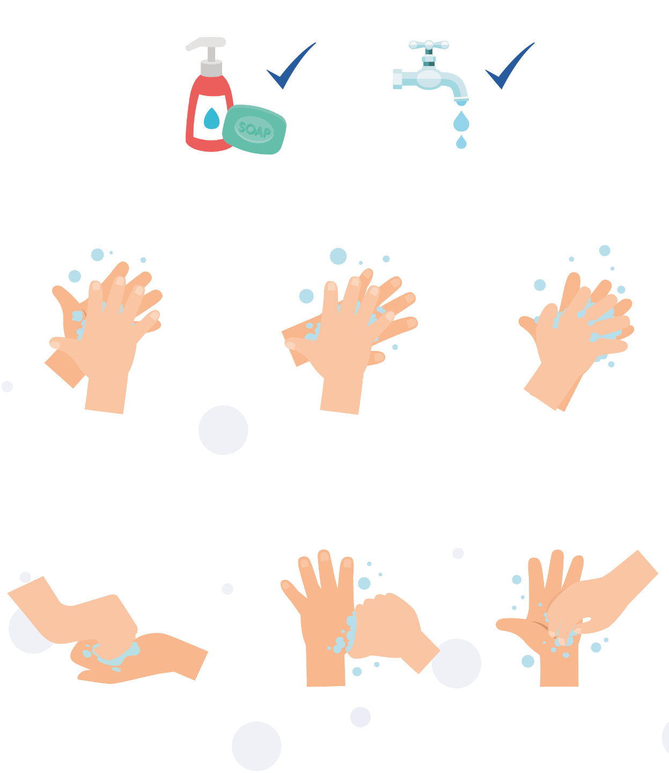

1
2
3

Palm to palm
Back of hands
Between fingers
4
5
6

Back of fingers
Thumbs
Tip of fingers
To help keep time, sing ‘Happy Birthday’ twice

SW1 - Hand Hygiene Quiz
Quiz: Hand Hygiene
Please tick as many answers as appropriate
How can you spread microbes to others? (2 points)
- By touching them
- By looking at them
- By speaking to them on the phone
- By sneezing
Why should we use soap to wash our hands? (2 points)
- It helps remove invisible microbes too small to be seen by our eyes
- It breaks up the oil on our hands which trap microbes
- It keeps our hands moist
- It doesn’t matter if we use soap or not
Which is NOT one of the 6 steps of hand washing? (1 point)
- Palm to palm
- The thumbs
- Arms
- In between fingers
Who might be at risk as a result of you not washing your hands properly? (1 point)
- You
- Your family
- Your friends
- All of the above
When should we wash our hands? (3 points)
- After stroking a pet
- After sneezing or coughing
- After watching TV
- After using the bathroom or changing a soiled nappy
How can you stop harmful microbes from spreading? (2 points)
- Do nothing
- Wash hands in water
- Use hand sanitiser if soap and water are not available
- Wash your hands with running water and soap
After we sneeze into our tissue, we should: (2 points)
- Wash our hands immediately
- Dry our hands on our clothes
- Take antibiotics
- Put the tissue straight into the bin
How long should we wash our hands for? (1 point)
- 10 seconds
- 20 seconds (length of Happy birthday song twice)
- 1 minute
- 5 minutes

SW2 - Respiratory Hygiene Quiz
Quiz: Respiratory Hygiene
Please tick as many answers as appropriate
How can you spread microbes to others? (3 points)
- Touching
- Sleeping
- Sneezing
- Coughing
After we sneeze into our hands, we should: (2 points)
- Wash our hands
- Dry our hands on our clothes
- Take antibiotics
- None of the above is necessary
If you do not have a tissue available, the next best thing is to sneeze: (1 point)
- Into your hands
- Into your sleeve
- Into an empty space
- Onto your desk
The best way to stop microbes from spreading is: (2 points)
- To use your hand to cover your sneeze
- To use a tissue to cover your sneeze
- To use a sleeve if you haven’t got a tissue
- To drink plenty of fluids
What should you do with a tissue after sneezing into it? (1 point)
- Put it in your pocket for next time
- Put it straight in the bin
- Put it up your sleeve for next time
- Any of the above
What might happen if we don’t wash our hands after sneezing into them? (1 point)
- Nothing
- Transfer harmful microbes to other people
- Help protect our microbes
Infection Prevention and Control (IPC): Sexually Transmitted Infections (STIs)
Key Stage 4

Lesson 6: Sexually Transmitted Infections
A classroom-based activity demonstrates how easily STIs can be transmitted. Using chlamydia as an example, this lesson helps students to understand an individuals’ susceptibility to sexually transmitted infection and the potential severity of its consequences.

Learning Outcomes

All students will:
- Understand that infections can be spread easily through sexual contact.
- Understand what they can do to protect themselves against STIs.
- Know that not everyone with an STI has symptoms.
- Understand that non-barrier forms of contraception do not protect against STIs.

Most students will:
- Understand how easily infections like chlamydia can spread among young people.
- Begin to explore effective communication around condom use

Curriculum Links

PHSE/RHSE
- Health and prevention
- Intimate and sexual relationships
- Sexual health

Science
- Working scientifically
- Biology

English
- Reading
- Writing

Lesson 6: Sexually Transmitted Infections

Resources Required

Introduction

Per class
- Copy of PP1

Main Activity: Test Tube Experiment

Per student
- 3 clean test tubes
- Copy of SW1
Per class
- Test tube rack
- Iodine
- Starch Water
- Gloves
- Cling film

Activity 2: Looking for legitimate sources of information

Per student
- Copy of SW2
- Copy of TS1

Activity 3: Safer Sex: Risks, Communication, and Information

Per student
- Post-it notes
- Pens/pencils

Per class
- 4 A3 sheets of paper

Activity 4: Raising Awareness about Gonorrhoea

Per student/group
- Device to create a presentation (optional)
- Pens/ pencils
- Paper

Activity 5: Condom Negotiation

Per student
- Copy of SH1
- Copy of SH2
- Copy of SW3

Extension Activity 1: Sexual Health Bingo

Per student
- Copy of SW4
- Pens

Per class
- Copy of TS2 Box/hat (to draw cards out of)
- Prizes (optional)

Extension Activity 2: STI Quiz

Per student
- Copy of SW5

Supporting Materials
- TS1 STI Misconceptions
- TS2 Sexual Health Bingo Caller Cards
- SH1 Let’s Talk About Condoms – Ineffective
- SH2 Let’s Talk About Condoms – Effective
- SW1 Spread of STIs Test Tube Experiment
- SW2 STI Misconceptions
- SW3 Let’s Talk STEM Worksheet
- SW4 Sexual Health Bingo
- SW5 STI Quiz

Advanced Preparation
Test Tube Experiment
- Section A
  - Half-fill a test-tube with milk – one per student
  - Replace one of the test-tubes with starch
- Section B
  - Half-fill a second set of test-tubes with milk
  - Replace one of the test-tubes with starch
- Section C
  - Fill 4 test-tubes with milk
  - Place cotton plugs or cling film over the top of 2 of the test tubes
  - Fill an extra test-tube with starch
- Photocopy SW1 for each student
NOTE: This activity can be used to demonstrate the spread of other types of infection.
Extension Activity: Sexual Health Bingo
- Print bingo playing cards (SW4).
- Print, cut and fold Sexual Health Bingo Caller Cards (TS2) and put in box/hat etc.
- Organise prizes if required
Lesson 6: Sexually Transmitted Infections

Key Words
Chlamydia
Condom
Contraception
Gonorrhoea
Safe Sex
Sexually Transmitted Infections (STI)
Health & Safety
For safe microbiological practices in the classroom consult CLEAPSS
www.cleapss.org.uk

Weblinks
e-bug.eu/eng/KS4/lesson/ STIs

Introduction
- Recap on your sex education ground rules or use the suggested rules provided in the teacher refresher at the start of the pack.
- Begin the lesson by explaining to students that there are many ways in which microbes can be transmitted, e.g. touch, sneezing or through contaminated food or drinking water. Highlight that another important route of transmission is through the exchange of bodily fluid, i.e. unprotected sexual intercourse.
To encourage students to talk about the topic, ask if they have ever heard of any STIs and if they know what causes them. Use the MS PowerPoint activity found at (e-bug.eu/eng/KS4/lesson/STIs) to help explain this.
- Explain that STIs are generally transmitted through unprotected sexual contact i.e. not using a condom, although some of the infections can be transmitted in other ways such as shared needles and syringes or skin-to-skin contact or from mother to unborn child and through breast milk. This is because some STIs are carried in the blood and transmission of this bodily fluid can also transmit the infection.
- Emphasise that non-barrier forms of contraception, e.g. the contraceptive pill, DO NOT protect against STIs.
- Note that the terms STI (Sexually Transmitted Infection) and STD (Sexually Transmitted Disease) are equivalent terms. An infection is defined as the invasion of the body by a microbe. While an infection can cause symptoms and complications that alter the normal function of the body, it does not depend upon this to be classed as an infection. A disease, by contrast, causes specific health complications. Therefore, STI is used as a broader term.

Activity

Main Activity: Test Tube Experiment
This activity is best carried out as a class exercise. Ask students to record their results throughout the experiment on SW1

Section A
- Explain to the students that they will be simulating sexual contact by exchanging fluid (representing bodily fluid) between the two test tubes. Pass the test tubes around the class making sure that each student gets a test tube full of fluid.
DO NOT let the students know that one of the test-tubes contains starch, although the teacher should know who has that test tube.
NOTE: It may be important to select a student to take the test tube containing starch who will not be concerned or embarrassed when they realise they have been the ‘carrier’.
- Tell each student that they must exchange fluid with 5 other students (for a class smaller than 25 reduce the number of exchanges to three or four). Ask students to record this on SW1. Prompt students to mix outside their normal group of friends.
- When finished, tell the class that one of them carried fluid which contained a simulated STI. The teacher should go around the class testing for the STI by adding a drop of iodine to each test tube. If the fluid turns black that person was infected.
This experiment reinforces how easily and inconspicuously and STI can spread from person to person.

Section B
- Repeat the activity by reducing the number of times students exchange fluid (have sexual encounters) to one or two. Do the class notice the decrease in the number of infected people?

Section C
- Choose five people from the class to carry out a demonstration. Show the class which student has the ‘infected’ test tube. Provide the other four students with the remaining test tubes, two of which are covered in cling film.
- Ask the student with the ‘infected’ tube to have a ‘sexual encounter’ with each of the five other students in turn. NOTE Do not mix fluids this time, simply let the infected student drop some of their fluid into the other test tubes using a dropper, the recipient must mix the sample well.
- Test each of the student samples for an STI using the iodine.
- Indicate that during these sexual encounters the cling film represented a condom and that these students didn’t contract the infection.
Possible discussion points with students after this experiment include:
  - The ease of transmission: Discuss with the students how easy the STI was spread from one person to the next. Were they surprised about any of the ways STIs can spread from person to person?
  - Reducing the risk of infection: Talk about how far and quickly STIs can spread and how reducing the number of contacts automatically reduces the risk of infection.
  - Personal responsibility for your own health: It is important that young people are responsible for and feel empowered to look after their own health, this includes their sexual health. We should avoid discussions around ‘blame’ of sexual partners.
  - Difficult conversations: Imagining a difficult conversation where you have to advise a sexual partner to get checked/treated for an STI - better to prevent infection instead

Activity 2: Looking for legitimate sources of information (non-lab activity)
Young people are most likely to search the internet for information about pleasure, relationships or symptoms of STIs, or to use sources viewed as legitimate, such as the NHS. Using the internet, ask students to bust some common STI misconceptions on SW2. This activity can be adapted to a class discussion. Answers can be found on TS1.

Activity 3: Brainstormer: Safer sex, Risks and Communication and Information
- Put four large sheets of paper up around the room, with the following questions written on each sheet:
- What are the risks of having unprotected sex?
- What does safe sex mean to you?
- How can we communicate with each other to make sex safer?
- How can we become more comfortable talking about safer sex with partners and in general?
- Provide students with post-it notes. Ask students to write their thoughts and suggestions on the post-it notes and then stick their answers onto the relevant sheets.

Activity 4: Raising awareness about Gonorrhoea (non-lab activity)
This activity can be conducted in small groups or as an individual task. Making use of classroom devices with internet access and/or textbooks, ask students to research the disease-causing microbes in SW3 to fill in the gaps. Answers can be found at TS3. The is a row empty for students to select their own pathogenic (harmful) microbe to research. Once completed, this table can serve as a great way to consolidate information.

Activity 5: Condom Negotiation
- Building on the discussion using the questions above, reinforce the importance of making individual decisions and discussing sexual decisions and safer sex with partners. This activity focuses on partner communication surrounding decisions to have sex and using condoms to provide good protection from STIs. Ask students to practice effective and ineffective communication techniques regarding negotiation of condom use through the following role-play activity.
- Distribute the ‘Let’s Talk About Condoms: Ineffective’ handout (SH1). After students have performed the role-play record feedback on the white board.
- Repeat the process with the ‘Let’s Talk About Condoms: Effective handout (SH2).
- As a group discuss the following:
  - Which communication is more effective?
  - What makes one communication more effective?
  - What elements of assertive communication did Tai use?
- Distribute the Let’s Talk handout (SW3). This final activity gives students the opportunity to practice assertive communication regarding condom use.
- Ask students to pair up, agree on the narrative of the conversation and role play to either groups or to the class.
- Debrief the exercise by asking students to reflect upon their responses and to decide if they have demonstrated assertiveness

Discussion
Check for understanding by asking the students the following questions:
Who can contract STIs?
Answer: Anyone who has had unprotected sex with someone who has an STI can contract an STI. STIs are NOT exclusive to people who you may consider engage in risky behaviours such as drug use, sex work, multiple sexual partners, and/or anal sex. You only need to have a sexual encounter with an infected person once to contract the infection and that person may not know that they are infected.
What is an STI?
Answer: Sexually Transmitted Infections (STIs) are infections which are mainly passed from one person to another (that is transmitted) during sexual contact. There are at least 25 different STIs with a range of different symptoms. These diseases may be spread through vaginal, anal or oral sex.
How can we reduce the risk of contracting an STI?
Answer: There are several ways to prevent contracting an STI. These include:
- Abstinence: The only sure way to prevent contracting an STI is not to have oral, anal or vaginal sexual contact.
- Use condoms: Condoms are the recommended preventative measure; however, condoms only protect the skin they cover, any sores or warts found on the genital region not covered by the condom can still spread to another person’s skin.
- Talk to your partner: Talk to your partner about safer sex practices, for example, using a condom. If you have a new partner discuss the option of you both being tested for an STI before committing to a sexual relationship.
- People should get tested and have regular check-ups: When sexually active, especially if you change sexual partners, even if you do not appear to have any symptoms, it is still very important to have regular tests and check-ups to make sure you do not have an infection. Not all STIs show symptoms at first, if at all.
Do other forms of contraception, other than the condom, protect against STIs? NO. The other methods of contraception only protect against pregnancy, they will NOT protect against contracting an STI.
What are the symptoms of an STI?
Answer: Symptoms of sexually transmitted infections vary, but the most common are soreness, unusual lumps or sores, itching, pain when urinating, bleeding between periods and/or an unusual discharge from the genital region.
Does everyone who contracts an STI show symptoms?
Answer: NO, STIs are a common problem because many people are infected without realising it. In some cases, women do not realise they have an infection until they experience infertility problems in later life.

Where can I go for further advice and be tested?
Answer: Ask your school nurse or General Practitioner (GP), or visit a GUM clinic. Ordering a home testing kit online is now much more widely available.

Extension Activities

Sexual Health Bingo
Reinvention of the classic bingo game using sexual health terms instead of numbers.
Aim: Participants are introduced to sexual health concepts relating to safer sex, STIs and sexual health testing.
Give each participant a Sexual Health bingo playing card (SW4) and pen. Explain game rules. One at a time, draw a Sexual Health bingo caller’s card from the box/hat (TS2). Read the item on the caller’s card and an associated health message. Use the information on the caller’s cards to introduce more information, discuss and check everyone’s understanding. Anyone with this item on their playing card can mark it off with a cross. The first person to cross off a complete horizontal, vertical or diagonal row and call out “Bingo!‘’ wins the game. Alternatively, play can continue until there is a first, second or third place.
When playing this game, be prepared to slow down or speed up the pace of play according to the needs of students. Also consider spelling out any words to assist young people in locating them.
Key messages:
- To keep sex safe always use a condom and get tested regularly for STIs
- Condoms are most effective when used properly
- Familiarise yourself with condoms, how to use them and where to get them
- Condoms offer the best protection against STIs and at the same time prevent unplanned pregnancies
- Condoms when used correctly during oral sex, can prevent STIs
- Young people have a right to make their own decisions about sex
- Consent can be given and taken away at any time
- Condoms are strong and flexible
- Most STIs don’t have symptoms – you can’t tell who has an STI
- STI testing is quick, easy, painless and usually free with the NHS/ GUM sexual health clinic
- Most STI tests are self-collected urine tests or swabs
- Young people who are sexually active should be tested for STIs when they change partners or at least every year, even if they have no symptoms
- Talk with your partner/s about sexual health
- Each person is unique and has a right to feel comfortable with who they are

Guest Speaker
Invite a guest speaker in from a local young persons’ clinic/(school) nurse to give a talk about the free and confidential services they offer. Write up a list of questions you want to ask them in advance.

Learning Consolidation
Provide groups of 3 to 4 students with SW5 Quiz. The team with the most points wins.

TS1 - STI Misconceptions Teacher Sheet
STI Misconceptions
I can’t get an STI from oral sex
False. Although the risk of getting an STI through oral sex is generally less than from vaginal or anal sex, there is still a risk. The infections most commonly passed on through oral sex are herpes simplex, gonorrhoea and syphilis.
I can get herpes from a toilet seat
False. Herpes simplex virus (HSV) is spread by direct contact of mucous membranes (the soft tissue located at your genitals and mouth) with a herpes sore, saliva, or genital secretions of a person with a herpes infection. Transmission of herpes usually occurs during kissing, or oral, anal, or vaginal sex.
Getting an STI test is painful and embarrassing
False. Many STI tests are as quick and easy as giving a urine sample. Some tests might also involve having blood taken, a visual examination to look for signs of infection, or using a swab (like a smaller, soft and rounded cotton bud) on the genital area. If a swab is needed, some services will offer you the option of using it yourself. Health professionals carry out sexual health check-ups every day – and they don’t look at an STI test as a reflection on your behaviour, but as a responsible health choice.
The pill can protect you from contracting STIs
False. The contraceptive pill is effective against preventing pregnancy. It is not effective against protecting against STIs. People with many sexual partners have STIs False. STIs do not discriminate against the number of partners a person may have. Anyone can get a STI, it doesn’t matter if you have one partner or multiple. STIs can be passed through unprotected sex.
STIs will go away on their own
False. It is unlikely that an STI will go away by itself. Getting tested is the first step in seeking treatment for an STI. Delaying treatment could lead to unintended long-term consequences.

TS2 - Sexual Health Caller Cards
STI
_ _ _ _ _
STI stands for Sexually Transmitted Infection
Protection
_ _ _ _ _
The best form of protection from STIs is condoms

Oral
_ _ _ _ _
Condoms can help you stay safe during oral sex
Painless
_ _ _ _ _
Getting a sexual health test is painless

Check-up
_ _ _ _ _
Getting tested for STIs should be part of your normal health check-up
Sex
_ _ _ _ _
If you’re having sex, you can keep it safe by always using a condom

Condoms
_ _ _ _ _
Condoms are the only form of protection that prevent pregnancy and STIs
Tested
_ _ _ _ _
If you’re having sex, stay safe by testing for STIs regularly

TS2 - Sexual Health Caller Cards
Common
_ _ _ _ _
It’s pretty common for someone to have an STI and not know about it
Symptoms
_ _ _ _ _
Most of the time, people who get STIs don’t have symptoms

Free
_ _ _ _ _
Most of the time, sexual health tests are free
Urine
_ _ _ _ _
The most common STI test for young people is a urine sample

Confidential
_ _ _ _ _
STI tests are completely confidential
Quick
_ _ _ _ _
Getting a sexual health test is quick

Treated
_ _ _ _ _
Most STIs can be treated with no dramas whatsoever
Better
_ _ _ _ _
If you have an STI, the earlier you start treatment, the better

TS2 - Sexual Health Caller Cards
Breaks
_ _ _ _ _
If a condom breaks during sex, it will no longer protect you from STIs.
Untreated
_ _ _ _ _
Infections that are left untreated can lead to long term negative consequences. The sooner you start treatment, the better.

Anyone
_ _ _ _ _
Anyone can get an STI, and they may not know they have one! This is why testing is so important.
Plan
_ _ _ _ _
Plan with your sexual partner how you will protect yourself from STIs. This may be by using a condom and agreeing to both get tested.

Contact
_ _ _ _ _
Sexual contact can result in catching an STI. Testing and using a condom will reduce this risk.
Lubricant
_ _ _ _ _
Lubricant can be used to improve the experience of sex. However, make sure you use a water-based lubricant to avoid weakening a condom.

Easy
_ _ _ _ _
This word is sometimes used negatively to explain why some people might get an STI. But this is absolutely not true. Anyone can get an STI.
The Pill
_ _ _ _ _
the pill is a form of contraception that can prevent pregnancy. However, it does not protect against STIs.

SH1 - Let’s Talk About Condoms example Ineffective handout
Let’s Talk About Condoms
Example 1
Ineffective
Luke and Tai have been dating/going out for several months and have come close to having sex. Luke wants to use protection during sex.
Luke: Tai, could I talk to you about something?
Tai: Sure Luke, we can talk about anything. What is it?
Luke: I want to use a condom, I’m worried that you have an STI.
Tai: Why are you being weird? I’m perfectly healthy. Can’t we just see what happens…
Luke: Ok, I'm sorry. I was just hoping we could talk.
Tai: I want to talk, too. Just not about that. Let's talk about
something else…

SH2 - Let’s Talk About Condoms example effective handout
Let’s Talk About Condoms
Example 2
Effective
Luke and Tai have been dating/going out for several months and have come close to having sex. Tai wants to use protection during sex.
Tai: Luke, could I talk to you about something?
Luke: Sure Tai, we can talk about anything. What is it?
Tai: I want to have sex, but I’m worried about STIs and getting pregnant.
Luke: Same, I’m worried about both of those things as well. I was just afraid of bringing it up first.
Tai: I want us to be prepared when we decide to have sex - you know, to use a condom and get tested beforehand.
Luke: Oh, so you mean you want to use condoms?
Tai: Yeah, I care about both of us. I don't want us to take the chance of getting an STI or getting pregnant. Do you agree?
Luke: Yeah! I do agree, I care about you too and want to have sex with you.

SW1 - Spread of STIs Test Tube Experiment Student Recording Sheet
Spread of STIs Experiment: Worksheet
Section A
Consider the order of people who you had a ‘sexual encounter’ with and whether or not they had the STI:
Sexual encounter | Were they infected?
1
2
3
4
5

How many people in the class contracted the infection? ____________________
Did you contract the infection? _______________________________________

Section B
Consider the order of people who you had a ‘sexual encounter’ with and whether or not they had the STI:
Sexual encounter | Were they infected?
1
2
How many people in the class contracted the infection? ____________________
Did you contract the infection? ________________________________________
Why was there a reduction in the number of people who contracted the infection this time? ________________________________________________________

Section C - Results
Sexual encounter | Were they infected? | Colour after | Reason for colour change
1
2
3
4

What does the cling film or cotton balls represent?
________________________________________________________________
Why did some of the people not get infected even though they had a sexual
encounter with someone who had an STI? ________________________________________________________________

SW2 - STI Misconceptions Worksheet
STI Misconceptions
Using the internet, bust these common misconceptions about STIs. Write down accurate information about each of the following issues and what information source you have used.

I can’t get an STI from oral sex

I can get herpes from a toilet seat

Getting an STI test is painful and embarrassing

The pill can protect you from contracting STIs

STIs will go away on their own

SW3 - Let’s Talk Worksheet
Let’s Talk
You know that your friend is planning on having sex.
You want your friend to know that it is important to use a condom.
Directions:
In pairs, use what you’ve learned about assertive communication and condoms to complete this conversation.
YOU: “I want to talk to you about condoms. You are planning to use them, aren’t you?”
YOUR FRIEND: “Who are you, the health police? I don’t know…condoms interrupt the mood.”
YOU:
YOUR FRIEND:
YOU:
YOUR FRIEND:
YOU:
YOUR FRIEND:
YOU:
YOUR FRIEND:

SW4 - Sexual Health Bingo worksheet
Sexual Health Bingo
Symptoms
Check-up
Oral
Tested
Untreated
Common
Free
Protection
Anyone
Condoms
Plan
Contact
Painless
Lubricant
Easy
The ‘pill’
Confidential
Better
Quick
Symptoms
Urine
STI
Treated
Breaks

SW5 – STI Quiz
Quiz: Sexually Transmitted Infections
Please tick as many answers as appropriate
How can sexual transmitted infections spread? (3 points)
- Vaginal sex
- Anal sex
- Sexting
- Oral sex

Who can contract an STI? (1 point)
- Anyone who has had unprotected sex
- Only single people
- Only older people
- Only men

Do sexually transmitted have symptoms (1 point)
- Always
- Never
- It depends on the infection
- Yes, but only in females
The BEST way to prevent transmission of sexually transmitted infections is: (1 point)
- Contraceptive pill
- Condoms
- Shower after sex
- Monitoring basal body temperature

Which of the following are STIs? (2 points)
- Chlamydia
- Gonorrhoea
- Influenza
- Malaria

Infection Prevention and Control (IPC): Vaccinations
Key Stage 4

Lesson 7: Vaccinations
This lesson includes a detailed presentation and animations showing how the body fights harmful microbes daily. Students will take part in an in-depth discussion about vaccinations, including busting some common vaccine misconceptions.

Learning Outcomes

All students will:
- Understand that vaccinations help individuals to develop immunity against an infection(s) and help to fight off the infection(s).
- Understand why vaccines are important to students now and throughout their life.
- Understand the important diseases prevented by vaccines, and why these are important to young people, including students.

Most students will:
- Understand how the media, and epidemics, can affect vaccine uptake positively and negatively.

Curriculum Links

PHSE/RHSE
- Health and prevention
- Intimate and sexual relationships
- Sexual health

Science
- Scientific thinking
- Experimental skills and strategies
- Analysis and evaluation

Biology
- Cells
- Health and disease

English
- Reading
- Writing

Art & Design
- Graphic communication

Lesson 7: Vaccinations

Resources Required

Main Activity: Immunity and Vaccinations Worksheet

Per class
- Animation e-bug.eu/eng/KS4/ lesson/vaccinations
- Copy of TS1 and TS2

Per student
- Copy of SW1

Extension Activity 1: Student Debate kit

Per class
- Vaccinations Debate Kit
- Resources – I’m a Scientist Debate Kits freely available from: debate.imascientist.org. uk/the-kits/#vaccinations

Extension Activity 2: Vaccine Misconceptions

Per class
- Copy of PP1
- Copy of HPV Fact Sheet freely available from| www.gov.uk/ government/publications/ hpv-vaccine-vaccination-guideleaflet Copy of TS3

Per Student
- Copy of SW2

Supporting Materials
- TS1 Teacher Sheets Animation Clip Answers
- TS2 Immune System Worksheet Teacher Answers
- TS3 Vaccine Misconceptions Worksheet
- SW1 Immune System worksheet
- SW2 Vaccine misconceptions
- SH1 I’m a Scientist Debate Kit (available from debate.imascientist.org.uk/the-kits/#vaccinations)

Advanced Preparation
- Copy SW1 and SW2 for each student.
- Download the interactive vaccination misconceptions slides and prepare animations by accessing the e-Bug website e-bug.eu/eng/KS4/ lesson/ vaccinations.
- In advance for the lesson, you can ask students to complete their own personalised vaccination timeline, available on the e-Bug website. This timeline will detail all the vaccinations students should have had; they can discuss this at home with their parents. Immunisations that students have (not) had are personal and should not be discussed as a class. Students may be very surprised at the number of immunisations that have been available to them in their lifetime.
Lesson 7: Vaccinations

Key Words
Antibody
Antigen
COVID-19
HPV
Immune system
Immunity
Vaccines
Health & Safety
For safe microbiological practices in the classroom consult CLEAPSS
www.cleapss.org.uk

Weblinks
e-bug.eu/eng/KS4/lesson/ Vaccinations

Introduction
- Provide an introduction for students, describing that they are going to learn about vaccinations, and why they are so important. Students will be learning facts, will discuss some common misconceptions, and the influence of others when making decisions about vaccinations. Students will learn if and how the media influence vaccine uptake, subsequent disease rates and herd immunity.
- Ask students what they already know about vaccinations. Questions to be discussed could include:
  - Do you know what a vaccination is?
  - How does a vaccination work?
  - What vaccinations do children usually have, and at what ages?
  - What vaccinations have you had?
  - Why do you think you need vaccinations against diseases such as the flu, measles, mumps and rubella (MMR) or COVID-19?
  - Do students know what herd immunity is? Ask students to describe this in their own words. (The herd immunity animation on e-bug.eu/eng/ KS4/lesson/Vaccinations website could be used if students are still confused about herd immunity).
- Be prepared that some students may question the safety of vaccines. The teacher refresher section at the beginning of the pack may help you answer any questions that arise.

Activity

Main Activity: Immunity and Vaccinations Worksheet
- Ask students to watch the immunisation animation clips available through the e-Bug website. The animations are divided into three clips and cover immunity and vaccinations. Guidance to complement the animation clips can be found in TS1.
- Provide each student with a copy of SW1. Students should answer the questions based on the information provided in the animation. Answers can be found in TS2.

Discussion
Discuss these common vaccination questions with the class
What is vaccination?
Answer: Vaccinations are another means of helping our immune system protect us against harmful diseases. They use your body’s natural defences to build resistance to specific infections and help build our immune system stronger.
Why should I get vaccinated?
Answer: Vaccines have saved millions of lives. Without vaccines, we are at serious risk of illness and disability from diseases like measles and meningitis. Vaccinations protect ourselves from illness and others from getting ill too. Not everyone can be vaccinated, sometimes very young babies, very old people and people with serious illness e.g. a weakened immune system caused by disease or treatment– these people depend on others getting vaccinated to prevent the spread of infection and protect them.
Why is vaccination important?
Answer: Vaccines are a safe and effective way in preventing us from getting ill. Today there are vaccines to protect us from at least 20 diseases including tetanus, influenza, measles, mumps, polio and meningitis. When getting vaccinated, we aren’t just protecting ourselves but also the people around us. Vaccines help prevent the spread of infection.
How does a vaccine work?
Answer: When the vaccine is injected into the body the immune system attacks it as if harmful microbes were attacking the body. White blood cells, a part of our immune system, create lots of antibodies to attach to specific markers on the surface of the vaccine organisms. These markers are called antigens. It takes our immune system around two weeks to learn about the vaccine organisms and while this is happening, we might feel a little tired or develop a sore arm. This is because the immune system is working hard to kill or eliminate all of the vaccine organisms. Because the vaccine is either a killed or extremely weakened version of the microbes, our immune system can process the vaccine and it will not make you ill. By successfully eliminating all the vaccine, the immune system remembers how to combat those microbes. The next time microbes carrying the same markers/antigen enter the body the immune system is ready to fight it before it has a chance to make you ill. This means you develop immunity against diseases.

Extension Activities
Extension Activity: Vaccination Debate Kit
- Developed in collaboration with ‘I’m a Scientist’, the vaccine debate kit facilitates a structured practice debate about a controversial topic. Download the vaccination debate kit, freely available from debate.imascientist.org.uk/the-kits/#vaccinations.
- There are eight-character cards. Divide the class into a maximum of eight groups, or as many characters as you wish to cover. Assign each group a character.
- Work through each round of the debates as instructed and encourage students to consider their opinions. The structure demonstrates to students how to build a discussion and reinforce their opinions with facts. Teacher notes are included in the kit to help carry out the lesson effectively.

Learning Consolidation
Ask students to consolidate their knowledge of all vaccines and produce a public information infographic. This can be used to help students to practice disseminating useful information whilst engaging with their local community.

TS1 - Teacher Sheet
This sheet provides additional information for teachers and is designed to be used alongside the e-Bug vaccinations animation. The animation is divided into 3 clips.
Clip 1
Introduction:
In order to understand how vaccines work, we first need to know how the immune system works and how vaccines stimulate the immune system to provide protection against infectious diseases. This short animation will describe how the immune system fights infection and explain how it responds to a vaccine. The function of the immune system is to distinguish foreign substances from substances that are part of our own bodies. The part, or parts, of any foreign substance that are recognised by the immune system are known as antigens. Antigens are present on bacteria, on viruses and on foreign cells from transfusions or organ transplants. Antigens may also be chemicals such as toxins or components of vaccines.
Innate immunity:
The body’s first line of defence against foreign substances is the variety of physical barriers it possesses in order to prevent entry. This includes tears, gastric acid, skin and tiny hairs called cilia. The specialisation of each of these barriers is explained below:
- Skin: Skin provides a physical barrier for our body. Entry through this barrier for pathogens (micro-organisms that cause disease) can occur when the skin is broken, irritated or damaged from cuts and wounds.
- Tears: The eye has a mechanism of cleaning itself through the movement of substances through blinking. The film of moisture over the eye can trap substances such as dust and through blinking can move it to the corners of the eye where it can be removed. Our tears also contain enzymes such as lysozyme and amylase, which can kill some bacteria providing another level of protection.
- Gastric acid in the stomach: The acid in our stomach not only aids digestion but can also kill some pathogens. Pathogens that are not killed by this acid can potentially cause disease, such as Salmonella which causes food poisoning.
- Cilia: Cilia are small hairs found along the airways in our nose and lungs. These hairs are located next to mucosal cells which secrete mucus. The mucus can trap particles we inhale, including bacteria and viruses. The movement of the hairs in the nose stimulates sneezing and, in the lungs, they can move the mucus to the throat where it can be coughed out or swallowed.
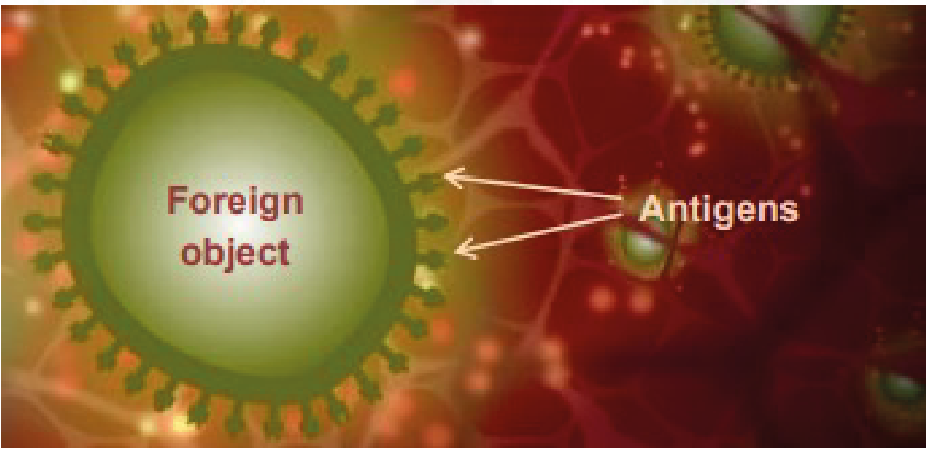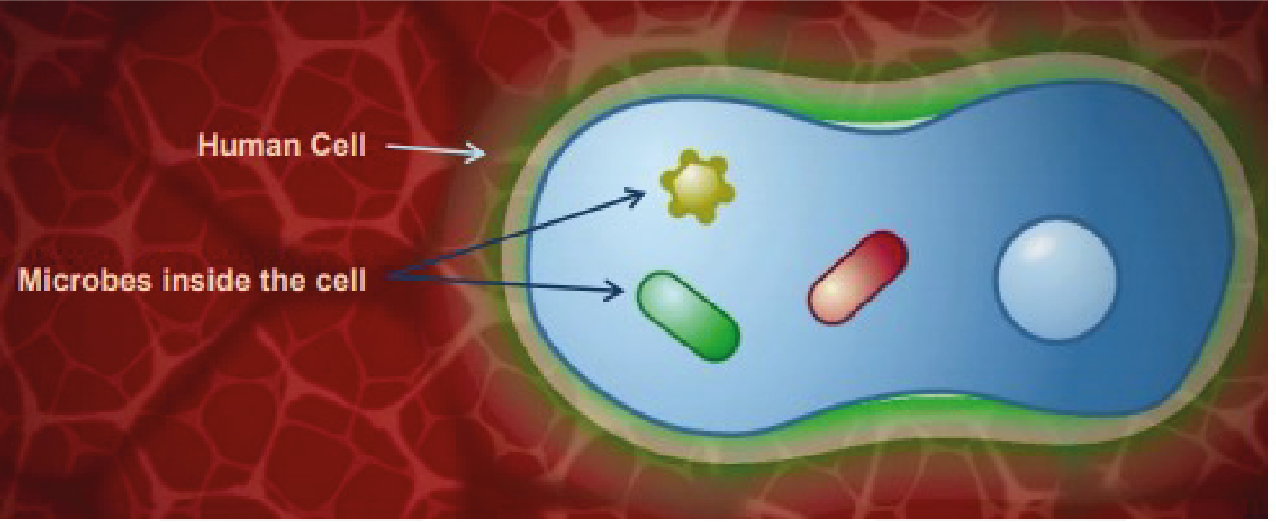

TS1 - Teacher Sheet
However, if these barriers are breached, for example by bacteria entering the body through the skin, the antigens encounter large cells called macrophages which are resident in the skin. The word macrophage means ‘big-eater’. If a macrophage recognises the antigen as something foreign and not ‘self’ it engulfs it by a process called phagocytosis and can destroy it. Inflammation at the site also causes the release of small proteins called cytokines that help regulate the immune response and attract additional macrophages from the blood stream to the site. This first and immediate response is known as innate immunity. Although rapid, it is non-specific, it is the same for all antigens and the immune system does not retain any memory of the encounter with the antigen.
The different immune defences are carried out by variety of immune cells. The innate immune system is made up of leukocytes and other cells such as natural killer cells. Leukocytes include macrophages and neutrophils and the main characteristic of these cells is that they can carry out phagocytosis. Phagocytosis results in destruction of the foreign substance by fusing the digested material with the lysosome. The lysosome provides harsh conditions to kill the pathogen which includes using specialised lysosomal enzymes and providing highly acidic conditions. Natural killer cells kill other cells that are ‘stressed’ such as viral or bacterial-infected cells. This is a crucial part of the innate immune system as some bacteria and viruses can get inside cells and so are ‘hidden’ from the innate immune system, such as meningococci and mycobacteria.
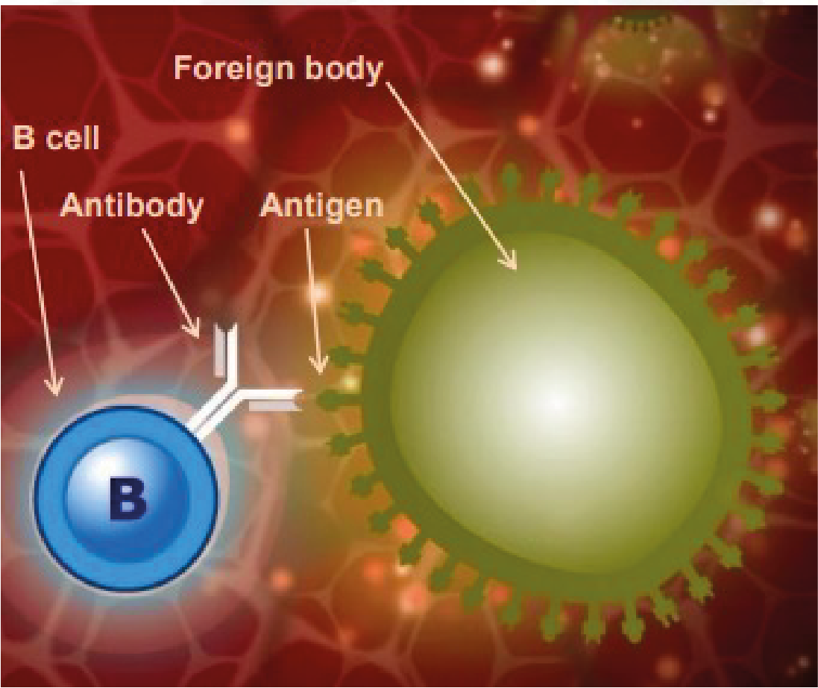

TS1 - Teacher Sheet
Acquired immunity:
Sometimes, the innate response needs help to eliminate the antigen. In addition to phagocytosis, macrophages can also transport antigen to sites where an acquired immune response can be activated. When the macrophage bearing an antigen enters the lymphatic system it moves towards the lymphoid organs which include the spleen, the tonsils, adenoids and Peyer’s patches. These organs are rich in two types of specialised white blood cells called lymphocytes. Also known as B cells and T cells, these lymphocytes are distributed in strategic sites throughout the body ready to respond to antigens. There are also many B and T cells circulating in the blood.
The innate immune system stimulates the acquired immune system by showing the acquired immune cells the antigen that the foreign body has. These cells are therefore called antigen-presenting cells (APC). Dendritic cells and macrophages can carry this out and so can also be classified as APC. This occurs after the APC has travelled through the lymphatic system to where the specialised acquired immune cells reside.
The stimulation of the lymphocytes in the lymph nodes, however, produces a strong cascade of lymphocyte activation as one APC cell can stimulate many B and T cells. T cells are specific cells that are involved in the cell-mediated response and B cells are cells involved in the humoral immune response.
Clip 2:
B cells and T cells: B and T cells have different functions. B cells respond to free antigens or those that are on the surface of organisms that circulate outside and between cells of the body, this includes most types of bacteria. However, they cannot recognise antigens located inside cells such as viral proteins or certain bacteria such as Meningococci and Mycobacteria which have adapted to live in cells and therefore make detection by the immune system more difficult.
B cells produce specific antibodies by interacting with the antigen presented by an APC. Antibodies are a complementary match to the antigen and stimulate killing/disposal of the foreign substance.
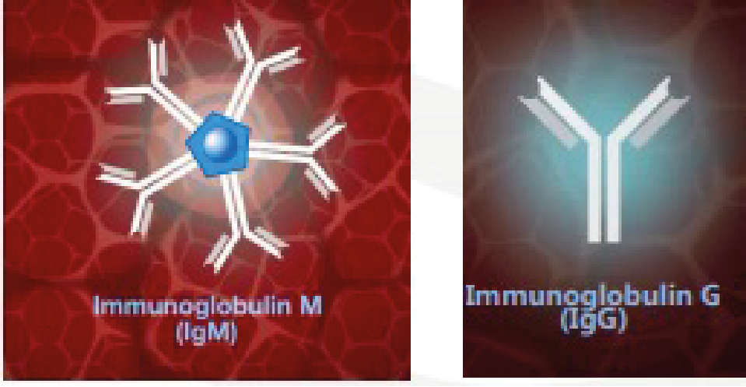

TS1 - Teacher Sheet
B cells manufacture antibodies, however, most antigens do not stimulate B cells to produce antibodies without the help of T cells. The response to these antigens is therefore referred to as T cell dependent. Unlike B cells, T cells can recognise intracellular antigens provided they are expressed on the cell surface. T cells do not manufacture antibodies, but they do secrete cytokines which influence other immune cells.
Humoral response:
B cells circulate with a molecule of a 3-dimensional protein called antibodies on their surface. The antibodies, also known as immunoglobulins, have antigen binding sites where the protein molecules are folded in such a way as to form a 3-dimensional cleft into which only antigens of a corresponding shape can bind. There is also a binding site for macrophages and neutrophils. The part of the antigen that binds to the antibodies is known as the epitope.
When one of the antibodies molecules has a surfaced receptor with exactly the right shape to recognise the antigen, it binds to it like a lock and key. The B cells then enlarge considerably and become plasma cells which are antibodies manufacturing cells capable of producing up to 100,000 antibodies molecules a minute. The antibodies molecules they produce have receptors with the same shape that recognise the antigen in the first place, and this is known as the humoral response. The first time an infection or vaccine antigen is encountered the antibodies produced is called immunoglobulin M or IgM. IgM circulates as five molecules bound together with a total of 10 binding sites for rapid and effective binding to antigen. If the same antigen is encountered again, the antibodies class changes to immunoglobulin G (IgG). This is known as class switching. Class switching means that the overall structure of the antibodies changes apart from the antigen binding domain which stays the same in order to match the antigen.
When an antigen binds to an antibody there can be three outcomes:
- The binding of the antibody to the antigen will immobilise the foreign substance and neutralise it. This is the case for toxins and other harmful substances.
- The antibodies surround the foreign substance, which can immobilise it ready for phagocytosis by a cell such as a macrophage. Immunoglobulin G (IgG)
- The complement system is activated. The complement system is a major part of the humoral response. After antibodies bind to the foreign body, the complement system can attach. The complement system is made up of complement molecules which are proteins that have protease activity, i.e. can break down other proteins.
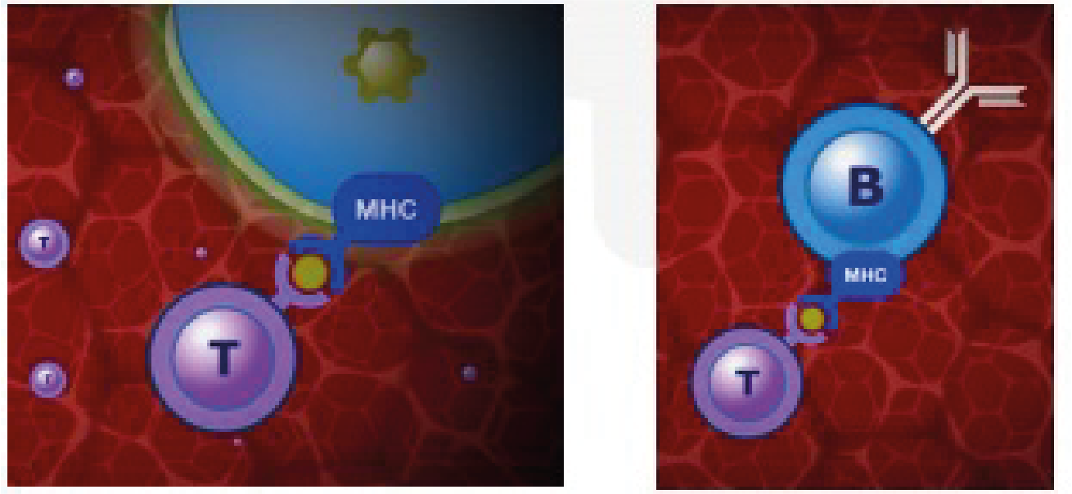

TS1 - Teacher Sheet
The attachment of complement molecules produce a protease cascade whereby one complement molecule breaks down the next, activating its protease activity so that it can breakdown the next complement molecule and so on. The result of the cascade is the production of molecules that can attract other immune cells to the site and also increase vascular permeability so that the immune cells can get to the site easily through the vasculature. Some complement molecules can recognise carbohydrate molecules on the surface of bacteria without the need for antibody binding and some complement binding can actually induce killing by disrupting the plasma membrane of the bacterium.
Cell mediated immunity:
When cells contain intracellular antigens a bit of the antigen is carried to the cell surface using molecules that are part of the major histocompatibility complex or MHC. T cells can recognise a combination of the MHC molecule and the antigen. When the T cells binds to the MHC-antigen complex, the activated cells enlarge, multiply and secret cytokines, which can then affect other immune cells nearby, and other toxic molecules such as granulysin. Granulysin induces apoptosis in the infected cell by generating holes in the membrane. The holes then promote unregulated ion, water and molecule entry into the cell causing cytolysis (osmotic lysis of the cell).
There are various types of T cell; among these are those that can destroy an infected cell known as cytotoxic T cells. Another sort, known as helper T cells, can help and stimulate B cells to produce antibody. When an antigen binds to the antibody receptor on a B cell, a bit of the antigen is also taken up into the cell and is the presented to the B cell surface by an MHC molecule. This MHC-antigen complex is recognised by a T cell, usually a T helper cell, which secretes cytokines. In this case the cytokines assist the B cells to proliferate to form identical cells producing the same antibody.
MHC platforms can also mount antigens that indicate a tumour cell. To a certain extent the immune system can recognise abnormal cells and clear them by inducing apoptosis.

TS1 - Teacher Sheet
Clip 3:
Memory response:
A few of the B cells are stimulated by the T cells to remain as memory cells and to retain the memory of the antigen antibody encounter. When the memory cells meet the antigen again, either as a natural infection or in a booster dose of vaccine antibodies of the right specificity are produced much more quickly and in greater numbers than during the first response. In contrast to the first response when short lasting IgM is made, the antibody produced is mainly IgG which persists for longer. Each time the memory cells encounter the same antigen the immune response is boosted. Because a pathogen, or a vaccine, may contain many different antigens many different B cells are stimulated at once and many
different antibodies may be produced. The capacity of our immune system is enormous and can make billions of different antibodies. If different vaccines are given at the same time, then different antibodies are produced at the same time as well. In a similar way to B cells, there are also T memory cells made as a result of the first encounter with the antigen. When these T memory cells meet the antigen again, they are able to respond more quickly and effectively. The specific humoral, cell-mediated and memory responses are known as acquired or adaptive immunity.
Vaccinations:
Vaccination stimulates the immune responses that have just been described, but importantly, it does so without the risks of the disease itself. It works by stimulating a pool of memory B and T cells to be made which, if and when the antigen is subsequently encountered, produce antigen specific responses fast enough to prevent disease developing. It also stimulates production of antigen specific antibody including IgG which persists after vaccination and provides early defence against infection. Knowledge of how vaccines work with the immune system allows us to understand the vaccine schedule more clearly.
When an individual is vaccinated, the processes in the immune system that are stimulated to mimic natural immunity are antigen recognition, antibody production and a formation of a memory response. This all occurs without disease progression. The vaccine will contain the antigen of the disease, or a
toxoid (an inactive version of a toxin) if the disease in question is caused by a toxin such as diphtheria or tetanus. In some cases, the vaccination can be administered via a nasal spray like the childhood flu vaccine which means the vaccine is taken up through the nasal lining.
The antigens within the vaccine are then recognised by the immune system as described earlier, and are taken up by APC, and the APC travels and is transported to the lymph nodes. The antigen is then presented to B cells which cause the production of antibodies and generations of memory B and T cells. If the individual being vaccinated then comes into contact with the actual pathogen bearing the same antigen, a memory response is stimulated resulting in clearance of the pathogen without the occurrence of disease.
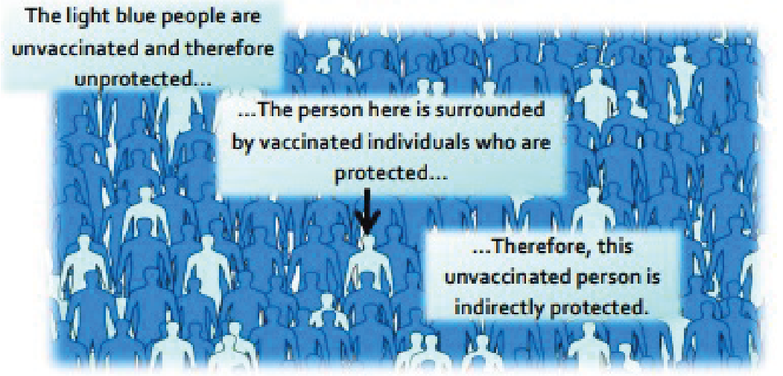

TS1 - Teacher Sheet
Booster vaccinations are given to keep circulating antibody numbers at high levels. If they are missed, then the memory response may be weakened and may result in the individual contracting the disease.
In the case of the flu, annual/seasonal vaccinations are administered because the influenza virus is able to change its antigens on its surface resulting in the need for a different vaccination for the different antigens.
This change in antigens can arise from one of two ways, antigenic shift and antigenic drift. Antigenic shift is where two or more different strains of virus combine to form a new virus. This occurs if an individual is infected with different viruses at one time. Antigenic drift is when the antigen on the virus gradually changes over time due to a change in the genetic material inside the virus. This can occur if the genetic material undergoes a mutation.
The light blue people are unvaccinated and therefore unprotected
The person here is surrounded by vaccinated individuals who are protected…
Therefore, this unvaccinated person is indirectly protected
What is herd immunity and why is it important?
A small proportion of people in every population do not respond to vaccines and remain unprotected despite vaccination. In addition, people who are severely immuno-compromised are unable to receive live vaccines. Therefore, these people are dependent on not being exposed to infection in the first place. If a sufficient number of people are vaccinated in the population vaccine preventable infections are not able to transmit successfully because most people are immune. Therefore, people who are susceptible are indirectly protected by the presence of these immune individuals. This is known as herd immunity. High levels of vaccine coverage must be maintained in the population to achieve and preserve herd immunity and to protect those who cannot be immunised.
References:
Gessner, B.D., Feikin, D.R. (2014) Vaccine preventable disease incidence as a complement to vaccine efficacy for setting vaccine policy. Vaccine 30;32(26):3133-8
Malech, H.L., Deleo, F.R., Quinn, M.T. (2014) The role of neutrophils in the immune system: an overview. Methods Mol Biol. 1124:3-10
McIntyre, W.J., Tami, J.A. (1992) Introduction to immunology. Pharmacotherapy 12(2 Pt 2):2S-10S Web link Pasupuleti, M., Schmidtchen, A., Malmsten, M. (2012) Antimicrobial peptides: key components of the innate immune system. Crit Rev Biotechnol. 32(2):143-71
Storey, M., Jordan, S. (2008) An overview of the immune system. Nurs Stand. 23(15-17):47-56

TS2 - Student Worksheet 2 Teacher Answers
Immune System Worksheet - Answers
- We have various types of physical barriers to prevent invasion by a micro-organism. Name three of these barriers and explain how they are specialised to prevent infection.
Any three of the following: Skin, Cilia/hairs in [nose/throat/lungs], Tears, Gastric/stomach acid Skin provides a physical barrier for our body. Entry through this barrier for pathogens (micro-organisms that cause disease) can occur when the skin is broken/ irritated/ damaged Tears: The eye has a mechanism of cleaning itself through the movement of substances through blinking. The film of moisture over the eye can trap substances such as dust and through blinking can move it to the corners of the eye where it can be removed. Our tears also contain enzymes, called lysozyme and amylase which can kill some bacteria providing another level of protection. Gastric acid in the stomach: The acid in our stomach not only aids digestion but can also kill some pathogens. Pathogens that are not killed by this acid can potentially cause disease, such as Salmonella which causes food poisoning. Cilia: Cilia are small hairs found along the airways in our nose and lungs. These hairs are located next to mucosal cells which secrete mucus. The mucus can trap particles we inhale, including bacteria and viruses. The movement of the hairs in the nose stimulates sneezing and, in the lungs, they can move the mucus to the throat where it can be coughed out or swallowed.

- If a micro-organism isn’t cleared from the body by the innate response (phagocyte response), what happens next?
The innate immune response may not always clear an infection. If this happens, the acquired/adaptive immunity is activated. The macrophages that have taken up the antigen can also transport the antigen to sites where an acquired immune response can be activated. When the macrophage bearing an antigen enters the lymphatic system it circulates towards the lymphoid organs which include the spleen, the tonsils, adenoids and Peyer’s patches. These organs are rich in two types of specialised white blood cells called lymphocytes. Also known as B cells and T cells, these lymphocytes are distributed in strategic sites throughout the body ready to respond to antigens. There are also many B and T cells circulating in the blood.

TS2 - Student Worksheet 2 Teacher Answers
Immune System Worksheet - Answers
3. Legionella pneumophila is a bacterium that causes Legionnaire’s disease. In humans it is engulfed by macrophages but is able to evade the normal mechanisms that macrophages use to kill it. It is therefore able to live inside the macrophage and use its nutrients to stay alive.
- Why can’t B cells recognise the L. pneumophila antigens?
B cells cannot recognise intracellular antigens as they respond to free antigens. Free antigens are found outside our own cells or on the surface of organisms that circulate around our body. L. pneumophila is an intracellular pathogen/micro-organism and so does not display a free antigen to the immune system.

- How would the immune system identify L. pneumophila and how is it removed from the body?
The antigen from L. pneumophila can be displayed on an MHC molecule on the surface of the infected cell. This means that it can be identified by the immune system. MHC molecules on our own cells are recognised by cytotoxic T cells. Once identified, the T cell can release cytokines to influence other cells of the immune system.

- Why would someone with a deficiency in T-cells be more prone to an intracellular micro-organism infection?
T cells are crucial in identifying an intracellular infection. Without them the immune system can fail to identify and destroy these intracellular pathogens and they would be able to replicate and spread to other cells. Some examples include: viruses, mycobacteria and meningococcal bacteria.

4. Once the acquired immune response is initiated, plasma cells (lymphocytes) can produce antibodies. Explain why antibodies will only be effective against one antigen.
When the receptors on the B cell surface recognise free antigens, they are stimulated to become plasma cells (lymphocytes) which make antibody. The antibodies protein molecules are folded in such a way as to form a 3-dimensional cleft into which only antigens of a corresponding shape can bind.

TS2 - Student Worksheet 2 Teacher Answers
Immune System Worksheet - Answers
5. Cytokines have many roles in the immune response. From the animation, can you describe two ways that cytokines help the body fight infection?
Two of the following:
Cytokines can:
- Help regulate the innate immune response and attract additional macrophages from the blood stream to the site of infection.
- T cells do not manufacture antibodies, but they can secrete cytokines which influence other immune cells.
- When the T cells binds to the MHC-antigen complex, the activated T cells enlarge, multiply and secrete cytokines which can then affect other immune cells nearby.
- When an antigen binds to the antibody receptor on a B cell, a bit of the antigen is also taken up into the cell and is then presented to the B cell surface by an MHC molecule. This MHC-antigen complex is recognised by a T cell, usually a T helper cell, which secretes cytokines. In this case the cytokines assist the B cells to proliferate to form identical cells producing the same antibody.

6. Clostridium botulinum is a bacterium that produces the botulinum neurotoxin. This is commonly known in the medical industry as Botox. It is the botulinum toxin that is lethal as it causes flaccid paralysis in humans and animals. Clostridium botulinum that produces it however is not considered dangerous by itself. The immune system can recognise toxins as well as micro-organisms.

- How does the immune system recognise and clear toxins?
The immune system uses the humoral response of the adaptive immunity to clear toxins. This involves the binding of an antibody to the toxin/antigen and it can be immobilised and neutralised.

b) Why would a vaccine for the Clostridium botulinum bacterium not be considered as effective as a vaccine against the botulinum toxin?
The toxin is the lethal component. Without the toxin the bacterium is not considered dangerous. A vaccine against the toxin is effective because it can stimulate the immune system to produce antibodies against the toxin thus preventing the harmful effects of the disease.

TS2 - Student Worksheet 2 Teacher Answers
Immune System Worksheet - Answers
7. What is the function of the following cells:
- Cytotoxic T cells?
Cytotoxic T cells can recognise intracellular antigens and kill infected cells

- Helper T cells?
Helper T cells are involved in T-cell dependent responses. They can help stimulate B cells to proliferate and they can also help them to become plasma cells.

- Plasma cells?
Plasma cells are derived from B cells. Once a B cell recognises a free antigen it can become a plasma cell. These plasma cells are antibody producing cells and so are large in size.

8. Explain why vaccines are preventative in protecting against infection.
Vaccines show the antigen for a particular infection to the immune system so that specific antibodies can be produced without the disease developing in the individual. If an individual contracts the disease naturally a vaccine will not help as the specific antibodies will already have been produced. Vaccines provide immunity artificially whereas a disease will give natural immunity. Contracting the disease is potentially dangerous so vaccination is safer.

9. Explain how a vaccine results in a memory response in the immune system.
A vaccine contains antigenic material/antigens for a micro-organism/disease. This results in the production of antibodies by the plasma cells/B cells that are complementary/a match to the antigen from the vaccine. The antibodies produced in a memory response are IgG/immunoglobulin G, so they persist for a long time in the body. Some of the B cells and T cells involved in identifying the antigen from the vaccine differentiate/change into memory cells which will mount a quicker immune response the next time the antigen is encountered.

TS2 - Student Worksheet 2 Teacher Answers
Immune System Worksheet - Answers
10. Herd immunity arises when a significant proportion of the population is vaccinated against a disease. What could happen if the vaccination rates were to fall in a population for the following vaccines? (Hint: think about their transmission methods. Measles is spread through touch and in the air through
contagious droplets from infected people, and cholera is a water-borne disease).

- Measles
If vaccination rates were to fall for measles vaccines, sporadic outbreaks could occur as the measles can pass between unvaccinated and susceptible individuals in the air or through contact with an infected person.

b) Cholera
Just like measles, decreased vaccination rates for cholera in countries where cholera is a major health concern, can result in outbreaks. Herd immunity is still important; however, as cholera is a water-borne disease it can still affect people who are unvaccinated even if they are around people who have been vaccinated.

TS3 – Vaccine Misconceptions Answers
Vaccine Misconceptions
- Answers
- Natural immunity is better than acquired immunity.
False. Natural immunity occurs when exposed to the actual disease. While it can prevent an individual from getting the infection again, the individual may become very ill, suffer long term health effects, or in some cases, risk death. Acquired immunity through vaccination does not carry these same risks.

- The needle will hurt.
True. You might face a sharp scratch, but this will go away very fast. Sometimes you will feel a sore arm after the vaccination, but this is because the body is working hard to kill or eliminate all of the vaccine organisms. It is this process which provides the individual immunity against future disease.

- You will get side effects from the vaccination.
Sometimes. Side effects are very rare and depend on the vaccine being received. A sore arm or feeling tired can be common, as the body is working to produce the antibodies required to fight the vaccine. Side effects are very carefully monitored, and a vaccination will not be approved if the risks of negative side effects outweigh the benefits.

- The diseases we are vaccinated for are so rare, I won’t get the disease.
False. Diseases we are vaccinated for are rare because of vaccines. Vaccination has successfully reduced the prevalence of fatal diseases including polio, measles, and now, COVID-19 amongst many others. However, if people stop being vaccinated for these diseases, we will lose our herd immunity and the number of people infected will increase. This is why it is so important to take the vaccinations recommended by your doctor, to ensure you protect yourself and others.

- Vaccines are not safe.
False. Vaccines go through a rigorous process of trials in labs, on animals, and on humans to check that they are effective and to monitor for side effects. All vaccines delivered in the UK have to be approved by the Medicines and Healthcare products Regulatory Agency (MHRA) who make sure that all medicines and vaccines meet rigorous standards. Once approved, health officials continue to monitor the side effects of vaccines and can respond quickly if there is any evidence to suggest that a vaccine is no longer safe.

SW1 - Student Worksheet - Immune System Section A
Immune System Worksheet
- We have various types of physical barriers to prevent invasion by a microorganism. Name three of these barriers and explain how they are specialised to prevent infection.

- If a microorganism isn’t cleared from the body by the innate immune response (when the body’s phagocytes respond to eliminate the pathogen), what happens next?

- Legionella pneumophila is a bacterium that causes Legionnaire’s disease. In humans it is engulfed by macrophages but is able to evade the normal mechanisms that macrophages use to kill it. It is therefore able to live inside the macrophage and use its nutrients to stay alive.
a) Why can’t B cells recognise the L. pneumophila antigens?
b) How would the immune system identify L. pneumophila and how is it removed from the body?
c) Why would someone with a deficiency in T cells be more prone to intracellular microorganism infection?

- Once the acquired immune response is initiated, plasma cells (lymphocytes) can produce antibodies. Explain why antibodies will only be effective against one pathogen.

- Cytokines have many roles in the immune response. From the animation, can you describe two ways that cytokines help the body fight infection?

SW1 - Student Worksheet - Immune System Section B
Immune System Worksheet
6. Clostridium botulinum is a bacterium that produces the botulinum neurotoxin. This is commonly known in the medical industry as Botox. It is the botulinum toxin that is lethal as it causes flaccid paralysis in humans and animals. Clostridium botulinum that produces it however is not considered dangerous by itself. The immune system can recognise toxins as well as microorganisms.
a) How does the immune system recognise and clear toxins?
b) Why would a vaccine for the Clostridium botulinum bacterium not be considered as effective as a vaccine against the botulinum toxin?
7. What is the function of the following cells:
a) Cytotoxic T cells?
b) Helper T cells?
c) Plasma cells (lymphocytes)?
8. Explain why vaccines are preventative in protecting against infection.
9. Explain how a vaccine results in a memory response in the immune system.
10. Herd immunity arises when a significant proportion of the population is vaccinated against a disease. What could happen if the vaccination rates were to fall in a population for the following vaccines? (Hint: think about their transmission methods. Measles is spread through touch and in the air through contagious droplets from infected people, and cholera is a water-borne disease).
a) MMR
b) Cholera

SW2- Vaccine Misconceptions worksheet
Vaccine Misconceptions
Worksheet
Following your class discussion, bust these common misconceptions about vaccines. Write down accurate information about each of the following issues.
- Natural immunity is better than acquired immunity.
- The needle will hurt.
- You will get side effects from the vaccination.
- The diseases we are vaccinated for are so rare, I won’t get the disease.
- Vaccines are not safe.

SW3 – Vaccination Timeline Template

Vaccination Timeline

Treatment of Infection: Antibiotic Use and Antimicrobial Resistance
Key Stage 4

Lesson 8: Antibiotic Use and Antimicrobial Resistance
Introductory lesson to antibiotics and their use. This lesson introduces students to the growing global public health threat of antimicrobial resistance (AMR) through an agar plate experiment.

Learning Outcomes:

All students will:
- Understand that antibiotics do not work on viruses, as bacteria and viruses have different structures.
- Understand that bacteria are continually adapting to develop ways of not being killed by antibiotics, this is called antibiotic resistance.
- Understand that taking antibiotics also affects your useful bacteria, not just the ones causing an infection.
- Understand that antibiotic resistant bacteria can be carried by healthy or ill people and passed onto others without knowing.
- Understand that antibiotic resistance spreads between different bacteria within our body.
- Understand that controlling antibiotic resistance is everyone’s responsibility including you

Curriculum Links

PHSE/RHSE
- Health and prevention

Science
- Scientific thinking
- Experimental skills and strategies
- Analysis and evaluation

English
- Reading
- Writing

Art & Design
- Graphic communication
Lesson 8: Antibiotic Use and Antimicrobial Resistance

Resources Required

Main Activity: Agar Experiment

Per student
- Copy of SW1
- Copy of SW2
- Copy of SW3
- Gloves

Per class/group
- Copy of TS2
- Petri dishes
- Base Agar
- Hot plate
- Phenol Red*
- Wax Crayon/marker
- Disposable droppers
- Hydrochloric acid
- Cork borer
- Test tubes
- Test tube rack

Activity 2: Antibiotics ‘Right’ or ‘Wrong’?

Per student
- Copy of SW4

Additional Supporting Materials:
- Copy of TS1
- Copy of SH1

Supporting Materials
- TS1 Agar experiment Advanced Preparation
- TS2 Teacher Answer Sheet
- SH1 Antibiotic Sensitivity Test Results
- SW1 Agar Experiment worksheet
- SW2 Agar Experiment Conclusions
- SW3 Differentiated Agar Experiment Conclusions
- SW4 Antibiotics Right or Wrong

Advanced Preparation
- Follow instructions in TS1 to prepare for the Agar experiment
- Print off SW1 and SW2 or SW3 (differentiated version adaptable for students of different abilities) for each student in advance
- Antibiotic videos: Introduction to Antibiotics antibioticguardian.com OR https://youtu.be/HN5ultN7JaM
- Antibiotics Animation e-bug.eu/eng/KS4/lesson/ Antibiotic-AntimicrobialResistance Copy SW1 and SW2 for each student.

Lesson 8: Antibiotic Use and Antimicrobial Resistance

Key Words
Antibiotic
Antimicrobial resistance
Immune system
Infection
Medicine
Natural selection
Stewardship
Health & Safety
For safe microbiological practices in the classroom consult CLEAPSS
www.cleapss.org.uk

Weblinks
e-bug.eu/eng/KS4/lesson/ Antibiotic-Antimicrobial-Resistance

Introduction
- Explain that students are going to learn about how antibiotics work to kill bacteria and how the bacteria are fighting back and becoming resistant to the antibiotics. Antibiotic resistance is becoming a global health threat and it can affect everyone – antibiotic resistant bacteria can easily spread from person to person. It is everyone’s responsibility to ensure antibiotics are used correctly.
- Show the students the 2-minute Introduction to Antibiotics Video.
- Next, watch the e-Bug animation. Throughout the animation there are choice points to allow teachers to pause and discuss the content with the students.
- Highlight that the discovery of new antibiotics has slowed down and explain that many pharmaceutical companies are no longer spending money to develop new antibiotics, despite the increasing problem of resistance.

Activity

Main Activity: Agar Experiment
- This activity should be carried out in small groups (3 - 5 students).
- A workbench should be set up for each group containing:
  - 4 agar culture plates with indicator, each labelled with a patient’s name.
  - 4 test tube racks, each containing 5 antibiotic solutions (refer to guidance in TS1), each next to its corresponding agar plate.
- Provide students with a copy of SW1 and SW2 or SW3 (differentiated version) to record their results.
- Explain that Eva is working in a hospital lab and it is her job to grow microbial cultures from swabs taken from patients at a doctor’s surgery. Eva then tests whether the microbes are killed by a range of antibiotics. The results help the doctor decide what microbe is causing the illness and which antibiotics, if any, to prescribe.
- Highlight that the red colour represents the microbes growing in the agar; it may help here to show them an agar plate with no indicator (yellow), i.e. no growth.
- Place plates on a sheet of white paper. Students should label each bore hole and drop antibiotics, one drop at a time, into the appropriately labelled hole until the hole is filled with the antibiotic.
- Replace the lid of the Petri dish and leave for 5 minutes.
- After 5 minutes, students should measure the size of the decolourised zone (inhibition) if present. You may wish to show students SH1 for an illustration of the expected results.
- Students should complete their worksheets (SW1, 2 or 3) in groups and discuss with the teacher.

Activity 2 - Antibiotics ‘Right’ or ‘Wrong’?
Use the ‘right or wrong’ worksheet provided to learn about how to take antibiotics correctly. Provide each student a copy of the worksheet (SW4). For each statement, discuss with the group whether they are right or wrong and reasons why, as provided below.
Statement 1: Wrong
Most common infections that cause coughing and sneezing are caused by viruses and will get better by themselves with bed rest and fluid intake. Antibiotics are not effective against viruses.
Statement 2: Right
Antibiotics should be taken exactly as advised by your healthcare professional.
Statement 3: Wrong
You must not use other people’s or any leftover antibiotics.
Statement 4: Right
Most common infections that cause coughing and sneezing are caused by viruses and will get better by themselves with bed rest and fluid intake. Antibiotics are not effective against viruses.
Statement 5: Wrong
Antibiotics can help severe bacterial infections such as pneumonia or kidney/ urine infections.
Statement 6: Wrong
Antibiotics should be taken exactly as advised by your healthcare professional.
Statement 7: Wrong
Antibiotics are not effective against headaches or viruses, such as the one that causes flu.
Statement 8: Right
If you over-use antibiotics they might not work when you really need them for a severe infection.

Discussion
Discuss the questions on the student’s worksheet (SW2/3) with the class:
Antibiotics don’t cure the cold or flu, what should the doctor recommend or prescribe to a patient to get better?
Answer: Antibiotics can only treat bacterial infections and the flu is caused by a virus. Coughs and colds are caused by viruses and in many cases the body’s own natural defences will fight these infections. Other medicines from the pharmacist help with the symptoms of coughs and colds. Doctors can prescribe pain killers to help reduce the pain and fever associated with the infection.
Differentiated answer: b
What would happen if a patient was prescribed an antibiotic to treat a bacterial infection, but the bacteria was resistant to that antibiotic?
Answer: Nothing, the antibiotic would not be able to kill the bacteria causing the illness therefore the patient would not get any better.
Differentiated answer: a
If you had some Penicillin left over in your cupboard from a previous sore throat, would you take them later to treat a cut on your leg that got infected? Explain your answer.
Answer: No, you should never use other people’s antibiotics or antibiotics which have been prescribed for a previous infection. There are many different types of antibiotics which treat different bacterial infections. Doctors prescribe specific antibiotics for specific illnesses and at a dose suitable for that patient. Taking someone else’s antibiotics may mean your infection does not get better.
Differentiated answer: a
A patient doesn’t want to take the prescribed antibiotic for their wound infection. They say: ‘I took more than half of those pills the doc gave me before and the infection went away for a while but came back worse!’ Can you explain why this happened?
Answer: It is very important to finish a course of prescribed antibiotics, not just stop half way through. Failure to finish the course may result in not all the bacteria being killed and possibly becoming resistant to that antibiotic in future.
Differentiated answer: c

Discuss with the class:
1. Their understanding of antibiotic resistance.
2. Ask what resistant bacteria they have heard of? Describe Methicillin-resistant Staphylococcus aureus and tuberculosis as two examples:
- Methicillin-resistant Staphylococcus aureus (MRSA) is a bacterial strain that is resistant to beta-lactam antibiotics, flucloxacillin and cephalosporins. MRSA infections can be very difficult to treat. MRSA infections are more common in people in hospitals or care settings, but they can also occur in the community. MRSA rates have fallen in the last few years, due to increased awareness, efforts to tackle infection control in hospitals e.g. thorough hand washing and swabbing patients, and reduction of broad-spectrum antibiotic use. In 2006, 1.8% of hospital patients were reported to have MRSA and this fell to 0.1% in 2012.
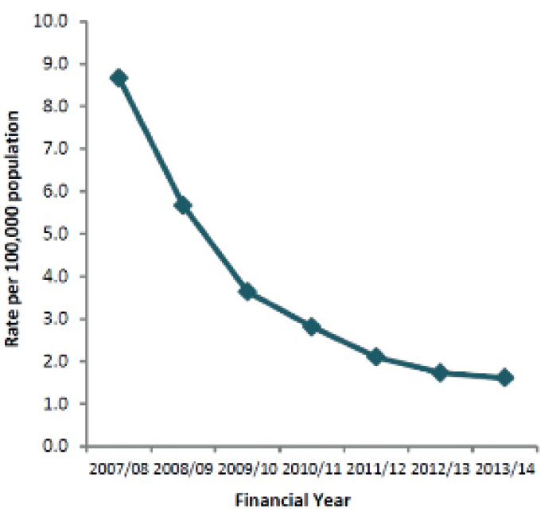
The figure above shows the downward trend in rates of MRSA bacteraemia (bacteria in blood) from 8.8 reported cases per 100,000 population in 2007/8 to 1.6 reported cases per 100,000 in 2013/14. This data is taken from the Public Health England Annual Epidemiology Commentary 2013/14.
- Some antibiotic resistant strains of tuberculosis (TB) are known as Multi-drug-resistant tuberculosis (MDR-TB). These strains are resistant to the two most commonly used antibiotics to treat TB. As of 2013, 3.6% of new tuberculosis cases are caused by MDR-TB. The WHO estimates that there were almost 0.5 million new MDR-TB cases in the world in 2012. MDR-TB can have a mortality rate of up to 80% and the drugs used to treat MDR-TB are more expensive than those used to treat TB and they can have more adverse side effects. To treat TB well you need to take 2, 3 or 4 antibiotics at once. Not taking them correctly (due to lack of funding for treatment or counterfeit antibiotics) has led to increased resistance, so it has now become a major problem.

Extension Activities

Extension Activity: Essay Writing
- Ask the students to write an essay based on the message from the e-Bug antibiotics animation and the common misconceptions they have learnt about during the lesson.
- They should consider the following points:
  - What are the most common misconceptions around antibiotics and why might there be such widespread misunderstanding?
  - How would tackling common misconceptions around antibiotics help to slow or prevent the rise of resistance?
  - What methods or approaches should be used to tackle misconceptions?
  - Personal, family or friends’ experiences of antibiotics can also be included, such as why antibiotics were taken and if the user thought they may have been unnecessary. What would have helped in this situation?

Learning Consolidation
Check for understanding by asking students if the following statements are true or false.
- Antibiotics do not work on viruses, as bacteria and viruses have different structures.
Answer: True

- Bacteria are continually adapting to develop ways of not being killed by antibiotics, this is called antibiotic adaptation.
Answer: False, it is called antibiotic resistance.

- Antibiotic resistant bacteria can be carried by healthy or ill people and can be passed on silently to others.
Answer: True

TS1 - Agar Experiment Advanced Preparation
Advanced Preparation
The following preparation is for 1 group of 5 students
For a visual of workbench set up visit www.e-bug.eu
Materials Required
- Petri dishes
- Hydrochloric acid
- Wax Crayon/marker
- Base Agar
- 20 Test tubes
- Disposable droppers
- Hot plate
- 5 Test tube racks
- Cork borer
- Phenol Red
Agar Plate Preparation
- Make up 100ml of base agar following the manufacturer’s instructions.
- When cooled slightly, but not solid, pour 1 agar plate (to demonstrate no growth). When complete add enough (~10 drops) 2 – 4% Phenol Red to turn the agar a deep red/dark orange and mix well.
- Pour approx. 20ml into each petri dish and leave to cool.
- When solidified, make 5 evenly spaced bore holes in each agar plate.
- Label each Petri dish with Patient A, B, C and D
Antibiotic (test-tube) Preparation
Patient | Penicillin | Methicillin | Erythromycin | Vancomycin | Amoxicillin
A | Water | Water | Water | Water | Water
B | 10%HCl | 5% HCl | 1% HCl | 0.05% HCl | 5% HCl
C | Water | Water | 1% HCl | 0.05% HCl | Water
D | Water | 0.05% HCl | 0.05% HCl | 0.05% HCl | Water
1. Set up a test tube rack of 5 test tubes for each patient. Label each test tube with one of the following labels
a. Penicillin b. Methicillin c. Oxacillin d. Vancomycin e. Amoxicillin
2. Transfer 5ml of the following solutions into the appropriately labelled test tube
NB: It is extremely important to have the correct concentrations of HCl (antibiotics) for each patient.
3. Set up a work bench for the group as follows:
- Place the appropriate patient’s agar plate next to each corresponding rack of test tubes at 4 stations across the bench
- A dropper for each test tube
- A ruler with mm markings
- It may be easier for students if they place each patient’s agar plate on a piece of white paper and label the paper next to each bore hole with the antibiotic name.
Patient | Penicillin | Methicillin | Erythromycin | Vancomycin | Amoxicillin | Diagnosis
A | No | No | No | No | No | Influenza
B | Yes | Yes | Yes | Yes | Yes | Strep Throat
D | No | Yes | Yes | Yes | No | Staphylococcus wound infection
C | No | No | No | Yes | No | MRSA

TS2 - Agar Experiment Teacher Answer Sheet
Agar Experiment Teacher Answer Sheet
Plate Results
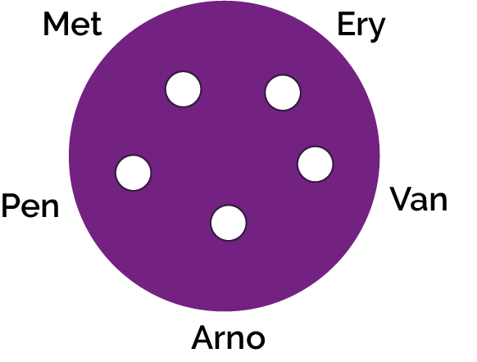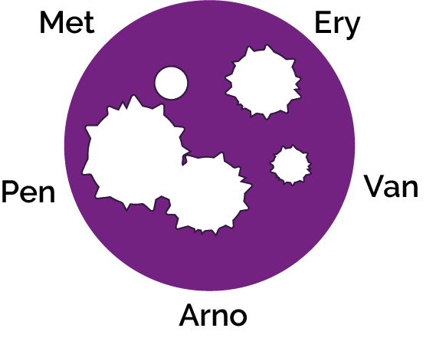
Plate Results Explained
Yes means Sensitive – no zone of growth visible
No means Not sensitive – no zone visible
Patient A:
Influenza is caused by a virus as such none of the antibiotics will have an effect as antibiotics can only be used on bacterial infections.
Patient B:
Sore throat infections are quite common and generally get better on their own. In severe cases, most antibiotics will treat this infection. Penicillin is the antibiotic of choice for this infection as the group of bacteria responsible (Streptococcus) have yet to develop a mechanism of resistance. Antibiotics should not be given unnecessarily for mild sore throats as 80% of sore throats are due to viruses and other bacteria can develop resistance during treatment.
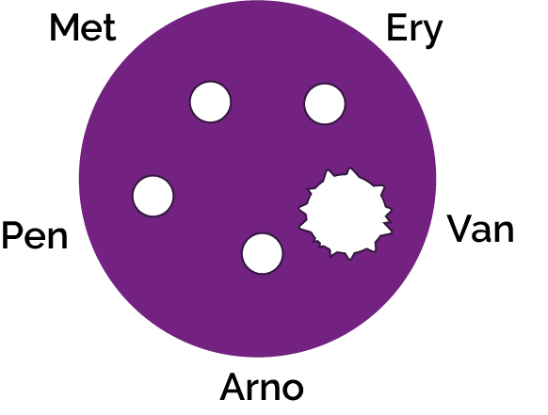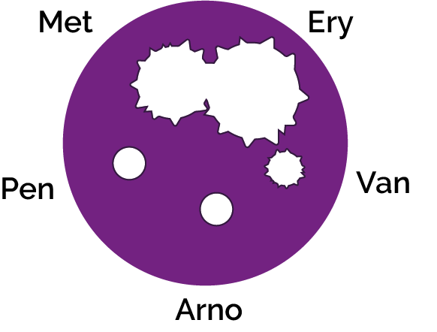

TS2 - Agar Experiment Teacher Answer Sheet
Agar Experiment Teacher Answer Sheet
Plate Results Explained
Patient C:
Methicillin Resistant Staphylococcus aureus (MRSA) infections are becoming increasingly difficult to treat. These S.aureus bacteria have developed resistance to Methicillin, the previous antibiotic of choice. Vancomycin in one of the last lines of defence against these potentially fatal bacteria however some organisms have been detected with also show resistance to this.
Patient D:
Penicillin was the first antibiotic discovered and produced, unfortunately many people viewed it as a ‘wonder drug’ and used it to treat many common infections. This resulted in the majority of Staphylococcal bacteria quickly developing resistance to this antibiotic. As ampicillin is a derivative of penicillin, Staphylococcus bacteria are resistant to this as well. Methicillin is the drug of choice for this sensitive Staphylococcus infection.

SH1 - Antibiotic Sensitivity Test Results
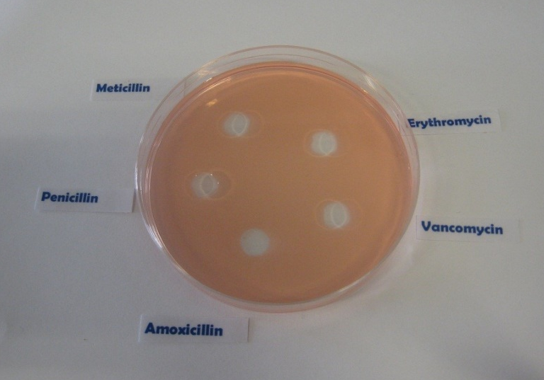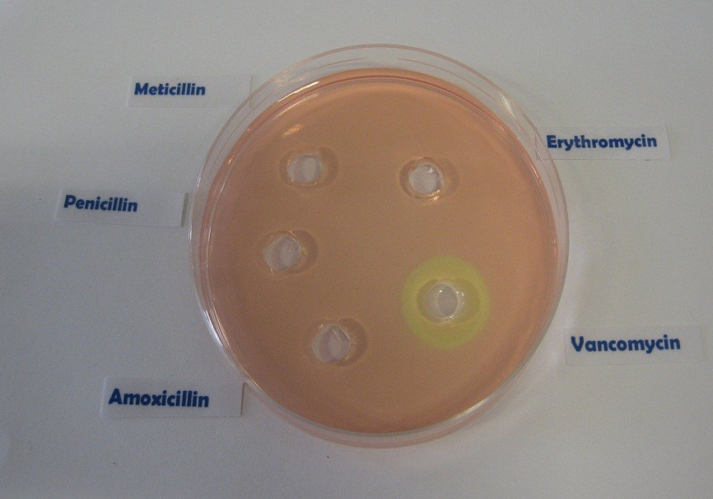
Patient B
Patient D
Antibiotic Sensitivity Test Results
Patient A
Patient C

SW1 - Agar Experiment Worksheet - Section A
Agar Experiment Worksheet: Results
Eva is on a summer work placement at the local hospital laboratory.
It is her job to read the test results and fill in the paperwork. Eva has missed up some of the test results.
Her results sheet shows the following:
Patient | Peni-cillin | Meti-cillin | Erythro-mycin | Vanco-mycin | Amoxi-cillin | Diagnosis
 | No | No | No | No | No | Influenza
 | Yes | Yes | Yes | Yes | Yes | Strep throat
 | No | Yes | Yes | Yes | No | Staphylococcus wound infection
 | No | No | No |  | No | MRSA
Yes means Sensitive – no zone of growth visible
No means Not sensitive – no zone visible
She has cultured the infectious organism isolated from each of the patients on agar plates and identified the diagnosis.
Can you repeat the antibiotic sensitivity test and match the patient to the results?

SW1 - Agar Experiment Conclusions Worksheet- Section B
Agar Experiment Student Worksheet: Results
In the results section below, record the results of your sensitivity test and identify which antibiotic you would recommend the doctor to prescribe.
Flu  (Influenza virus) | Zone of Inhibition  Size (mm)
Penicillin
Methicillin
Erythromycin
Vancomycin
Amoxicillin
Strep Throat  (Streptococcus) | Zone of Inhibition  Size (mm)
Penicillin
Methicillin
Erythromycin
Vancomycin
Amoxicillin
Patient A___________________
Patient B___________________
Staph Wound  Infection  (Staphylococcus aureus) | Zone of Inhibition  Size (mm)
Penicillin
Methicillin
Erythromycin
Vancomycin
Amoxicillin
Recommended antibiotic
_________________________
Recommended antibiotic
_________________________

Patient C___________________
Patient D___________________
MRSA  (Methicillin  Resistant  Staphylococcus aureus) | Zone of Inhibition  Size (mm)
Penicillin
Methicillin
Erythromycin
Vancomycin
Amoxicillin
Recommended antibiotic
_________________________
Recommended antibiotic
_________________________

SW2 - Agar Experiment Conclusions Worksheet
Agar Experiment Student
Worksheet: Conclusions
- Antibiotics don’t cure the cold or flu, what should the doctor recommend or prescribe to patient A to get better?
________________________________________________________________________________________________________________________________________________________________________________________________________
- Methicillin used to be used to treat a Staphylococcal infection, what would happen to Patient C’s infection if they had been prescribed Methicillin?
________________________________________________________________________________________________________________________________________________________________________________________________________
- If you had some amoxicillin left over in your cupboard from a previous chest infection, would you take them later to treat a cut on your leg that got infected? Explain your answer.
________________________________________________________________________________________________________________________________________________________________________________________________________
- Patient D doesn’t want to take the prescribed flucloxacillin for their wound infection.
“I took more than half of those pills the doc gave me before and it went away for a while but came back worse.”
Can you explain why this happened?
__________________________________________________________________________________________________________________________________________________________________________________________________________________________________________________________

SW3 - Differentiated Agar Experiment Conclusions Worksheet
Agar Experiment Student
Worksheet: Conclusions
- Antibiotics don’t cure the cold or flu, what should the doctor recommend or prescribe to patient A to get better?
A) Antibiotics can be used to treat viral infections, the doctor should prescribe antibiotics.
B) Antibiotics can only be used to treat bacterial infections; the cold or flu is caused by a virus. The doctor should prescribe medicines to help with the symptoms.
C) The doctor should prescribe antifungals.

- Methicillin used to be used to treat a Staphylococcal infection, what would happen to Patient C’s infection if they had been prescribed Methicillin?
A) Nothing. MRSA is resistant to antibiotics.
B) Patient C would have gotten better; their infection would have gone away.

- If you had some amoxicillin left over in your cupboard from a previous chest infection, would you take them later to treat a cut on your leg that got infected? Explain your answer.
A) No, you should never use other people’s antibiotics or antibiotics which have been prescribed for a previous infection. There are many different types of antibiotics which treat different bacterial infections. Doctors prescribe specific antibiotics for specific illnesses and at a dose suitable for that patient. Taking someone else’s antibiotics may mean your infection does not get better.
B) No, you should get some new medicine.
C) Yes.

- Patient D doesn’t want to take the prescribed flucloxacillin for their wound infection.
“I took more than half of those pills the doc gave me before and it went away for a while but came back worse.”
Can you explain why this happened?
A) Patient D should not have taken their medicine.
B) Patient D should only have taken one pill.
C) It is very important to finish a course of prescribed antibiotics, not just stop halfway through. Failure to finish the course may result in not all the bacteria being killed and possibly becoming resistant to that antibiotic in future.

SW4 Antibiotics Right or Wrong?
Antibiotics Right or Wrong?
Discuss which of these statements are right or wrong.
1 He was coughing and sneezing everywhere. You would have thought the doctor would have given him antibiotics!
2 My doctor told me to take my antibiotics for 5 days so that is what I did.
3 When my friend was ill, I gave her my old antibiotics. I like helping my friends.
4 Antibiotics don’t help coughs and colds; you just need bed rest, lots of fluids and eat healthily.
5 All drugs are bad for you. I can’t see the point in taking antibiotics.
6 My doctor gave me
antibiotics to take for 10 days but I feel better after 3 days so I’m going to stop taking them.
7 My headache and flu symptoms are really getting me down. I think I need antibiotics!
8 I don’t take antibiotics unless I really need them as they might not work in the future.

e-Bug Key Stage Four Teacher Answers

Lesson Two: Micro-organisms: Useful Microbes

SW1 Useful Microbes and Their Properties
Also available in TS1
Useful Microbe Name | Type | Use
Lactic acid bacteria | Bacteria | Produce cheese, yoghurt, kefir and kimchi.
Saccharomyces | Fungi | Make bread, beer, cider and wine
Acetic acid bacteria (AAB) | Bacteria | Traditional manufacturing of vinegar
Bacillus thuringiensis (Bt) | Bacteria | Organic pesticide
Cyanobacteria | Bacteria | Grown in open ponds or photobioreactors and fed CO2 and other nutrients to support photosynthesis. The cell components can be extracted to make biodiesel or bioethanol (from carbohydrates, with the help of Saccharomyces).

Lesson Three: Micro-organisms: Harmful Microbes

SW1 Disease Match Sheets
Also available in TS1
- Infectious Microbe
Infectious Microbe | Disease
Bacteria | Bacterial meningitis, Chlamydia, MRSA
Virus | HIV, Chickenpox, Flu, Measles, Glandular Fever
Fungi | Thrush

- Symptoms
Symptoms | Disease
Asymptomatic | Chlamydia, MRSA
Fever | Flu, Measles, Chickenpox, Bacterial meningitis
Rash | Bacterial meningitis, Chickenpox, Measles
Sore Throat | Flu, Glandular fever
Tiredness | Glandular fever
Lesions | HIV
Whitish Discharge | Chlamydia, Thrush

- Transmission
Transmission | Disease
Sexual Contact | Chlamydia, HIV, Thrush
Blood | Bacterial meningitis, HIV
Touch | Flu, Measles, Chickenpox, MRSA
Inhalation | Flu, Measles, Chickenpox, Bacterial meningitis
Mouth to mouth | Flu, Glandular fever

- Prevention of Infection
Prevention | Disease
Wash hands | Flu, Measles, Chickenpox, MRSA, Bacterial meningitis
Cover coughs and sneezes | Flu, Measles, Chickenpox, Bacterial meningitis
Use a condom | Chlamydia, HIV, Thrush
Avoid unnecessary antibiotic use | MRSA, Thrush
Vaccination | Chickenpox, Measles, Flu

- Treatment of Infections
Treatment | Disease
Antibiotics | Chlamydia, Bacterial meningitis, MRSA
Bed rest | Chickenpox, Glandular fever, Measles, Flu
Antifungals | Thrush
Fluid intake | Chickenpox, Glandular fever, Measles, Flu

Points to Note
MRSA is an antibiotic resistant bacterium; it is specifically resistant to methicillin and some other commonly used antibiotics. Its resistance status is attributed to the overuse and misuse of this and other antibiotics. Treatment is still via antibiotic therapy; however, MRSA is also developing resistance to these as well.

SW2 Disease Match Differentiated Disease Match
Also available in TS2
- Infectious Microbe
Infectious Microbe | Disease
Bacteria | Chlamydia
Virus | Chickenpox, Flu, Measles
Fungi | Thrush

- Symptoms
Symptoms | Disease
Asymptomatic | Chlamydia
Fever | Flu, Measles, Chickenpox
Rash | Chickenpox, Measles
Sore Throat | Flu
Whitish Discharge | Chlamydia, Thrush

- Transmission
Transmission | Disease
Sexual Contact | Chlamydia, Thrush
Touch | Flu, Measles, Chickenpox
Inhalation | Flu, Measles, Chickenpox
Mouth to mouth | Flu

- Prevention of Infection
Prevention | Disease
Wash hands | Flu, Measles, Chickenpox
Cover coughs and sneezes | Flu, Measles, Chickenpox
Use a condom | Chlamydia, Thrush
Avoid unnecessary antibiotic use | Thrush
Vaccination | Flu, Measles, Chickenpox

- Treatment of Infections
Treatment | Disease
Antibiotics | Chlamydia
Bed rest | Flu, Measles, Chickenpox
Antifungals | Thrush
Fluid intake | Flu, Measles, Chickenpox

SW3 Harmful Microbes Fill in the Blanks
Also available in TS3
Disease | Pathogen | Transmission | Symptoms | Prevention | Treatment | Problems
HIV/ AIDS | Virus | Exchange of bodily fluids (e.g., sharing needles) and breast milk from infected mother | Early - flu like symptoms. Later - immune system so damaged that get infections easily | Barrier during intercourse, screening of blood, not sharing needles and bottle feeding. No vaccine | Anti-retroviral drugs allow sufferers to live very long life. Stem cell transplants (novel treatment in early stages of research and development) | Fatal if not treated. In some people, the virus has become resistant to the antiretroviral medication leading to concerns for the future of HIV treatment
Measles | Virus | Inhalation of droplets from sneezes and coughs | Red rash and fever | MMR Vaccine | No treatment | Can be fatal if there are complications
Salmonella | Bacteria | Contaminated food or food prepared in unhygienic conditions | Fever, abdominal cramps, vomiting and diarrhoea | Good food hygiene | Antibiotics given to the young and very old to prevent severe dehydrations | Can cause long term health problems, though this is rare. The bacteria are becoming resistant to some antibiotics
Gonorrhoea | Bacteria | Sexually transmitted | Early symptoms include yellow/ green discharge from infected areas and pain when urinating | Condoms | Antibiotics | If untreated can lead to infertility, ectopic pregnancy, and pelvic pain. The bacteria are becoming resistant to antibiotics meaning they are more difficult to treat
Malaria | Protist | Vector - mosquito | Flu-like symptoms | Preventing mosquitos from breeding and mosquito needs treated with insecticide | Anti-malarial drugs | Fatal if not treated, with children under 5 the most vulnerable group. In some regions, antimalarial drug resistance has become a problem
COVID-19 | Virus | Droplet transmission | Flu-like symptoms | Wearing a face cover Practicing social distancing COVID-19 vaccine | Symptomatic treatments | Long term effects of disease unknown – ongoing research in this area

Lesson Four: Infection Prevention and Control (IPC) Hand and Respiratory Hygiene

SW1 Hand Hygiene Quiz
How can you spread microbes to others?
- By touching them
- By sneezing
Why should we use soap to wash our hands?
- It helps remove invisible microbes too small to be seen by the naked eye
- It breaks up the oil on our hands which trap microbes
Which is NOT one of the six steps of handwashing?
- Arms
Who might be at risk as a result of you not washing your hands properly?
- All of the above
When should we wash our hands?
- After stroking a pet
- After sneezing or coughing
- After using the bathroom or changing a soiled nappy
How can you stop harmful microbes from spreading?
- Use hand sanitiser if soap and water are not available
- Wash your hands with running water and soap
After we sneeze into our tissue, we should:
- Wash our hands immediately
- Put the tissue straight into the bin
How long should we wash our hands for?
- 20 seconds (happy birthday song twice)

SW2 Respiratory Hygiene Quiz
How can you spread microbes to others?
- Touching
- Sneezing
- Coughing
After we sneeze into our hands, we should:
- Wash our hands
If you do not have a tissue available, the next best thing is to sneeze:
- Into your sleeve
When sneezing, the best way to stop microbes from spreading is:
- To use a tissue to cover your sneeze
What should you do with a tissue after sneezing into it?
- Put it straight in the bin
What might happen if we don’t wash our hands after sneezing into them?
- Transfer microbes to other people
- Nothing

Lesson Six Infection Prevention and Control: Sexually Transmitted Infections (STIs)

SW2 STI Misconceptions
Also available in TS1
I can’t get an STI from oral sex
False. Although the risk of getting an STI through oral sex is generally less than from vaginal or anal sex, there is still a risk. The infections most commonly passed on through oral sex are herpes simplex, gonorrhoea and syphilis.

I can get herpes from a toilet seat
False. Herpes simplex virus (HSV) is spread by direct contact of mucous membranes (the soft tissue located at your genitals and mouth) with a herpes sore, saliva, or genital secretions of a person with a herpes infection. Transmission of herpes usually occurs during kissing, or oral, anal, or vaginal sex.

Getting an STI test is painful and embarrassing
False. Many STI tests are as quick and easy as giving a urine sample. Some tests might also involve having blood taken, a visual examination to look for signs of infection, or using a swab (like a smaller, soft and rounded cotton bud) on the genital area. If a swab is needed, some services will offer you the option of using it yourself. Health professionals carry out sexual health check-ups every day – and they don’t look at an STI test as a reflection on your behaviour, but as a responsible health choice.

The pill can protect you from contracting STIs
False. The contraceptive pill is effective against preventing pregnancy. It is not effective against protecting against STIs.

People with many sexual partners have STIs
False. STIs do not discriminate against the number of partners a person may have. Anyone can get a STI, it doesn’t matter if you have one partner or multiple. STIs can be passed through unprotected sex.

STIs will go away on their own
False. It is unlikely that an STI will go away by itself. Getting tested is the first step in seeking treatment for an STI. Delaying treatment could lead to unintended long-term consequences.

SW4 Sexual Health Bingo – Caller Cards (TS2)
STI - STI stands for Sexually Transmitted Infection

Protection - The best form of protection from STIs is condoms

Oral - Condoms can help you stay safe during oral sex

Painless - Getting a sexual health test is painless

Common – It’s pretty common for someone to have an STI and not know about it

Symptoms – Most of the time, people who get STIs don’t have symptoms

Free – Most of the time, sexual health tests are free

Urine – The most common STI test for young people is a urine sample

Confidential – STI tests are completely confidential

Quick – Getting a sexual health test is quick

Treated – Most STIs can be treated with no dramas whatsoever

Better – If you have an STI, the earlier you start treatment, the better

Check-up - Getting tested for STIs should be part of your normal health check-up

Sex - If you’re having sex you can keep it safe by always using a condom

Condoms - Condoms are the only form of protection that prevent pregnancy and STIs

Tested - If you’re having sex, stay safe by testing for STIs regularly

Untreated- Infections that are left untreated can lead to long term negative consequences. The sooner you start treatment, the better.

Anyone- Anyone can get an STI, and they may not know they have one! This is why testing is so important.

Plan- Plan with your sexual partner how you will protect yourself from STIs. This may be by using a condom and agreeing to both get tested.

Contact- Sexual contact can result in catching an STI. Testing and using a condom will reduce this risk.

Lubricant- Lubricant can be used to improve the experience of sex. However, make sure you use a water-based lubricant to avoid weakening a condom.

Easy- This word is sometimes used negatively to explain why some people might get an STI. But this is absolutely not true. Anyone can get an STI.

The Pill- the pill is a form of contraception that can prevent pregnancy. However, it does not protect against STIs.

Breaks- If a condom breaks during sex, it will no longer protect you from STIs.

SW5 STI Quiz
How can sexually transmitted infections spread?
- Vaginal sex
- Anal sex
- Oral sex

Who can contract an STI?
- Anyone who has unprotected sex

Do sexually transmitted infections have symptoms?
- It depends on the infection

The BEST way to prevent transmission of sexually transmitted infections is?
- Condoms
Note: the best way to prevent any transmission of STIs is abstinence.

Which of the following are STIs?
- Chlamydia
- Gonorrhoea

Lesson Seven: Infection Prevention and Control: Vaccinations

SW1 Immune System Worksheet
Also available in TS2
1. We have various types of physical barriers to prevent invasion by a micro-organism. Name three of these barriers and explain how they are specialised to prevent infection.

Any three of the following: Skin, Cilia/hairs in [nose/throat/lungs], Tears, Gastric/stomach acid Skin provides a physical barrier for our body. Entry through this barrier for pathogens (micro-organisms that cause disease) can occur when the skin is broken/ irritated/ damaged Tears: The eye has a mechanism of cleaning itself through the movement of substances through blinking. The film of moisture over the eye can trap substances such as dust and through blinking can move it to the corners of the eye where it can be removed. Our tears also contain enzymes, called lysozyme and amylase which can kill some bacteria providing another level of protection. Gastric acid in the stomach: The acid in our stomach not only aids digestion but can also kill some pathogens. Pathogens that are not killed by this acid can potentially cause disease, such as Salmonella which causes food poisoning. Cilia: Cilia are small hairs found along the airways in our nose and lungs. These hairs are located next to mucosal cells which secrete mucus. The mucus can trap particles we inhale, including bacteria and viruses. The movement of the hairs in the nose stimulates sneezing and in the lungs; they can move the mucus to the throat where it can be coughed out or swallowed.

2. If a micro-organism isn’t cleared from the body by the innate response (phagocyte response), what happens next?

The innate immune response may not always clear an infection. If this happens, the acquired/adaptive immunity is activated. The macrophages that have taken up the antigen can also transport the antigen to sites where an acquired immune response can be activated. When the macrophage bearing an antigen enters the lymphatic system it circulates towards the lymphoid organs which include the spleen, the tonsils, adenoids and Peyer’s patches. These organs are rich in two types of specialised white blood cells called lymphocytes. Also known as B cells and T cells, these lymphocytes are distributed in strategic sites throughout the body ready to respond to antigens. There are also many B and T cells circulating in the blood.

3. Legionella pneumophila is a bacterium that causes Legionnaire’s disease. In humans it is engulfed by macrophages but is able to evade the normal mechanisms that macrophages use to kill it. It is therefore able to live inside the macrophage and use its nutrients to stay alive.

a) Why can’t B cells recognise the L. pneumophila antigens?
B cells cannot recognise intracellular antigens as they respond to free antigens. Free antigens are found outside our own cells or on the surface of organisms that circulate around our body. L. pneumophila is an intracellular pathogen/micro-organism and so does not display a free antigen to the immune system.
b) How would the immune system identify L. pneumophila and how is it removed from the body?
The antigen from L. pneumophila can be displayed on an MHC molecule on the surface of the infected cell. This means that it can be identified by the immune system. MHC molecules on our own cells are recognised by cytotoxic T cells. Once identified, the T cell can release cytokines to influence other cells of the immune system.
c) Why would someone with a deficiency in T-cells be more prone to an intracellular micro-organism infection?
T cells are crucial in identifying an intracellular infection. Without them the immune system can fail to identify and destroy these intracellular pathogens and they would be able to replicate and spread to other cells. Some examples include: viruses, mycobacteria and meningococcal bacteria.

4. Once the acquired immune response is initiated, plasma cells (lymphocytes) can produce antibodies. Explain why antibodies will only be effective against one antigen.
When the receptors on the B cell surface recognise free antigens, they are stimulated to become plasma cells (lymphocytes) which make antibody. The antibodies protein molecules are folded in such a way as to form a 3-dimensional cleft into which only antigens of a corresponding shape can bind.

5. Cytokines have many roles in the immune response. From the animation, can you describe two ways that cytokines help the body fight infection?
Two of the following: Cytokines can:
• Help regulate the innate immune response and attract additional macrophages from the blood stream to the site of infection.
• T cells do not manufacture antibodies, but they can secrete cytokines which influence other immune cells.
• When the T cells binds to the MHC-antigen complex, the activated T cells enlarge, multiply and secrete cytokines which can then affect other immune cells nearby.
• When an antigen binds to the antibody receptor on a B cell, a bit of the antigen is also taken up into the cell and is then presented to the B cell surface by an MHC molecule. This MHC-antigen complex is recognised by a T cell, usually a T helper cell, which secretes cytokines. In this case the cytokines assist the B cells to proliferate to form identical cells producing the same antibody.

6. Clostridium botulinum is a bacterium that produces the botulinum neurotoxin. This is commonly known in the medical industry as Botox. It is the botulinum toxin that is lethal as it causes flaccid paralysis in humans and animals. Clostridium botulinum that produces it however is not considered dangerous by itself. The immune system can recognise toxins as well as micro-organisms.
a) How does the immune system recognise and clear toxins?
The immune system uses the humoral response of the adaptive immunity to clear toxins. This involves the binding of an antibody to the toxin/antigen and it can be immobilised and neutralised.

b) Why would a vaccine for the Clostridium botulinum bacterium not be considered as effective as a vaccine against the botulinum toxin?
The toxin is the lethal component. Without the toxin the bacterium is not considered dangerous. A vaccine against the toxin is effective because it can stimulate the immune system to produce antibodies against the toxin thus preventing the harmful effects of the disease.

7. What is the function of the following cells:
a) Cytotoxic T cells? Cytotoxic T cells can recognise intracellular antigens and kill infected cells.
b) Helper T cells? Helper T cells are involved in T-cell dependent responses. They can help stimulate B cells to proliferate and they can also help them to become plasma cells.
c) Plasma cells? Plasma cells are derived from B cells. Once a B cell recognises a free antigen it can become a plasma cell. These plasma cells are antibody producing cells and so are large in size.

8. Explain why vaccines are preventative in protecting against infection.
Vaccines show the antigen for a particular infection to the immune system so that specific antibodies can be produced without the disease developing in the individual. If an individual contracts the disease naturally a vaccine will not help as the specific antibodies will already have been produced. Vaccines provide immunity artificially whereas a disease will give natural immunity. Contracting the disease is potentially dangerous so vaccination is safer.

9. Explain how a vaccine results in a memory response in the immune system.
A vaccine contains antigenic material/antigens for a micro-organism/disease. This results in the production of antibodies by the plasma cells/B cells that are complementary/a match to the antigen from the vaccine. The antibodies produced in a memory response are IgG/immunoglobulin G, so they persist for a long time in the body. Some of the B cells and T cells involved in identifying the antigen from the vaccine differentiate/change into memory cells which will mount a quicker immune response the next time the antigen is encountered.

10. Herd immunity arises when a significant proportion of the population is vaccinated against a disease. What could happen if the vaccination rates were to fall in a population for the following vaccines? (Hint: think about their transmission methods. Measles is spread through touch and in the air through contagious droplets from infected people, and cholera is a water-borne disease).

a) Measles If vaccination rates were to fall for measles vaccines, sporadic outbreaks could occur as the measles can pass between unvaccinated and susceptible individuals in the air or through contact with an infected person.

b) Cholera Just like measles, decreased vaccination rates for cholera in countries where cholera is a major health concern, can result in outbreaks. Herd immunity is still important; however, as cholera is a water-borne disease it can still affect people who are unvaccinated even if they are around people who have been vaccinated.

SW2 Vaccine Misconceptions
Also available in TS3
1. Natural immunity is better than acquired immunity. False. Natural immunity occurs when exposed to the actual disease. While it can prevent an individual from getting the infection again, the individual may become very ill, suffer long term health effects, or in some cases, risk death. Acquired immunity through vaccination does not carry these same risks.

2. The needle will hurt. True. You might face a sharp scratch, but this will go away very fast. Sometimes you will feel a sore arm after the vaccination, but this is because the body is working hard to kill or eliminate all of the vaccine organisms. It is this process which provides the individual immunity against future disease.

3. You will get side effects from the vaccination. Sometimes. Side effects are very rare and depend on the vaccine being received. A sore arm or feeling tired can be common, as the body is working to produce the antibodies required to fight the vaccine. Side effects are very carefully monitored, and a vaccination will not be approved if the risks of negative side effects outweigh the benefits.

4. The diseases we are vaccinated for are so rare, I won’t get the disease. False. Diseases we are vaccinated for are rare because of vaccines. Vaccination has successfully reduced the prevalence of fatal diseases including polio, measles, and now, COVID-19 amongst many others. However, if people stop being vaccinated for these diseases, we will lose our herd immunity and the number of people infected will increase. This is why it is so important to take the vaccinations recommended by your doctor, to ensure you protect yourself and others.

5. Vaccines are not safe. False. Vaccines go through a rigorous process of trials in labs, on animals, and on humans to check that they are effective and to monitor for side effects. All vaccines delivered in the UK have to be approved by the Medicines and Healthcare products Regulatory Agency (MHRA) who make sure that all medicines and vaccines meet rigorous standards. Once approved, health officials continue to monitor the side effects of vaccines and can respond quickly if there is any evidence to suggest that a vaccine is no longer safe.

Treatment of Infection: Antibiotic Use and AMR

Agar Experiment Advanced Preparation
Also available in TS1
The following preparation is for 1 group of 5 students

Materials Required
Petri dishes
Hydrochloric acid
Wax Crayon/marker
Base Agar
5 Test tube racks
Cork borer
Phenol Red
20 Test tubes
Disposable droppers
Hot plate

Agar Plate Preparation
1. Make up 100ml of base agar following the manufacturer’s instructions.
2. When cooled slightly, but not solid, pour 1 agar plate (to demonstrate no growth). When complete add enough (~10 drops) 2 – 4% Phenol Red to turn the agar a deep red/dark orange and mix well.
3. Pour approx. 20ml into each petri dish and leave to cool.
4. When solidified, make 5 evenly spaced bore holes in each agar plate.
5. Label each Petri dish with Patient A, B, C and D

Antibiotic (test-tube) Preparation
1. Set up a test tube rack of 5 test tubes for each patient. Label each test tube with one of the following labels a. Penicillin b. Methicillin c. Oxacillin d. Vancomycin e. Amoxicillin
2. Transfer 5ml of the following solutions into the appropriately labelled test tube

Patient | Penicillin | Methicillin | Erythromycin | Vancomycin | Amoxicillin
A | Water | Water | Water | Water | Water
B | 10% HCl | 5% HCl | 1% HCl | 0.05% HCl | 5% HCl
C | Water | Water | 1% HCl | 0.05% HCl | Water
D | Wate | 0.05% HCl | 0.05% HCl | 0.05% HCl | Water

NB: It is extremely important to have the correct concentrations of HCl (antibiotics) for each patient.

3. Set up a work bench for the group as follows:
a. Place the appropriate patient’s agar plate next to each corresponding rack of test tubes at 4 stations across the bench
b. A dropper for each test tube
c. A ruler with mm markings
d. It may be easier for students if they place each patient’s agar plate on a piece of white paper and label the paper next to each bore hole with the antibiotic name.
SW1 Agar Experiment Results
Also available in TS2
Plate Result

Organism sensitivity to antibiotics

Patient | Penicillin | Methicillin | Erythromycin | Vancomycin | Amoxicillin | Diagnosis
A | X | X | X | X | X | Influenza
B | Y | Y | Y | Y | Y | Strep throat
C | X | Y | Y | Y | X | Staphylococcus wound infection
D | X | X | X | Y | X
Y – sensitive – zone of no growth visible; X – not sensitive – no zone visible

Plate Results Explained
Patient A: Influenza is caused by a virus and as such none of the antibiotics will have an effect as antibiotics can only be used on bacterial infections.

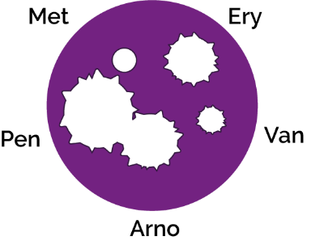Patient B: Sore throat infections are quite common and generally get better on their own. In severe cases, most antibiotics will treat this infection. Penicillin is the antibiotic of choice for this infection as the group of bacteria responsible (Streptococcus) have yet to develop a mechanism of resistance. Antibiotics should not be given unnecessarily for mild sore throats as 80% of sore throats are due to viruses and other bacteria can develop resistance during treatment.

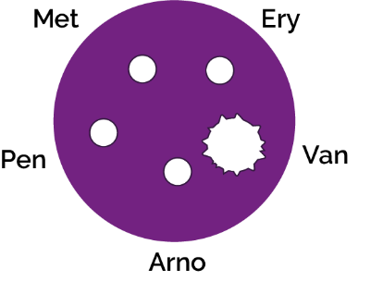Patient C: Methicillin Resistant Staphylococcus aureus (MRSA) infections are becoming increasingly difficult to treat. These S. aureus bacteria have developed resistance to Methicillin, the previous antibiotic of choice. Vancomycin is one of the last lines of defence against these potentially fatal bacteria however some organisms have been detected which also show resistance to this antibiotic.

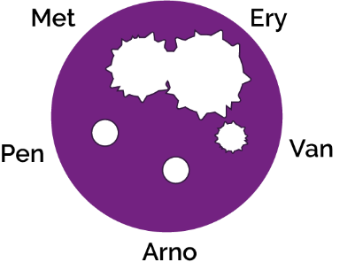Patient D: Penicillin was the first antibiotic discovered and produced, unfortunately many people viewed it as a ’wonder drug’ and used it to treat many common infections. This resulted in the majority of Staphylococcal bacteria quickly developing resistance to this antibiotic. As Ampicillin is a derivative of penicillin, Staphylococcus bacteria are resistant to it as well. Methicillin is the drug of choice for this sensitive Staphylococcus infection

SW2 and SW3 Agar Experiment Conclusions
1) Antibiotics don’t cure the cold or flu, what should the doctor recommend or prescribe to patient A to get better?

Antibiotics can only be used to treat bacterial infections; the cold or flu is caused by a virus. The doctor should prescribe medicines to help with the symptoms.

2) Methicillin used to be used to treat a Staphylococcal infection, what would happen to Patient C’s infection if they had been prescribed Methicillin?

Nothing. MRSA is resistant to antibiotics.

3) If you had some amoxicillin left over in your cupboard from a previous chest infection, would you take them later to treat a cut on your leg that got infected? Explain your answer.

No, you should never use other people’s antibiotics or antibiotics which have been prescribed for a previous infection. There are many different types of antibiotics which treat different bacterial infections. Doctors prescribe specific antibiotics for specific illnesses and at a dose suitable for that patient. Taking someone else’s antibiotics may mean your infection does not get better.

4) Patient D doesn’t want to take the prescribed flucloxacillin for their wound infection. “I took more than half of those pills the doc gave me before and it went away for a while but came back worse.” Can you explain why this happened?
It is very important to finish a course of prescribed antibiotics, not just stop halfway through. Failure to finish the course may result in not all the bacteria being killed and possibly becoming resistant to that antibiotic in future.

SW4 Antibiotics Right or Wrong
Statement 1: Wrong
Most common infections that cause coughing and sneezing are caused by viruses and will get better by themselves with bed rest and fluid intake. Antibiotics are not effective against viruses.
Statement 2: Right
Antibiotics should be taken exactly as advised by your healthcare professional.
Statement 3: Wrong
You must not use other people’s or any leftover antibiotics.
Statement 4: Right
Most common infections that cause coughing and sneezing are caused by viruses and will get better by themselves with bed rest and fluid intake. Antibiotics are not effective against viruses.
Statement 5: Wrong
Antibiotics can help severe bacterial infections such as pneumonia or kidney/urine infections.
Statement 6: Wrong
Antibiotics should be taken exactly as advised by your healthcare professional.
Statement 7: Wrong
Antibiotics are not effective against headaches or viruses, such as the one that causes flu.
Statement 8: Right
If you over-use antibiotics they might not work when you really need them for a severe infection.

