Infection Prevention and Control (IPC): Hand and Respiratory Hygiene
Key Stage 4

Lesson 4: Hand and Respiratory Hygiene
Through a classroom experiment, students learn how easily microbes can spread from one person to another by touch and why it is important to wash hands properly. Students will also learn how microbes can spread via droplet transmission (coughs and sneezes).

Learning Outcomes

All students will:
- Understand that infection can be spread through unclean hands.
- Understand that hand washing can prevent the spread of infection.
- Understand how pathogens can be transmitted.
- Understand that covering your mouth and nose with a tissue or your sleeve (not your hands) when you cough, or sneeze helps prevent the spread of infection.

Curriculum Links

PHSE/RHSE
- Health and prevention

Science
- Working scientifically
- Scientific attitudes
- Experimental skills and investigations
- Analysis and evaluation

Biology
- Cells
- Health and disease
- Development of medicines

English
- Reading
- Writing

Art & Design
- Graphic communication

Lesson 4: Hand and Respiratory Hygiene

Resources Required

Introduction

Per student
- Copy of SH1
- Copy of SH2

Main Activity: Toilet Paper Experiment

Per group
- 1 lawn culture of Saccharomyces cerevisiae on malt extract agar
- 3 malt extract agar plates
- Sterile swabs (see advanced preparation for how to make your own)
- Toilet paper of different thicknesses/styles
- Soap
- Disposable cup for waste materials
- Beaker
- Disinfectant (e.g. Virkon)
- Sterile forceps
- Autoclave bag
- Marker pen
- Adhesive tape
- To make own sterile swabs (optional)
- Cocktail sticks
- Absorbable cotton wool
- Autoclave bag
- Aluminium foil

Extension Activity 1: Stomach Bug Chain of Infection

Per student
- Copy of SH1
- Copy of SH2

Extension Activity 2 and 3: Hand and Respiratory Hygiene Quizzes

Per student
- Copy of SW1
- Copy of SW2

Additional Supporting Materials

Per class
- Copy of PP1 on the spread and prevention of infection (e-bug. eu/eng/KS4/lesson/ Hand-Respiratory-Hygiene)

Supporting Materials
- SH1 The Chain of Infection Poster
- SH2 Breaking the Chain of Infection Poster
- SH3 Hand Washing Poster
- SW1 Hand Hygiene Quiz
- SW2 Respiratory Hygiene Quiz

Advanced Preparation
Prepare the malt extract agar plates:
- Dissolve 15g malt extract and 18g bacteriological agar in 1L distilled water
Prepare the lawn cultures:
- Inoculate malt extract agar plates with a few drops of the Saccharomyces cerevisiae culture in malt extract broth.
- Spread the liquid evenly over the surface of the agar using a sterile glass rod spreader and incubate for 48 hours at 20–25°C.
Sterilise the forceps:
- Sterilise the forceps by covering them in aluminium foil and autoclaving.
To make sterile swabs (optional if not purchased):
- Commercially available (non-sterile) cotton buds/swabs shoud be avoided in case they are impregnated with antimicrobial chemicals.
- Wrap absorbable cotton wool around a cocktail stick. Sets of three should be wrapped in aluminium foil and sterilised in an autoclavable bag.
- You may wish to partially snap the cocktail sticks to create an L shape to assist dabbing yeast onto the agar plates.
Toilet paper selection:
- You may wish to provide both a traditional smooth-style and a soft paper for comparison.

Key Words
Bacteria
COVID-19
Epidemic
Fungi
Infection
Pandemic
Pathogens
Toxin
Virus
Health & Safety
Ensure that the students have no soap allergies or sensitive skin conditions.
Students and teachers must wash their hands thoroughly afterwards as there is a risk of inadvertently cultivating organisms already present on the skin.
All toilet paper, swabs and waste material should be placed in a disposable cup (one per group) and all disposable cups containing all waste material should be sterilised in an autoclave bag before being disposed of.
Dispose of all experimental material according to school policy on disposal of microbe cultures. For safe microbiological practices in the classroom consult CLEAPPS
www.cleapps.org.uk
Weblinks
e-bug.eu/eng/KS4/lesson/ Harmful-Microbes

Modifications
If there is an outbreak of respiratory illness and mask wearing is recommended, you can include a step to show how a mask can block the microbes from a sneeze/cough. Always include tissue as a step and reinforce the message to catch it, bin it, kill it and wash hands afterwards.
You may wish to display SH3 Hand Washing Poster to reinforce best had washing practices to students.

Introduction
- Begin the lesson by asking the class ‘if there are millions of disease-causing microbes in the world that live everywhere, why aren’t we ill all the time?’ Provide students with SH1 (The chain of Infection) and SH2 (Breaking the Chain) or MS PowerPoint presentation PP1 to explain the spread and prevention of infections.
- Highlight that there are different ways in which microbes can be transmitted to people. Ask students if they can think of any. Examples include through the food we eat, the water we drink and bathe in, the things we touch and from sneezing.
- Ask students: How many of you have washed your hands today? Ask why they washed their hands (to wash away any microbes that might be on their hands), and what would happen if they didn’t wash away the microbes (they might get ill).
- Tell the students that we use our hands all the time, and that they pick up millions of microbes every day. Although many of these are harmless some could be harmful.
- Explain to the class that we spread our microbes to our friends and others through touch, and therefore we wash our hands to help prevent the spread of microbes.
- Explain to students that they are going to do an activity to show them how best to wash their hands to remove any of the harmful microbes which may be on their hands..

Activity

Main Activity: Toilet paper experiment
This investigation uses the yeast Saccharomyces cerevisiae to simulate the contamination of hands with faecal microbes and the effectiveness of hand washing to remove them. The use of sterile swabs in this experiment represent the student’s hands and the yeast represents germs found in poo. The growth on plates A, B and C demonstrate what microbes would be left on their hands after going to the toilet.
- Before starting this experiment ask students to write down their predictions What do they expect to see in dishes A (no toilet paper), B (wiping with toilet paper) and C (wiping with toilet paper and washing their hands afterwards) in their next lesson?.
- Ask students to label the bases of three sterile malt agar plates with their name and the date.
- Students should wash their hands thoroughly, then dry them on a clean paper towel. Open the lawn plate of Saccharomyces cerevisiae and use a sterile swab to wipe over the surface lightly. Next lift the lid of dish A, touch the agar surface lightly with the same swab and quickly replace the lid. Students should now dispose of their swab in the disposable cup. This is the equivalent of the microbes that would be on your hands if you wiped without using toilet paper.
- Next, ask students to wrap a sterile swab in a layer of the toilet paper. Now opening their plate of Saccharomyces, (representing faeces), ask students to wipe the wrapped swab lightly over the surface in a similar manner to as before. Students should now use the sterile forceps to remove the toilet paper and place it in the cup provided. Then lifting the lid of plate B, ask students to touch the agar surface lightly with the same swab and quickly replace the lid. Students should now wash their hand thoroughly and dispose of the swab in the disposable cup. The sterile forceps should be placed in a beaker of disinfectant in between uses and not on the workbench.
- Each group should repeat step 4 using plate C with the following difference: After removing the toilet paper and discarding it into the bag, students should wash their swab thoroughly with soap and dry them on a clean paper towel. Now ask students to use the cleaned swab to touch the surface of plate C and quickly replace the lid. Students should wash their hand thoroughly and dispose of the swab. This will demonstrate the germs left on your hands after wiping and then washing your hands.
- Use two strips of tape to attach the lid loosely to the dishes. The dishes will be turned upside down and incubated until next lesson. All cups containing waste material should be placed into one autoclave bag and sterilised before being disposed of.
- Students should examine the agar plates without opening them. Students should notice that there is less yeast growth on plate B than plate A. This demonstrates that the toilet paper provided a physical barrier to prevent some, but not all, contamination from the yeast (faeces) to the swab (hands). Students should notice there is less growth on plate C than plate B. This demonstrates that hand washing removes most microbes after visiting the toilet.
This lesson reinforces the importance of hand washing after visiting the toilet. Optional: Each group may wish to use different thickness/style of toilet papers to further the scientific investigation if required.

Discussion
- Following the toilet paper experiment, ask students the following questions:
- Does the appearance of your dishes match your predictions?
- Are the class results consistent? If not, suggest reasons for any differences
- What do the results suggest about personal hygiene procedures?
- Why is it important to wash your hands (a) before meals, (b) after using the lavatory?
- Suggest as many methods as you can to prevent the spread of infectious disease.

Extension Activities

Stomach Bug Chain of Infection
- This activity can be carried out in groups of 2 – 4 students or as a classroom discussion.
- Ask students if they have ever had a stomach bug. With the help of SH1 and SH2, ask students to imagine the spread of gastroenteritis (a stomach bug) in their school from a single infected student.
- Ask the class to take into account the situations of everyday life in school (going to the toilets without washing hands or washing them without soap, going to eat at the school canteen, borrowing pens or other things from friends, holding hands, hugging friends, using a computer…).
- Ask the groups/class to report on ways in which the infection could spread and how quickly it could spread in their class or in the school. Ask them to consider the different ways they could stop the spread of infection.
- Suggest the students think about and discuss the difficulties they encounter with respect to hand hygiene in school and to suggest how to use the existing hygiene facilities better.

Spread of Infection on a Cruise Scenario
This activity can be used to demonstrate to students how infectious agents can easily spread globally, and that methods or prevention can be better than a cure.
- This can be carried out as a group or individual activity.
- Explain to students that they are going to predict how many people can become infected and how far influenza can travel in a week by an infected person.
- Tell the class that they are on a Mediterranean cruise that will call at ports in Spain, France, Italy, Malta and Greece. At each port-of-call passengers can choose to get off for shore excursions or stay on the ship. On the cruise there are:
  - A family who will be returning home to Australia after the cruise.
  - Two passengers planning an onward journey from Greece to Turkey.
  - Four passengers planning an interrailing excursion through Hungary, Czech Republic and Germany.
  - The remaining passengers plan to return home to the USA and China.
- A passenger boarding the cruise has a new strain of the influenza virus and it is very contagious.
  - Hypothesise and consider how many people he might infect and how far this virus could travel in 24 hours, and in 1 week.
  - What could have been done to prevent the infection travelling so far?

Teacher Notes
As so many people are travelling to so many destinations, it is impossible to accurately tell how fast the infection may travel. Consider:
- Destinations
- Whether everyone he comes in contact with becomes infected?
- Incubation period (the time elapsed between exposure to the virus and the development of signs and symptoms)

Learning Consolidation

Hand and Respiratory Hygiene Quizzes
Divide the class into pairs. Provide each pair with a copy of SW1 hand hygiene quiz and SW2 respiratory hygiene quiz to test their knowledge. This can be used before and/or after the lesson. The pair with the most points wins the quiz.

Infographic Activity
Students can further consolidate their knowledge of micro-organisms and the spread of infection by producing a public information infographic. This will help disseminate important hand and respiratory hygiene information whilst engaging students with their local community.

SH1 - The Chain of Infection Poster

Spread of infection
Harmful microbes need a way to be passed from a source to a person. This can be through:
• Direct touch/contact
• Sexual transmission
Harmful microbes are also spread via:
• Hands, hand contact surfaces (e.g. door handles, keyboards, toilets)
• Food contact surfaces
• Air
Source of infection
Someone or something carrying the harmful microbes that causes the infection. There are many different sources of infection, these can include:
• People already infected
• Pets or animals
• Contaminated food
Way out for microbes
Harmful microbes need a way to get out of an infected person or source before they can spread to someone else. Routes include:
• Sneezing, coughing, saliva
• Bodily fluid
• Juices from raw meat and poultry

The Chain of Infection
People at risk from
infection
We are all at risk from
infection, but some are at greater risk:
• People on medication
e.g chemotherapy
• The very young/elderly
• People with underlying diseases e.g HIV/AIDS, diabetes
Way in for microbes
Harmful microbes need a
way to enter the body before they can cause an infection. This can be
through:
• The food we eat
• Inhalation of aerosols
or droplets
• Open cuts or sores
• Things we put in our
mouths

SH2 - Breaking the Chain of Infection Poster
Spread of infection
• Wash hands thoroughly and regularly
• Cover cuts and open sores
• Take appropriate precautions during
sexual activity
Source of infection
• Isolate infected people
• Take care with raw food
• Wash pets regularly
• Treat pets for pathogens when needed
• Dispose of nappies and soiled clothing appropriately
Way out for microbes
Prevent any:
• Coughs and sneezes
• Faeces
• Vomit
• Bodily fluid
Getting onto surfaces or hands

Breaking the Chain of Infection
People at risk from
infection
Everyone:
• Take appropriate vaccinations
High risk people:
• Keep away from people who are infectious
• Take extra care about cleanliness
• Take extra care when cooking and preparing food
Way in for microbes
• Cover cuts and open sores with a water proof dressing
• Cook food properly
• Take care to drink only clean water

SH3 - Hand Washing Poster

Wash your hands with soap and water for 20 seconds
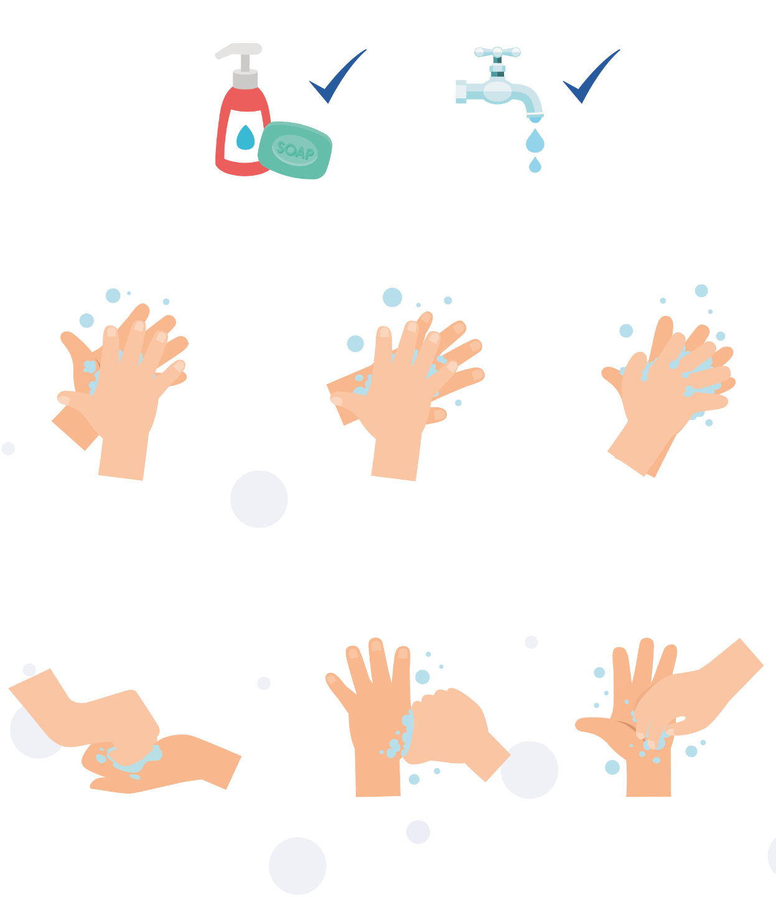

1
2
3

Palm to palm
Back of hands
Between fingers
4
5
6

Back of fingers
Thumbs
Tip of fingers
To help keep time, sing ‘Happy Birthday’ twice

SW1 - Hand Hygiene Quiz
Quiz: Hand Hygiene
Please tick as many answers as appropriate
How can you spread microbes to others? (2 points)
- By touching them
- By looking at them
- By speaking to them on the phone
- By sneezing
Why should we use soap to wash our hands? (2 points)
- It helps remove invisible microbes too small to be seen by our eyes
- It breaks up the oil on our hands which trap microbes
- It keeps our hands moist
- It doesn’t matter if we use soap or not
Which is NOT one of the 6 steps of hand washing? (1 point)
- Palm to palm
- The thumbs
- Arms
- In between fingers
Who might be at risk as a result of you not washing your hands properly? (1 point)
- You
- Your family
- Your friends
- All of the above
When should we wash our hands? (3 points)
- After stroking a pet
- After sneezing or coughing
- After watching TV
- After using the bathroom or changing a soiled nappy
How can you stop harmful microbes from spreading? (2 points)
- Do nothing
- Wash hands in water
- Use hand sanitiser if soap and water are not available
- Wash your hands with running water and soap
After we sneeze into our tissue, we should: (2 points)
- Wash our hands immediately
- Dry our hands on our clothes
- Take antibiotics
- Put the tissue straight into the bin
How long should we wash our hands for? (1 point)
- 10 seconds
- 20 seconds (length of Happy birthday song twice)
- 1 minute
- 5 minutes

SW2 - Respiratory Hygiene Quiz
Quiz: Respiratory Hygiene
Please tick as many answers as appropriate
How can you spread microbes to others? (3 points):
- Touching
- Sleeping
- Sneezing
- Coughing
After we sneeze into our hands, we should (2 points):
- Wash our hands
- Dry our hands on our clothes
- Take antibiotics
- None of the above is necessary
If you do not have a tissue available, the next best thing is to sneeze (1 point):
- Into your hands
- Into your sleeve
- Into an empty space
- Onto your desk
The best way to stop microbes from spreading is (2 points):
- To use your hand to cover your sneeze
- To use a tissue to cover your sneeze
- To use a sleeve if you haven’t got a tissue
- To drink plenty of fluids
What should you do with a tissue after sneezing into it? (1 point):
- Put it in your pocket for next time
- Put it straight in the bin
- Put it up your sleeve for next time
- Any of the above
What might happen if we don’t wash our hands after sneezing into them? (1 point):
- Nothing
- Transfer harmful microbes to other people
- Help protect our microbes

