

## SH1 - The Chain of Infection Poster

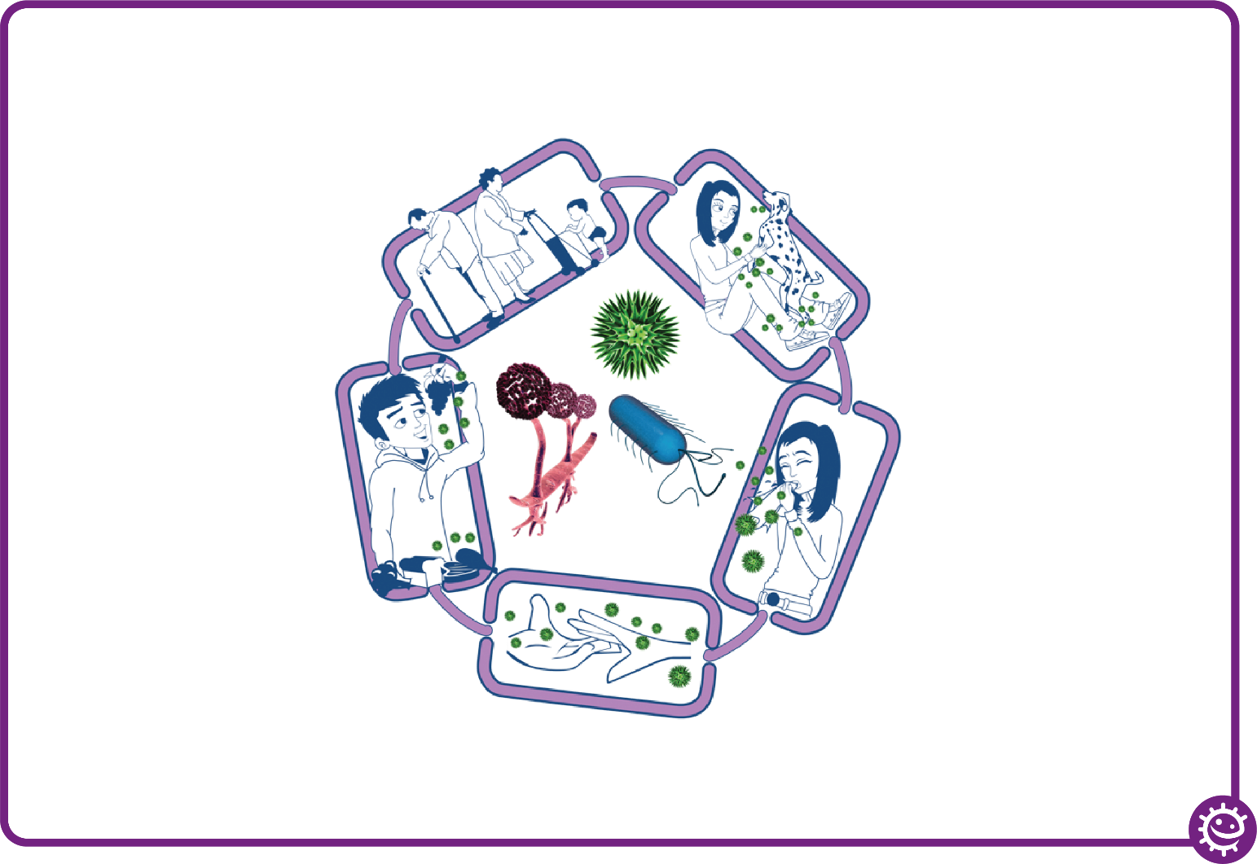

Spread of infection

Harmful microbes need a way to be passed from a source to a person. This can be through:

• Direct touch/contact

• Sexual transmission

Harmful microbes are also spread via:

• Hands, hand contact surfaces (e.g. door handles, keyboards, toilets)

• Food contact surfaces

• Air

Source of infection

Someone or something carrying the harmful microbes that causes the infection. There are many different sources of infection, these can include:

• People already infected

• Pets or animals

• Contaminated food

Way out for microbes

Harmful microbes need a way to get out of an infected person or source before they can spread to someone else. Routes include:

• Sneezing, coughing, saliva

• Bodily fluid

• Juices from raw meat and poultry

The Chain of Infection

People at risk from

infection

We are all at risk from

infection, but some are at greater risk:

• People on medication

e.g chemotherapy

• The very young/elderly

• People with underlying diseases e.g HIV/AIDS, diabetes

Way in for microbes

Harmful microbes need a

way to enter the body before they can cause an infection. This can be

through:

• The food we eat

• Inhalation of aerosols

or droplets

• Open cuts or sores

• Things we put in our

mouths



## SH2 - Breaking the Chain of Infection Poster

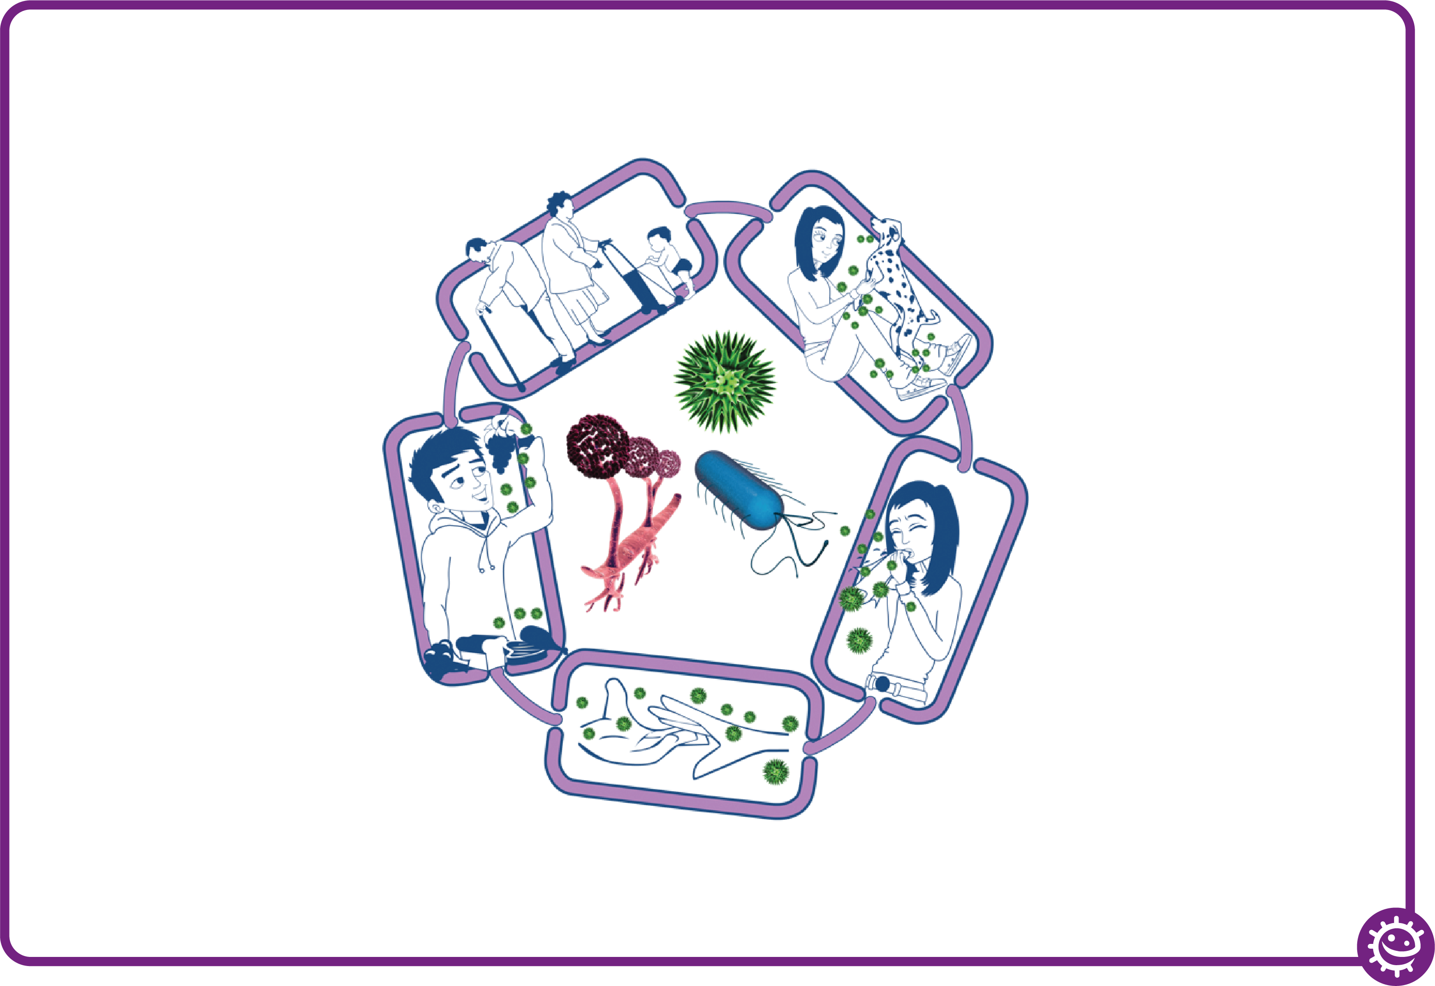

Spread of infection

• Wash hands thoroughly and regularly

• Cover cuts and open sores

• Take appropriate precautions during

sexual activity

Source of infection

• Isolate infected people

• Take care with raw food

• Wash pets regularly

• Treat pets for pathogens when needed

• Dispose of nappies and soiled clothing appropriately

Way out for microbes

Prevent any:

• Coughs and sneezes

• Faeces

• Vomit

• Bodily fluid

Getting onto surfaces or hands

Breaking the Chain of Infection

People at risk from

infection

Everyone:

• Take appropriate vaccinations

High risk people:

• Keep away from people who are infectious

• Take extra care about cleanliness

• Take extra care when cooking and preparing food

Way in for microbes

• Cover cuts and open sores with a water proof dressing

• Cook food properly

• Take care to drink only clean water