

## SH3 - Hand Washing Poster

### Wash your hands with soap and water for 20 seconds

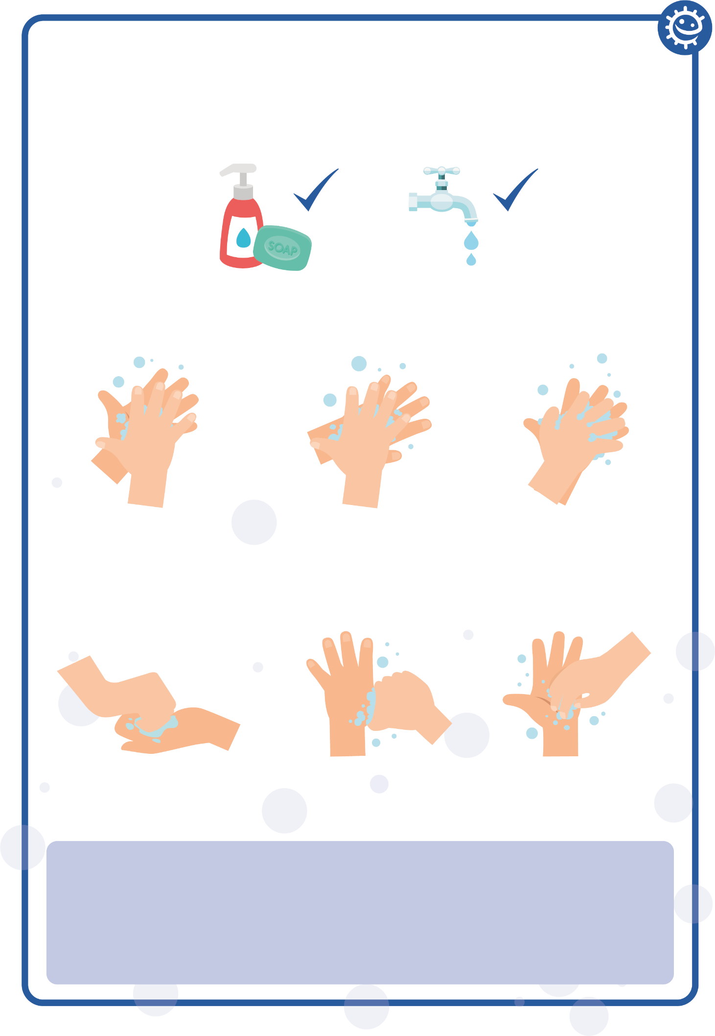

1

2

3

Palm to palm

Back of hands

Between fingers

4

5

6

Back of fingers

Thumbs

Tip of fingers

To help keep time, sing ‘Happy Birthday’ twice