Infection Prevention and Control (IPC): Vaccinations
Key Stage 4

Lesson 7: Vaccinations
This lesson includes a detailed presentation and animations showing how the body fights harmful microbes daily. Students will take part in an in-depth discussion about vaccinations, including busting some common vaccine misconceptions.

Learning Outcomes

All students will:
- Understand that vaccinations help individuals to develop immunity against an infection(s) and help to fight off the infection(s).
- Understand why vaccines are important to students now and throughout their life.
- Understand the important diseases prevented by vaccines, and why these are important to young people, including students.

Most students will:
- Understand how the media, and epidemics, can affect vaccine uptake positively and negatively.

Curriculum Links

PHSE/RHSE
- Health and prevention
- Intimate and sexual relationships
- Sexual health

Science
- Scientific thinking
- Experimental skills and strategies
- Analysis and evaluation

Biology
- Cells
- Health and disease

English
- Reading
- Writing

Art & Design
- Graphic communication

Lesson 7: Vaccinations

Resources Required

Main Activity: Immunity and Vaccinations Worksheet

Per class
- Animation e-bug.eu/eng/KS4/ lesson/vaccinations
- Copy of TS1 and TS2

Per student
- Copy of SW1

Extension Activity 1: Student Debate kit

Per class
- Vaccinations Debate Kit
- Resources – I’m a Scientist Debate Kits freely available from: debate.imascientist.org. uk/the-kits/#vaccinations

Extension Activity 2: Vaccine Misconceptions

Per class
- Copy of PP1
- Copy of HPV Fact Sheet freely available from| www.gov.uk/ government/publications/ hpv-vaccine-vaccination-guideleaflet Copy of TS3

Per Student
- Copy of SW2

Supporting Materials
- TS1 Teacher Sheets Animation Clip Answers
- TS2 Immune System Worksheet Teacher Answers
- TS3 Vaccine Misconceptions Worksheet
- SW1 Immune System worksheet
- SW2 Vaccine misconceptions
- SH1 I’m a Scientist Debate Kit (available from debate.imascientist.org.uk/the-kits/#vaccinations)

Advanced Preparation
- Copy SW1 and SW2 for each student.
- Download the interactive vaccination misconceptions slides and prepare animations by accessing the e-Bug website e-bug.eu/eng/KS4/ lesson/ vaccinations.
- In advance for the lesson, you can ask students to complete their own personalised vaccination timeline, available on the e-Bug website. This timeline will detail all the vaccinations students should have had; they can discuss this at home with their parents. Immunisations that students have (not) had are personal and should not be discussed as a class. Students may be very surprised at the number of immunisations that have been available to them in their lifetime.
Lesson 7: Vaccinations

Key Words
Antibody
Antigen
COVID-19
HPV
Immune system
Immunity
Vaccines
Health & Safety
For safe microbiological practices in the classroom consult CLEAPPS
www.cleapps.org.uk

Weblinks
e-bug.eu/eng/KS4/lesson/ Vaccinations

Introduction
- Provide an introduction for students, describing that they are going to learn about vaccinations, and why they are so important. Students will be learning facts, will discuss some common misconceptions, and the influence of others when making decisions about vaccinations. Students will learn if and how the media influence vaccine uptake, subsequent disease rates and herd immunity.
- Ask students what they already know about vaccinations. Questions to be discussed could include:
  - Do you know what a vaccination is?
  - How does a vaccination work?
  - What vaccinations do children usually have, and at what ages?
  - What vaccinations have you had?
  - Why do you think you need vaccinations against diseases such as the flu, measles, mumps and rubella (MMR) or COVID-19?
  - Do students know what herd immunity is? Ask students to describe this in their own words. (The herd immunity animation on e-bug.eu/eng/ KS4/lesson/Vaccinations website could be used if students are still confused about herd immunity).
- Be prepared that some students may question the safety of vaccines. The teacher refresher section at the beginning of the pack may help you answer any questions that arise.

Activity

Main Activity: Immunity and Vaccinations Worksheet
- Ask students to watch the immunisation animation clips available through the e-Bug website. The animations are divided into three clips and cover immunity and vaccinations. Guidance to complement the animation clips can be found in TS1.
- Provide each student with a copy of SW1. Students should answer the questions based on the information provided in the animation. Answers can be found in TS2.

Discussion
Discuss these common vaccination questions with the class
What is vaccination?
Answer: Vaccinations are another means of helping our immune system protect us against harmful diseases. They use your body’s natural defences to build resistance to specific infections and help build our immune system stronger.
Why should I get vaccinated?
Answer: Vaccines have saved millions of lives. Without vaccines, we are at serious risk of illness and disability from diseases like measles and meningitis. Vaccinations protect ourselves from illness and others from getting ill too. Not everyone can be vaccinated, sometimes very young babies, very old people and people with serious illness e.g. a weakened immune system caused by disease or treatment– these people depend on others getting vaccinated to prevent the spread of infection and protect them.
Why is vaccination important?
Answer: Vaccines are a safe and effective way in preventing us from getting ill. Today there are vaccines to protect us from at least 20 diseases including tetanus, influenza, measles, mumps, polio and meningitis. When getting vaccinated, we aren’t just protecting ourselves but also the people around us. Vaccines help prevent the spread of infection.
How does a vaccine work?
Answer: When the vaccine is injected into the body the immune system attacks it as if harmful microbes were attacking the body. White blood cells, a part of our immune system, create lots of antibodies to attach to specific markers on the surface of the vaccine organisms. These markers are called antigens. It takes our immune system around two weeks to learn about the vaccine organisms and while this is happening, we might feel a little tired or develop a sore arm. This is because the immune system is working hard to kill or eliminate all of the vaccine organisms. Because the vaccine is either a killed or extremely weakened version of the microbes, our immune system can process the vaccine and it will not make you ill. By successfully eliminating all the vaccine, the immune system remembers how to combat those microbes. The next time microbes carrying the same markers/antigen enter the body the immune system is ready to fight it before it has a chance to make you ill. This means you develop immunity against diseases.

Extension Activities
Extension Activity: Vaccination Debate Kit
- Developed in collaboration with ‘I’m a Scientist’, the vaccine debate kit facilitates a structured practice debate about a controversial topic. Download the vaccination debate kit, freely available from debate.imascientist.org.uk/the-kits/#vaccinations.
- There are eight-character cards. Divide the class into a maximum of eight groups, or as many characters as you wish to cover. Assign each group a character.
- Work through each round of the debates as instructed and encourage students to consider their opinions. The structure demonstrates to students how to build a discussion and reinforce their opinions with facts. Teacher notes are included in the kit to help carry out the lesson effectively.

Learning Consolidation
Ask students to consolidate their knowledge of all vaccines and produce a public information infographic. This can be used to help students to practice disseminating useful information whilst engaging with their local community.

TS1 - Teacher Sheet
This sheet provides additional information for teachers and is designed to be used alongside the e-Bug vaccinations animation. The animation is divided into 3 clips.
Clip 1
Introduction:
In order to understand how vaccines work, we first need to know how the immune system works and how vaccines stimulate the immune system to provide protection against infectious diseases. This short animation will describe how the immune system fights infection and explain how it responds to a vaccine. The function of the immune system is to distinguish foreign substances from substances that are part of our own bodies. The part, or parts, of any foreign substance that are recognised by the immune system are known as antigens. Antigens are present on bacteria, on viruses and on foreign cells from transfusions or organ transplants. Antigens may also be chemicals such as toxins or components of vaccines.
Innate immunity:
The body’s first line of defence against foreign substances is the variety of physical barriers it possesses in order to prevent entry. This includes tears, gastric acid, skin and tiny hairs called cilia. The specialisation of each of these barriers is explained below:
- Skin: Skin provides a physical barrier for our body. Entry through this barrier for pathogens (micro-organisms that cause disease) can occur when the skin is broken, irritated or damaged from cuts and wounds.
- Tears: The eye has a mechanism of cleaning itself through the movement of substances through blinking. The film of moisture over the eye can trap substances such as dust and through blinking can move it to the corners of the eye where it can be removed. Our tears also contain enzymes such as lysozyme and amylase, which can kill some bacteria providing another level of protection.
- Gastric acid in the stomach: The acid in our stomach not only aids digestion but can also kill some pathogens. Pathogens that are not killed by this acid can potentially cause disease, such as Salmonella which causes food poisoning.
- Cilia: Cilia are small hairs found along the airways in our nose and lungs. These hairs are located next to mucosal cells which secrete mucus. The mucus can trap particles we inhale, including bacteria and viruses. The movement of the hairs in the nose stimulates sneezing and in the lungs they can move the mucus to the throat where it can be coughed out or swallowed.
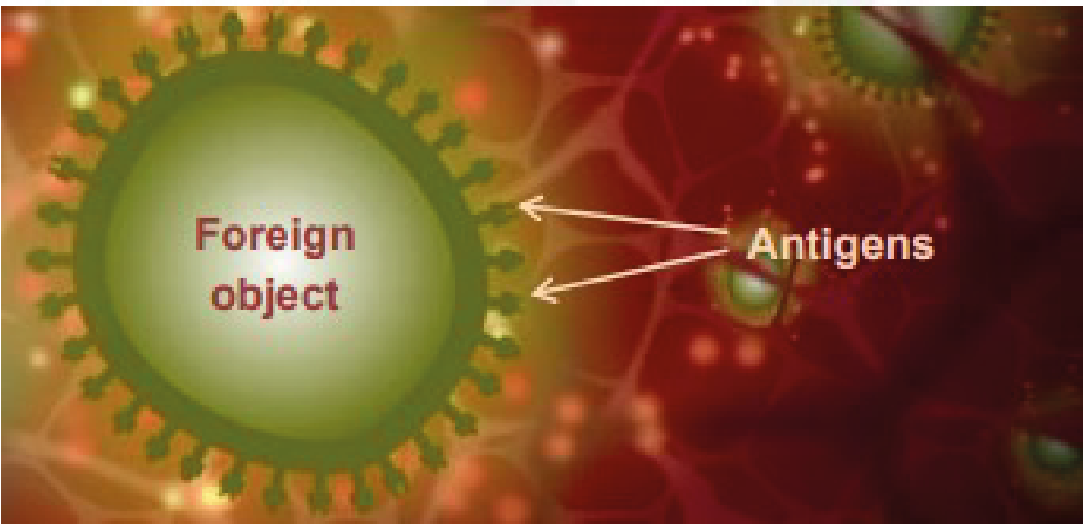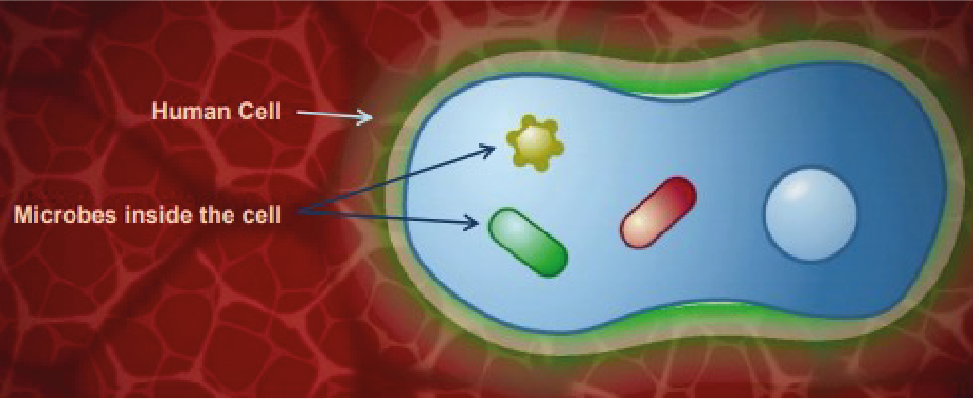

TS1 - Teacher Sheet
However, if these barriers are breached, for example by bacteria entering the body through the skin, the antigens encounter large cells called macrophages which are resident in the skin. The word macrophage means ‘big-eater’. If a macrophage recognises the antigen as something foreign and not ‘self’ it engulfs it by a process called phagocytosis and can destroy it. Inflammation at the site also causes the release of small proteins called cytokines that help regulate the immune response and attract additional macrophages from the blood stream to the site. This first and immediate response is known as innate immunity. Although rapid, it is non-specific, it is the same for all antigens and the immune system does not retain any memory of the encounter with the antigen.
The different immune defences are carried out by variety of immune cells. The innate immune system is made up of leukocytes and other cells such as natural killer cells. Leukocytes include macrophages and neutrophils and the main characteristic of these cells is that they can carry out phagocytosis. Phagocytosis results in destruction of the foreign substance by fusing the digested material with the lysosome. The lysosome provides harsh conditions to kill the pathogen which includes using specialised lysosomal enzymes and providing highly acidic conditions. Natural killer cells kill other cells that are ‘stressed’ such as viral or bacterial-infected cells. This is a crucial part of the innate immune system as some bacteria and viruses can get inside cells and so are ‘hidden’ from the innate immune system, such as meningococci and mycobacteria.
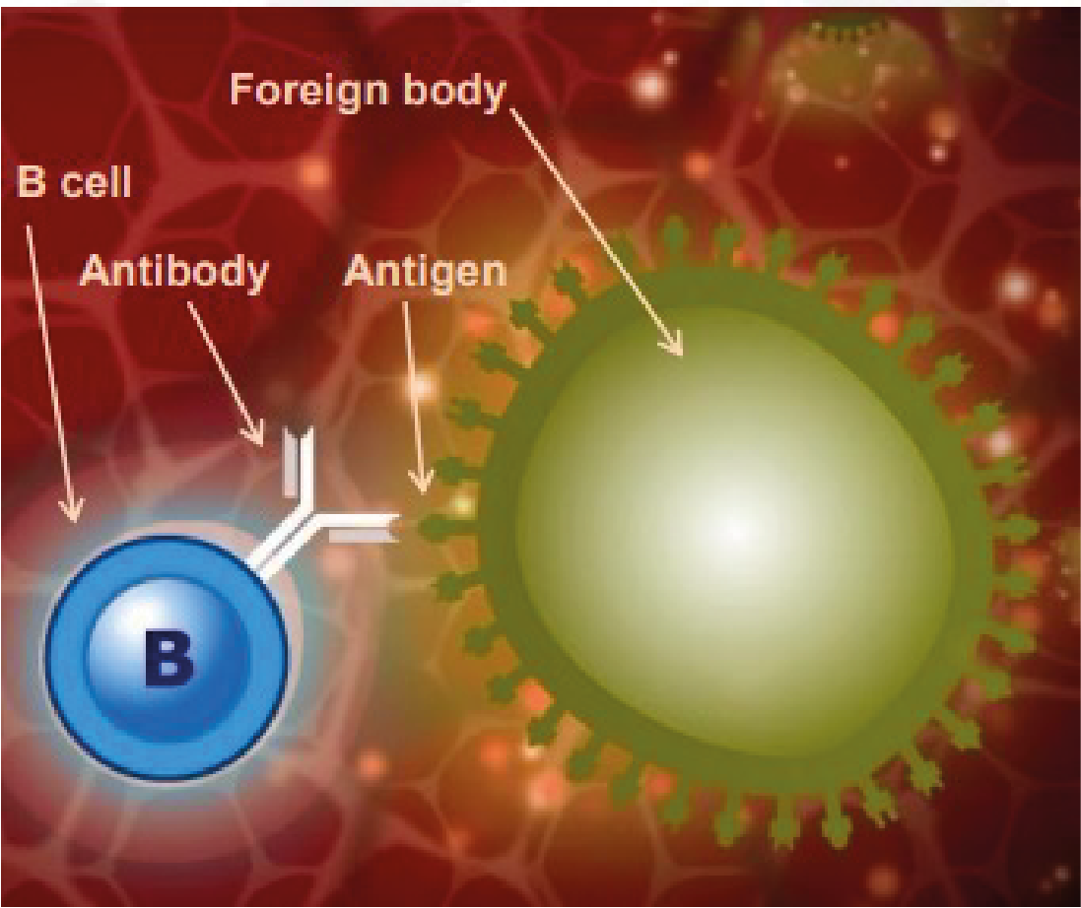

TS1 - Teacher Sheet
Acquired immunity:
Sometimes, the innate response needs help to eliminate the antigen. In addition to phagocytosis, macrophages can also transport antigen to sites where an acquired immune response can be activated. When the macrophage bearing an antigen enters the lymphatic system it moves towards the lymphoid organs which include the spleen, the tonsils, adenoids and Peyer’s patches. These organs are rich in two types of specialised white blood cells called lymphocytes. Also known as B cells and T cells, these lymphocytes are distributed in strategic sites throughout the body ready to respond to antigens. There are also many B and T cells circulating in the blood.
The innate immune system stimulates the acquired immune system by showing the acquired immune cells the antigen that the foreign body has. These cells are therefore called antigen-presenting cells (APC). Dendritic cells and macrophages can carry this out and so can also be classified as APC. This occurs after the APC has travelled through the lymphatic system to where the specialised acquired immune cells reside.
The stimulation of the lymphocytes in the lymph nodes, however, produces a strong cascade of lymphocyte activation as one APC cell can stimulate many B and T cells. T cells are specific cells that are involved in the cell-mediated response and B cells are cells involved in the humoral immune response.
Clip 2:
B cells and T cells: B and T cells have different functions. B cells respond to free antigens or those that are on the surface of organisms that circulate outside and between cells of the body, this includes most types of bacteria. However, they cannot recognise antigens located inside cells such as viral proteins or certain bacteria such as Meningococci and Mycobacteria which have adapted to live in cells and therefore make detection by the immune system more difficult.
B cells produce specific antibodies by interacting with the antigen presented by an APC. Antibodies are a complementary match to the antigen and stimulate killing/disposal of the foreign substance.
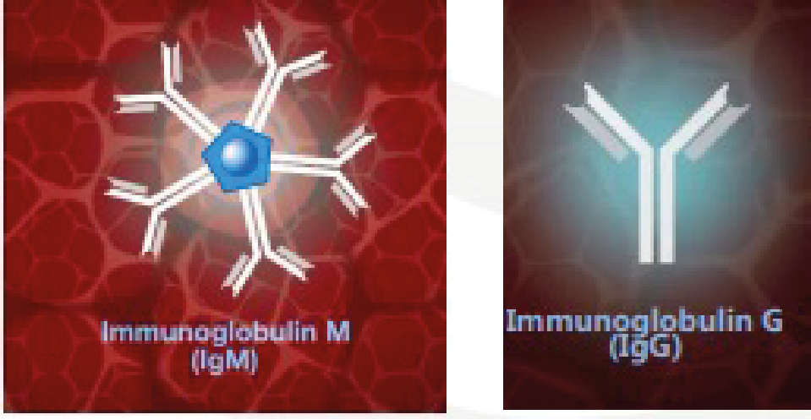

TS1 - Teacher Sheet
B cells manufacture antibodies, however, most antigens do not stimulate B cells to produce antibodies without the help of T cells. The response to these antigens is therefore referred to as T cell-dependent. Unlike B cells, T cells can recognise intracellular antigens provided they are expressed on the cell surface. T cells do not manufacture antibodies but they do secrete cytokines which influence other immune cells.
Humoral response:
B cells circulate with a molecule of a 3-dimensional protein called antibodies on their surface. The antibodies, also known as immunoglobulins, have antigen binding sites where the protein molecules are folded in such a way as to form a 3-dimensional cleft into which only antigens of a corresponding shape can bind. There is also a binding site for macrophages and neutrophils. The part of the antigen that binds to the antibodies is known as the epitope.
When one of the antibodies molecules has a surfaced receptor with exactly the right shape to recognise the antigen, it binds to it like a lock and key. The B cells then enlarge considerably and become plasma cells which are antibodies manufacturing cells capable of producing up to 100,000 antibodies molecules a minute. The antibodies molecules they produce have receptors with the same shape that recognise the antigen in the first place and this is known as the humoral response. The first time an infection or vaccine antigen is encountered the antibodies produced is called immunoglobulin M or IgM. IgM circulates as five molecules bound together with a total of 10 binding sites for rapid and effective binding to antigen. If the same antigen is encountered again, the antibodies class changes to immunoglobulin G (IgG). This is known as class switching. Class switching means that the overall structure of the antibodies changes apart from the antigen binding domain which stays the same in order to match the antigen.
When an antigen binds to an antibody there can be three outcomes:
- The binding of the antibody to the antigen will immobilise the foreign substance and neutralise it. This is the case for toxins and other harmful substances.
- The antibodies surround the foreign substance, which can immobilise it ready for phagocytosis by a cell such as a macrophage. Immunoglobulin G (IgG)
- The complement system is activated. The complement system is a major part of the humoral response. After antibodies bind to the foreign body, the complement system can attach. The complement system is made up of complement molecules which are proteins that have protease activity, i.e. can break down other proteins.
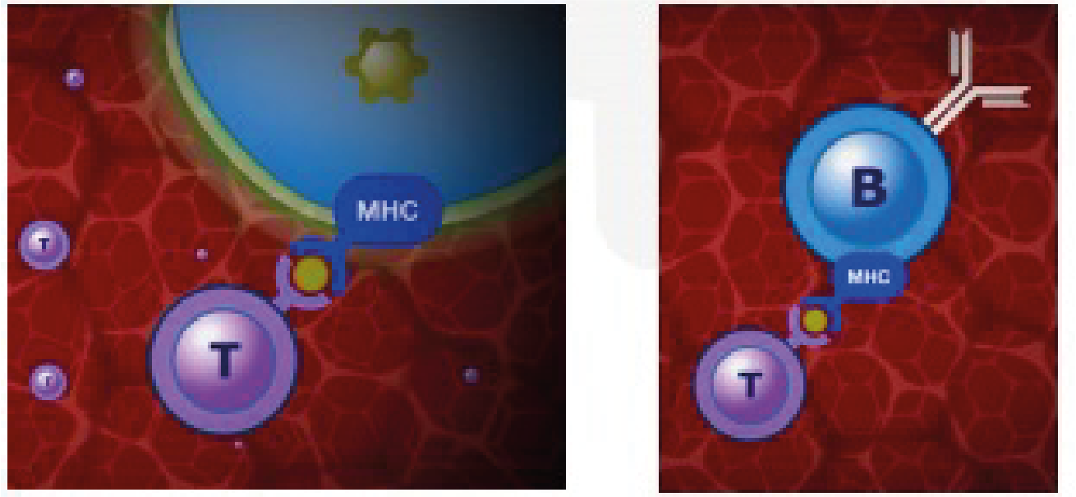

TS1 - Teacher Sheet
The attachment of complement molecules produce a protease cascade whereby one complement molecule breaks down the next, activating its protease activity so that it can breakdown the next complement molecule and so on. The result of the cascade is the production of molecules that can attract other immune cells to the site and also increase vascular permeability so that the immune cells can get to the site easily through the vasculature. Some complement molecules can recognise carbohydrate molecules on the surface of bacteria without the need for antibody binding and some complement binding can actually induce killing by disrupting the plasma membrane of the bacterium.
Cell mediated immunity:
When cells contain intracellular antigens a bit of the antigen is carried to the cell surface using molecules that are part of the major histocompatibility complex or MHC. T cells can recognise a combination of the MHC molecule and the antigen. When the T cells binds to the MHC-antigen complex, the activated cells enlarge, multiply and secret cytokines, which can then affect other immune cells nearby, and other toxic molecules such as granulysin. Granulysin induces apoptosis in the infected cell by generating holes in the membrane. The holes then promote unregulated ion, water and molecule entry into the cell causing cytolysis (osmotic lysis of the cell).
There are various types of T cell; among these are those that can destroy an infected cell known as cytotoxic T cells. Another sort, known as helper T cells, can help and stimulate B cells to produce antibody. When an antigen binds to the antibody receptor on a B cell, a bit of the antigen is also taken up into the cell and is the presented to the B cell surface by a MHC molecule. This MHC-antigen complex is recognised by a T cell, usually a T helper cell, which secretes cytokines. In this case the cytokines assist the B cells to proliferate to form identical cells producing the same antibody.
MHC platforms can also mount antigens that indicate a tumour cell. To a certain extent the immune system can recognise abnormal cells and clear them by inducing apoptosis.

TS1 - Teacher Sheet
Clip 3:
Memory response:
A few of the B cells are stimulated by the T cells to remain as memory cells and to retain the memory of the antigen antibody encounter. When the memory cells meet the antigen again, either as a natural infection or in a booster dose of vaccine antibodies of the right specificity are produced much more quickly and in greater numbers than during the first response. In contrast to the first response when short lasting IgM is made, the antibody produced is mainly IgG which persists for longer. Each time the memory cells encounter the same antigen the immune response is boosted. Because a pathogen, or a vaccine, may contain many different antigens many different B cells are stimulated at once and many
different antibodies may be produced. The capacity of our immune system is enormous and can make billions of different antibodies. If different vaccines are given at the same time then different antibodies are produced at the same time as well. In a similar way to B cells, there are also T memory cells made as a result of the first encounter with the antigen. When these T memory cells meet the antigen again they are able to respond more quickly and effectively. The specific humoral, cell-mediated and memory responses are known as acquired or adaptive immunity.
Vaccinations:
Vaccination stimulates the immune responses that have just been described, but importantly, it does so without the risks of the disease itself. It works by stimulating a pool of memory B and T cells to be made which, if and when the antigen is subsequently encountered, produce antigen specific responses fast enough to prevent disease developing. It also stimulates production of antigen specific antibody including IgG which persists after vaccination and provides early defence against infection. Knowledge of how vaccines work with the immune system allows us to understand the vaccine schedule more clearly.
When an individual is vaccinated, the processes in the immune system that are stimulated to mimic natural immunity are antigen recognition, antibody production and a formation of a memory response. This all occurs without disease progression. The vaccine will contain the antigen of the disease, or a
toxoid (an inactive version of a toxin) if the disease in question is caused by a toxin such as diphtheria or tetanus. In some cases, the vaccination can be administered via a nasal spray like the childhood flu vaccine which means the vaccine is taken up through the nasal lining.
The antigens within the vaccine are then recognised by the immune system as described earlier, and are taken up by APC, and the APC travels and is transported to the lymph nodes. The antigen is then presented to B cells which cause the production of antibodies and generations of memory B and T cells. If the individual being vaccinated then comes into contact with the actual pathogen bearing the same antigen, a memory response is stimulated resulting in clearance of the pathogen without the occurrence of disease.
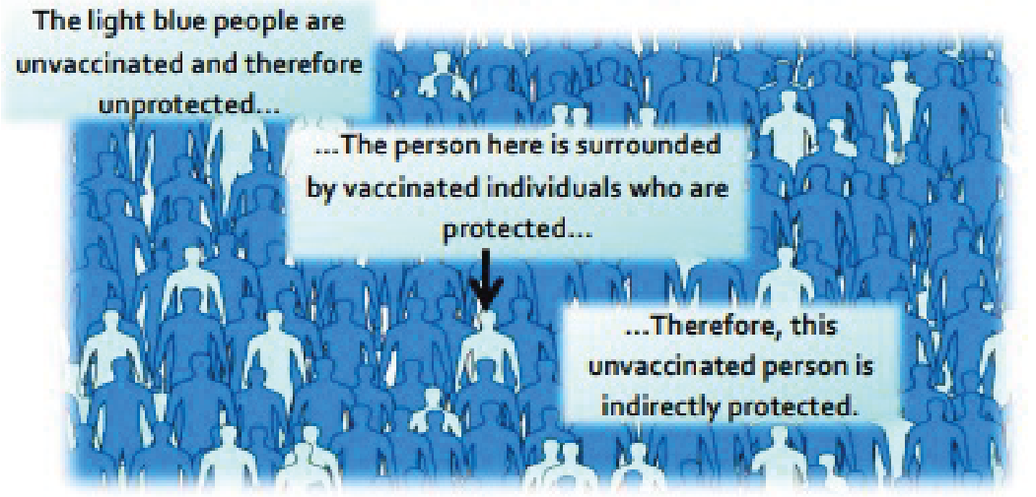

TS1 - Teacher Sheet
Booster vaccinations are given to keep circulating antibody numbers at high levels. If they are missed then the memory response may be weakened and may result in the individual contracting the disease.
In the case of the flu, annual/seasonal vaccinations are administered because the influenza virus is able to change its antigens on its surface resulting in the need for a different vaccination for the different antigens.
This change in antigens can arise from one of two ways; antigenic shift and antigenic drift. Antigenic shift is where two or more different strains of virus combine to form a new virus. This occurs if an individual is infected with different viruses at one time. Antigenic drift is when the antigen on the virus gradually changes over time due to a change in the genetic material inside the virus. This can occur if the genetic material undergoes a mutation.
The light blue people are unvaccinated and therefore unprotected
The person here is surrounded by vaccinated individuals who are protected…
Therefore, this unvaccinated person is indirectly protected
What is herd immunity and why is it important?
A small proportion of people in every population do not respond to vaccines and remain unprotected despite vaccination. In addition, people who are severely immuno-compromised are unable to receive live vaccines. Therefore, these people are dependent on not being exposed to infection in the first place. If a sufficient number of people are vaccinated in the population vaccine preventable infections are not able to transmit successfully because most people are immune. Therefore, people who are susceptible are indirectly protected by the presence of these immune individuals. This is known as herd immunity. High levels of vaccine coverage must be maintained in the population to achieve and preserve herd immunity and to protect those who cannot be immunised.
References:
Gessner, B.D., Feikin, D.R. (2014) Vaccine preventable disease incidence as a complement to vaccine efficacy for setting vaccine policy. Vaccine 30;32(26):3133-8
Malech, H.L., Deleo, F.R., Quinn, M.T. (2014) The role of neutrophils in the immune system: an overview. Methods Mol Biol. 1124:3-10
McIntyre, W.J., Tami, J.A. (1992) Introduction to immunology. Pharmacotherapy 12(2 Pt 2):2S-10S Web link Pasupuleti, M., Schmidtchen, A., Malmsten, M. (2012) Antimicrobial peptides: key components of the innate immune system. Crit Rev Biotechnol. 32(2):143-71
Storey, M., Jordan, S. (2008) An overview of the immune system. Nurs Stand. 23(15-17):47-56

TS2 - Student Worksheet 2 Teacher Answers
Immune System Worksheet - Answers
- We have various types of physical barriers to prevent invasion by a micro-organism. Name three of these barriers and explain how they are specialised to prevent infection.
Any three of the following: Skin, Cilia/hairs in [nose/throat/lungs], Tears, Gastric/stomach acid Skin provides a physical barrier for our body. Entry through this barrier for pathogens (micro-organisms that cause disease) can occur when the skin is broken/ irritated/ damaged Tears: The eye has a mechanism of cleaning itself through the movement of substances through blinking. The film of moisture over the eye can trap substances such as dust and through blinking can move it to the corners of the eye where it can be removed. Our tears also contain enzymes, called lysozyme and amylase which can kill some bacteria providing another level of protection. Gastric acid in the stomach: The acid in our stomach not only aids digestion but can also kill some pathogens. Pathogens that are not killed by this acid can potentially cause disease, such as Salmonella which causes food poisoning. Cilia: Cilia are small hairs found along the airways in our nose and lungs. These hairs are located next to mucosal cells which secrete mucus. The mucus can trap particles we inhale, including bacteria and viruses. The movement of the hairs in the nose stimulates sneezing and in the lungs they can move the mucus to the throat where it can be coughed out or swallowed.

- If a micro-organism isn’t cleared from the body by the innate response (phagocyte response), what happens next?
The innate immune response may not always clear an infection. If this happens, the acquired/adaptive immunity is activated. The macrophages that have taken up the antigen can also transport the antigen to sites where an acquired immune response can be activated. When the macrophage bearing an antigen enters the lymphatic system it circulates towards the lymphoid organs which include the spleen, the tonsils, adenoids and Peyer’s patches. These organs are rich in two types of specialised white blood cells called lymphocytes. Also known as B cells and T cells, these lymphocytes are distributed in strategic sites throughout the body ready to respond to antigens. There are also many B and T cells circulating in the blood.

TS2 - Student Worksheet 2 Teacher Answers
Immune System Worksheet - Answers
3. Legionella pneumophila is a bacterium that causes Legionnaire’s disease. In humans it is engulfed by macrophages but is able to evade the normal mechanisms that macrophages use to kill it. It is therefore able to live inside the macrophage and use it’s nutrients to stay alive.
- Why can’t B cells recognise the L. pneumophila antigens?
B cells cannot recognise intracellular antigens as they respond to free antigens. Free antigens are found outside our own cells or on the surface of organisms that circulate around our body. L. pneumophila is an intracellular pathogen/micro-organism and so does not display a free antigen to the immune system.

- How would the immune system identify L. pneumophila and how is it removed from the body?
The antigen from L. pneumophila can be displayed on an MHC molecule on the surface of the infected cell. This means that it can be identified by the immune system. MHC molecules on our own cells are recognised by cytotoxic T cells. Once identified, the T cell can release cytokines to influence other cells of the immune system.

- Why would someone with a deficiency in T-cells be more prone to an intracellular micro-organism infection?
T cells are crucial in identifying an intracellular infection. Without them the immune system can fail to identify and destroy these intracellular pathogens and they would be able to replicate and spread to other cells. Some examples include: viruses, mycobacteria and meningococcal bacteria.

4. Once the acquired immune response is initiated, plasma cells (lymphocytes) can produce antibodies. Explain why antibodies will only be effective against one antigen.
When the receptors on the B cell surface recognise free antigens they are stimulated to become plasma cells (lymphocytes) which make antibody. The antibodies protein molecules are folded in such a way as to form a 3-dimensional cleft into which only antigens of a corresponding shape can bind.

TS2 - Student Worksheet 2 Teacher Answers
Immune System Worksheet - Answers
5. Cytokines have many roles in the immune response. From the animation, can you describe two ways that cytokines help the body fight infection?
Two of the following:
Cytokines can:
- Help regulate the innate immune response and attract additional macrophages from the blood stream to the site of infection.
- T cells do not manufacture antibodies but they can secrete cytokines which influence other immune cells.
- When the T cells binds to the MHC-antigen complex, the activated T cells enlarge, multiply and secrete cytokines which can then affect other immune cells nearby.
- When an antigen binds to the antibody receptor on a B cell, a bit of the antigen is also taken up into the cell and is then presented to the B cell surface by a MHC molecule. This MHC-antigen complex is recognised by a T cell, usually a T helper cell, which secretes cytokines. In this case the cytokines assist the B cells to proliferate to form identical cells producing the same antibody.

6. Clostridium botulinum is a bacterium that produces the botulinum neurotoxin. This is commonly known in the medical industry as Botox. It is the botulinum toxin that is lethal as it causes flaccid paralysis in humans and animals. Clostridium botulinum that produces it however is not considered dangerous by itself. The immune system can recognise toxins as well as micro-organisms.

- How does the immune system recognise and clear toxins?
The immune system uses the humoral response of the adaptive immunity to clear toxins. This involves the binding of an antibody to the toxin/antigen and it can be immobilised and neutralised.

b) Why would a vaccine for the Clostridium botulinum bacterium not be considered as effective as a vaccine against the botulinum toxin?
The toxin is the lethal component. Without the toxin the bacterium is not considered dangerous. A vaccine against the toxin is effective because it can stimulate the immune system to produce antibodies against the toxin thus preventing the harmful effects of the disease.

TS2 - Student Worksheet 2 Teacher Answers
Immune System Worksheet - Answers
7. What is the function of the following cells:
- Cytotoxic T cells?
Cytotoxic T cells can recognise intracellular antigens and kill infected cells

- Helper T cells?
Helper T cells are involved in T-cell dependent responses. They can help stimulate B cells to proliferate and they can also help them to become plasma cells.

- Plasma cells?
Plasma cells are derived from B cells. Once a B cell recognises a free antigen it can become a plasma cell. These plasma cells are antibody producing cells and so are large in size.

8. Explain why vaccines are preventative in protecting against infection.
Vaccines show the antigen for a particular infection to the immune system so that specific antibodies can be produced without the disease developing in the individual. If an individual contracts the disease naturally a vaccine will not help as the specific antibodies will already have been produced. Vaccines provide immunity artificially whereas a disease will give natural immunity. Contracting the disease is potentially dangerous so vaccination is safer.

9. Explain how a vaccine results in a memory response in the immune system.
A vaccine contains antigenic material/antigens for a micro-organism/disease. This results in the production of antibodies by the plasma cells/B cells that are complementary/a match to the antigen from the vaccine. The antibodies produced in a memory response are IgG/immunoglobulin G so they persist for a long time in the body. Some of the B cells and T cells involved in identifying the antigen from the vaccine differentiate/change into memory cells which will mount a quicker immune response the next time the antigen is encountered.

TS2 - Student Worksheet 2 Teacher Answers
Immune System Worksheet - Answers
10. Herd immunity arises when a significant proportion of the population is vaccinated against a disease. What could happen if the vaccination rates were to fall in a population for the following vaccines? (Hint: think about their transmission methods. Measles is spread through touch and in the air through
contagious droplets from infected people, and cholera is a water-borne disease).

- Measles
If vaccination rates were to fall for measles vaccines, sporadic outbreaks could occur as the measles can pass between unvaccinated and susceptible individuals in the air or through contact with an infected person.

b) Cholera
Just like measles, decreased vaccination rates for cholera in countries where cholera is a major health concern, can result in outbreaks. Herd immunity is still important; however as cholera is a water-borne disease it can still affect people who are unvaccinated even if they are around people who have been vaccinated.

TS3 – Vaccine Misconceptions Answers
Vaccine Misconceptions
- Answers
- Natural immunity is better than acquired immunity.
False. Natural immunity occurs when exposed to the actual disease. While it can prevent an individual from getting the infection again, the individual may become very ill, suffer long term health effects, or in some cases, risk death. Acquired immunity through vaccination does not carry these same risks.

- The needle will hurt.
True. You might face a sharp scratch, but this will go away very fast. Sometimes you will feel a sore arm after the vaccination, but this is because the body is working hard to kill or eliminate all of the vaccine organisms. It is this process which provides the individual immunity against future disease.

- You will get side effects from the vaccination.
Sometimes. Side effects are very rare and depend on the vaccine being received. A sore arm or feeling tired can be common, as the body is working to produce the antibodies required to fight the vaccine. Side effects are very carefully monitored and a vaccination will not be approved if the risks of negative side effects outweigh the benefits.

- The diseases we are vaccinated for are so rare, I won’t get the disease.
False. Diseases we are vaccinated for are rare because of vaccines. Vaccination has successfully reduced the prevalence of fatal diseases including polio, measles, and now, COVID-19 amongst many others. However, if people stop being vaccinated for these diseases, we will lose our herd immunity and the number of people infected will increase. This is why it is so important to take the vaccinations recommended by your doctor, to ensure you protect yourself and others.

- Vaccines are not safe.
False. Vaccines go through a rigorous process of trials in labs, on animals, and on humans to check that they are effective and to monitor for side effects. All vaccines delivered in the UK have to be approved by the Medicines and Healthcare products Regulatory Agency (MHRA) who make sure that all medicines and vaccines meet rigorous standards. Once approved, health officials continue to monitor the side effects of vaccines and can respond quickly if there is any evidence to suggest that a vaccine is no longer safe.

SW1 - Student Worksheet - Immune System Section A
Immune System Worksheet
- We have various types of physical barriers to prevent invasion by a microorganism. Name three of these barriers and explain how they are specialised to prevent infection.

- If a microorganism isn’t cleared from the body by the innate immune response (when the body’s phagocytes respond to eliminate the pathogen), what happens next?

- Legionella pneumophila is a bacterium that causes Legionnaire’s disease. In humans it is engulfed by macrophages but is able to evade the normal mechanisms that macrophages use to kill it. It is therefore able to live inside the macrophage and use it’s nutrients to stay alive.
a) Why can’t B cells recognise the L. pneumophila antigens?
b) How would the immune system identify L. pneumophila and how is it removed from the body?
c) Why would someone with a deficiency in T cells be more prone to intracellular microorganism infection?

- Once the acquired immune response is initiated, plasma cells (lymphocytes) can produce antibodies. Explain why antibodies will only be effective against one pathogen.

- Cytokines have many roles in the immune response. From the animation, can you describe two ways that cytokines help the body fight infection?

SW1 - Student Worksheet - Immune System Section B
Immune System Worksheet
6. Clostridium botulinum is a bacterium that produces the botulinum neurotoxin. This is commonly known in the medical industry as Botox. It is the botulinum toxin that is lethal as it causes flaccid paralysis in humans and animals. Clostridium botulinum that produces it however is not considered dangerous by itself. The immune system can recognise toxins as well as microorganisms.
a) How does the immune system recognise and clear toxins?
b) Why would a vaccine for the Clostridium botulinum bacterium not be considered as effective as a vaccine against the botulinum toxin?
7. What is the function of the following cells:
a) Cytotoxic T cells?
b) Helper T cells?
c) Plasma cells (lymphocytes)?
8. Explain why vaccines are preventative in protecting against infection.
9. Explain how a vaccine results in a memory response in the immune system.
10. Herd immunity arises when a significant proportion of the population is vaccinated against a disease. What could happen if the vaccination rates were to fall in a population for the following vaccines? (Hint: think about their transmission methods. Measles is spread through touch and in the air through contagious droplets from infected people, and cholera is a water-borne disease).
a) MMR
b) Cholera

SW2- Vaccine Misconceptions worksheet
Vaccine Misconceptions
Worksheet
Following your class discussion, bust these common misconceptions about vaccines. Write down accurate information about each of the following issues.
- Natural immunity is better than acquired immunity.
- The needle will hurt.
- You will get side effects from the vaccination.
- The diseases we are vaccinated for are so rare, I won’t get the disease.
- Vaccines are not safe.

SW3 – Vaccination Timeline Template

Vaccination Timeline

