

## TS1 - Teacher Sheet

This sheet provides additional information for teachers and is designed to be used alongside the e-Bug vaccinations animation. The animation is divided into 3 clips.

Clip 1

Introduction:

In order to understand how vaccines work, we first need to know how the immune system works and how vaccines stimulate the immune system to provide protection against infectious diseases. This short animation will describe how the immune system fights infection and explain how it responds to a vaccine. The function of the immune system is to distinguish foreign substances from substances that are part of our own bodies. The part, or parts, of any foreign substance that are recognised by the immune system are known as antigens. Antigens are present on bacteria, on viruses and on foreign cells from transfusions or organ transplants. Antigens may also be chemicals such as toxins or components of vaccines.

Innate immunity:

The body’s first line of defence against foreign substances is the variety of physical barriers it possesses in order to prevent entry. This includes tears, gastric acid, skin and tiny hairs called cilia. The specialisation of each of these barriers is explained below:

* Skin: Skin provides a physical barrier for our body. Entry through this barrier for pathogens (micro-organisms that cause disease) can occur when the skin is broken, irritated or damaged from cuts and wounds.
* Tears: The eye has a mechanism of cleaning itself through the movement of substances through blinking. The film of moisture over the eye can trap substances such as dust and through blinking can move it to the corners of the eye where it can be removed. Our tears also contain enzymes such as lysozyme and amylase, which can kill some bacteria providing another level of protection.
* Gastric acid in the stomach: The acid in our stomach not only aids digestion but can also kill some pathogens. Pathogens that are not killed by this acid can potentially cause disease, such as Salmonella which causes food poisoning.
* Cilia: Cilia are small hairs found along the airways in our nose and lungs. These hairs are located next to mucosal cells which secrete mucus. The mucus can trap particles we inhale, including bacteria and viruses. The movement of the hairs in the nose stimulates sneezing and in the lungs they can move the mucus to the throat where it can be coughed out or swallowed.

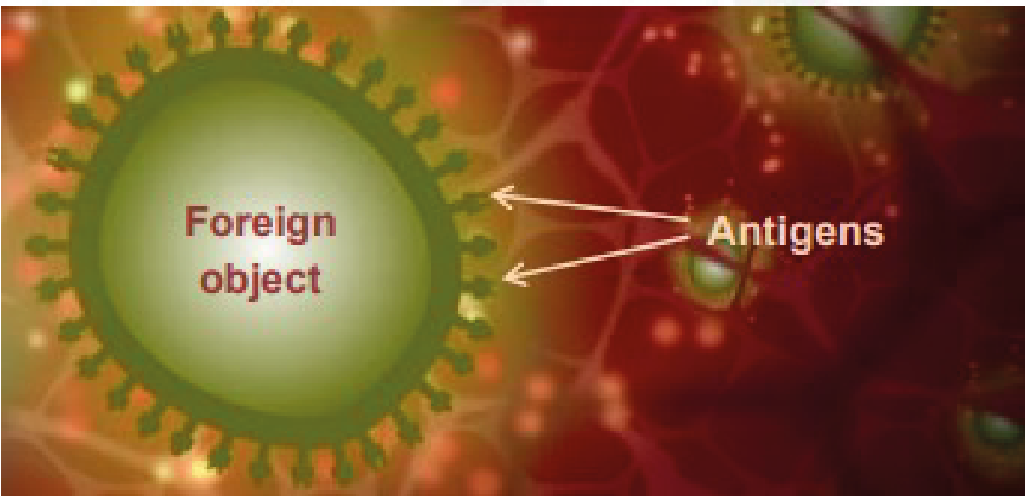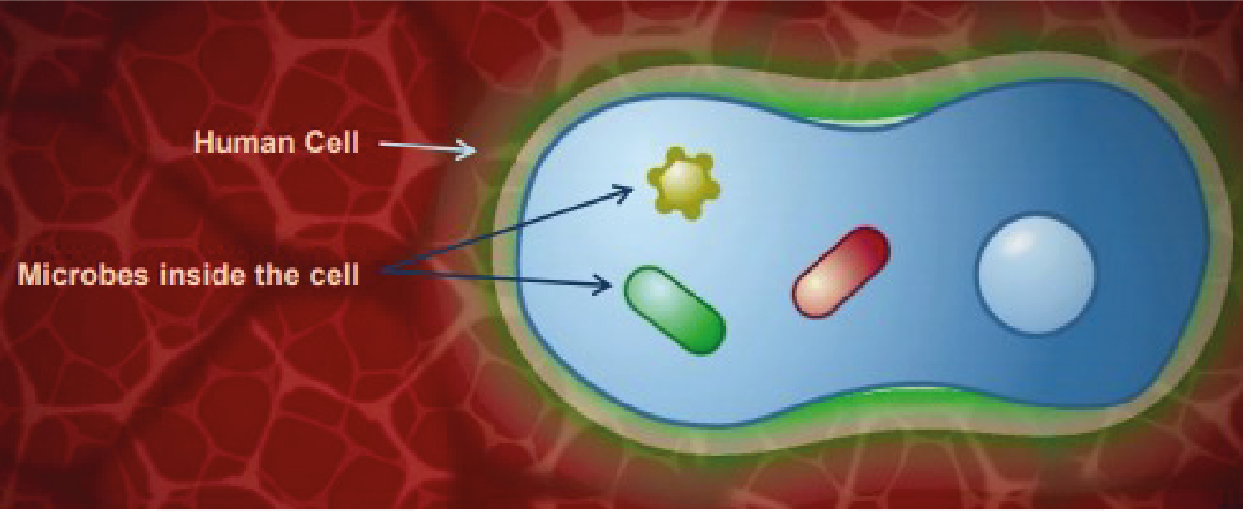



## TS1 - Teacher Sheet

However, if these barriers are breached, for example by bacteria entering the body through the skin, the antigens encounter large cells called macrophages which are resident in the skin. The word macrophage means ‘big-eater’. If a macrophage recognises the antigen as something foreign and not ‘self’ it engulfs it by a process called phagocytosis and can destroy it. Inflammation at the site also causes the release of small proteins called cytokines that help regulate the immune response and attract additional macrophages from the blood stream to the site. This first and immediate response is known as innate immunity. Although rapid, it is non-specific, it is the same for all antigens and the immune system does not retain any memory of the encounter with the antigen.

The different immune defences are carried out by variety of immune cells. The innate immune system is made up of leukocytes and other cells such as natural killer cells. Leukocytes include macrophages and neutrophils and the main characteristic of these cells is that they can carry out phagocytosis. Phagocytosis results in destruction of the foreign substance by fusing the digested material with the lysosome. The lysosome provides harsh conditions to kill the pathogen which includes using specialised lysosomal enzymes and providing highly acidic conditions. Natural killer cells kill other cells that are ‘stressed’ such as viral or bacterial-infected cells. This is a crucial part of the innate immune system as some bacteria and viruses can get inside cells and so are ‘hidden’ from the innate immune system, such as *meningococci* and *mycobacteria*.

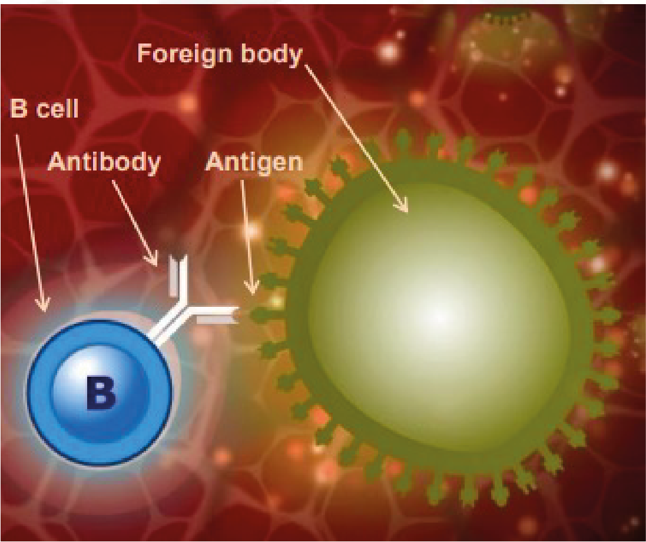



## TS1 - Teacher Sheet

Acquired immunity:

Sometimes, the innate response needs help to eliminate the antigen. In addition to phagocytosis, macrophages can also transport antigen to sites where an acquired immune response can be activated. When the macrophage bearing an antigen enters the lymphatic system it moves towards the lymphoid organs which include the spleen, the tonsils, adenoids and Peyer’s patches. These organs are rich in two types of specialised white blood cells called lymphocytes. Also known as B cells and T cells, these lymphocytes are distributed in strategic sites throughout the body ready to respond to antigens. There are also many B and T cells circulating in the blood.

The innate immune system stimulates the acquired immune system by showing the acquired immune cells the antigen that the foreign body has. These cells are therefore called antigen-presenting cells (APC). Dendritic cells and macrophages can carry this out and so can also be classified as APC. This occurs after the APC has travelled through the lymphatic system to where the specialised acquired immune cells reside.

The stimulation of the lymphocytes in the lymph nodes, however, produces a strong cascade of lymphocyte activation as one APC cell can stimulate many B and T cells. T cells are specific cells that are involved in the cell-mediated response and B cells are cells involved in the humoral immune response.

Clip 2:

B cells and T cells: B and T cells have different functions. B cells respond to free antigens or those that are on the surface of organisms that circulate outside and between cells of the body, this includes most types of bacteria. However, they cannot recognise antigens located inside cells such as viral proteins or certain bacteria such as *Meningococci* and *Mycobacteria* which have adapted to live in cells and therefore make detection by the immune system more difficult.

B cells produce specific antibodies by interacting with the antigen presented by an APC. Antibodies are a complementary match to the antigen and stimulate killing/disposal of the foreign substance.

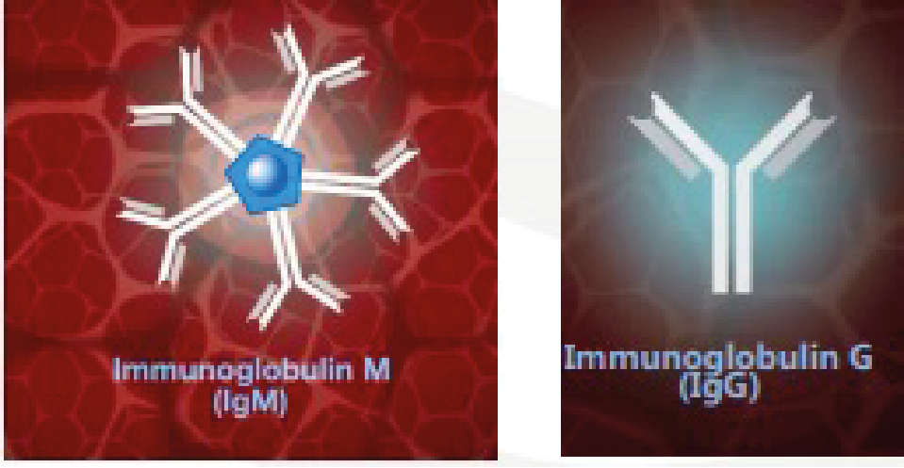



## TS1 - Teacher Sheet

B cells manufacture antibodies, however, most antigens do not stimulate B cells to produce antibodies without the help of T cells. The response to these antigens is therefore referred to as T cell-dependent. Unlike B cells, T cells can recognise intracellular antigens provided they are expressed on the cell surface. T cells do not manufacture antibodies but they do secrete cytokines which influence other immune cells.

Humoral response:

B cells circulate with a molecule of a 3-dimensional protein called antibodies on their surface. The antibodies, also known as immunoglobulins, have antigen binding sites where the protein molecules are folded in such a way as to form a 3-dimensional cleft into which only antigens of a corresponding shape can bind. There is also a binding site for macrophages and neutrophils. The part of the antigen that binds to the antibodies is known as the epitope.

When one of the antibodies molecules has a surfaced receptor with exactly the right shape to recognise the antigen, it binds to it like a lock and key. The B cells then enlarge considerably and become plasma cells which are antibodies manufacturing cells capable of producing up to 100,000 antibodies molecules a minute. The antibodies molecules they produce have receptors with the same shape that recognise the antigen in the first place and this is known as the humoral response. The first time an infection or vaccine antigen is encountered the antibodies produced is called immunoglobulin M or IgM. IgM circulates as five molecules bound together with a total of 10 binding sites for rapid and effective binding to antigen. If the same antigen is encountered again, the antibodies class changes to immunoglobulin G (IgG). This is known as class switching. Class switching means that the overall structure of the antibodies changes apart from the antigen binding domain which stays the same in order to match the antigen.

When an antigen binds to an antibody there can be three outcomes:

1. The binding of the antibody to the antigen will immobilise the foreign substance and neutralise it. This is the case for toxins and other harmful substances.
2. The antibodies surround the foreign substance, which can immobilise it ready for phagocytosis by a cell such as a macrophage. Immunoglobulin G (IgG)
3. The complement system is activated. The complement system is a major part of the humoral response. After antibodies bind to the foreign body, the complement system can attach. The complement system is made up of complement molecules which are proteins that have protease activity, i.e. can break down other proteins.

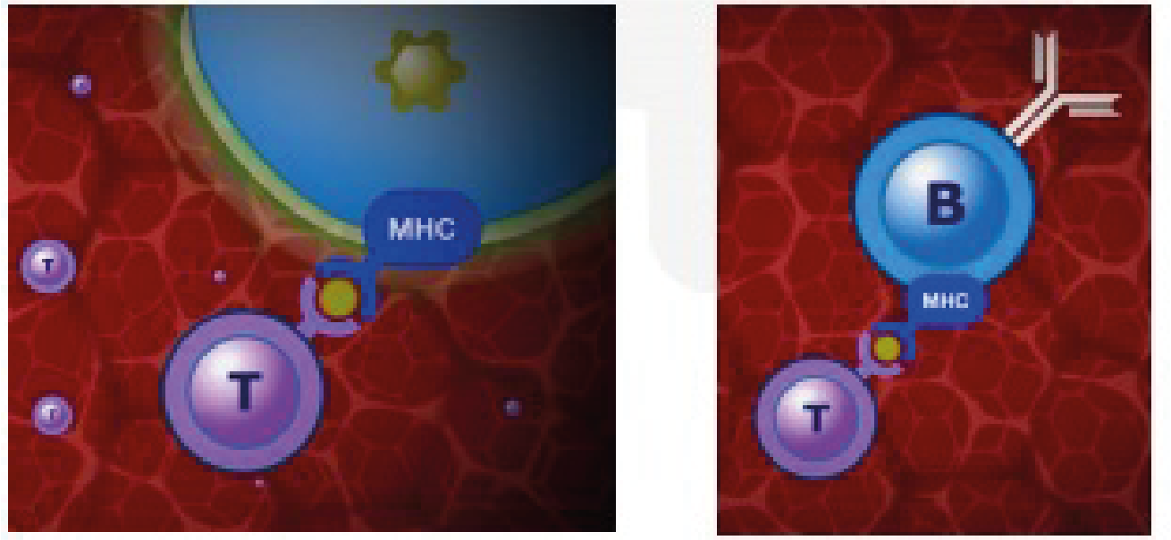



## TS1 - Teacher Sheet

The attachment of complement molecules produce a protease cascade whereby one complement molecule breaks down the next, activating its protease activity so that it can breakdown the next complement molecule and so on. The result of the cascade is the production of molecules that can attract other immune cells to the site and also increase vascular permeability so that the immune cells can get to the site easily through the vasculature. Some complement molecules can recognise carbohydrate molecules on the surface of bacteria without the need for antibody binding and some complement binding can actually induce killing by disrupting the plasma membrane of the bacterium.

Cell mediated immunity:

When cells contain intracellular antigens a bit of the antigen is carried to the cell surface using molecules that are part of the major histocompatibility complex or MHC. T cells can recognise a combination of the MHC molecule and the antigen. When the T cells binds to the MHC-antigen complex, the activated cells enlarge, multiply and secret cytokines, which can then affect other immune cells nearby, and other toxic molecules such as granulysin. Granulysin induces apoptosis in the infected cell by generating holes in the membrane. The holes then promote unregulated ion, water and molecule entry into the cell causing cytolysis (osmotic lysis of the cell).

There are various types of T cell; among these are those that can destroy an infected cell known as cytotoxic T cells. Another sort, known as helper T cells, can help and stimulate B cells to produce antibody. When an antigen binds to the antibody receptor on a B cell, a bit of the antigen is also taken up into the cell and is the presented to the B cell surface by a MHC molecule. This MHC-antigen complex is recognised by a T cell, usually a T helper cell, which secretes cytokines. In this case the cytokines assist the B cells to proliferate to form identical cells producing the same antibody.

MHC platforms can also mount antigens that indicate a tumour cell. To a certain extent the immune system can recognise abnormal cells and clear them by inducing apoptosis.



## TS1 - Teacher Sheet

Clip 3:

Memory response:

A few of the B cells are stimulated by the T cells to remain as memory cells and to retain the memory of the antigen antibody encounter. When the memory cells meet the antigen again, either as a natural infection or in a booster dose of vaccine antibodies of the right specificity are produced much more quickly and in greater numbers than during the first response. In contrast to the first response when short lasting IgM is made, the antibody produced is mainly IgG which persists for longer. Each time the memory cells encounter the same antigen the immune response is boosted. Because a pathogen, or a vaccine, may contain many different antigens many different B cells are stimulated at once and many

different antibodies may be produced. The capacity of our immune system is enormous and can make billions of different antibodies. If different vaccines are given at the same time then different antibodies are produced at the same time as well. In a similar way to B cells, there are also T memory cells made as a result of the first encounter with the antigen. When these T memory cells meet the antigen again they are able to respond more quickly and effectively. The specific humoral, cell-mediated and memory responses are known as acquired or adaptive immunity.

Vaccinations:

Vaccination stimulates the immune responses that have just been described, but importantly, it does so without the risks of the disease itself. It works by stimulating a pool of memory B and T cells to be made which, if and when the antigen is subsequently encountered, produce antigen specific responses fast enough to prevent disease developing. It also stimulates production of antigen specific antibody including IgG which persists after vaccination and provides early defence against infection. Knowledge of how vaccines work with the immune system allows us to understand the vaccine schedule more clearly.

When an individual is vaccinated, the processes in the immune system that are stimulated to mimic natural immunity are antigen recognition, antibody production and a formation of a memory response. This all occurs without disease progression. The vaccine will contain the antigen of the disease, or a

toxoid (an inactive version of a toxin) if the disease in question is caused by a toxin such as diphtheria or tetanus. In some cases, the vaccination can be administered via a nasal spray like the childhood flu vaccine which means the vaccine is taken up through the nasal lining.

The antigens within the vaccine are then recognised by the immune system as described earlier, and are taken up by APC, and the APC travels and is transported to the lymph nodes. The antigen is then presented to B cells which cause the production of antibodies and generations of memory B and T cells. If the individual being vaccinated then comes into contact with the actual pathogen bearing the same antigen, a memory response is stimulated resulting in clearance of the pathogen without the occurrence of disease.



## TS1 - Teacher Sheet

Booster vaccinations are given to keep circulating antibody numbers at high levels. If they are missed then the memory response may be weakened and may result in the individual contracting the disease.

In the case of the flu, annual/seasonal vaccinations are administered because the influenza virus is able to change its antigens on its surface resulting in the need for a different vaccination for the different antigens.

This change in antigens can arise from one of two ways; antigenic shift and antigenic drift. Antigenic shift is where two or more different strains of virus combine to form a new virus. This occurs if an individual is infected with different viruses at one time. Antigenic drift is when the antigen on the virus gradually changes over time due to a change in the genetic material inside the virus. This can occur if the genetic material undergoes a mutation.

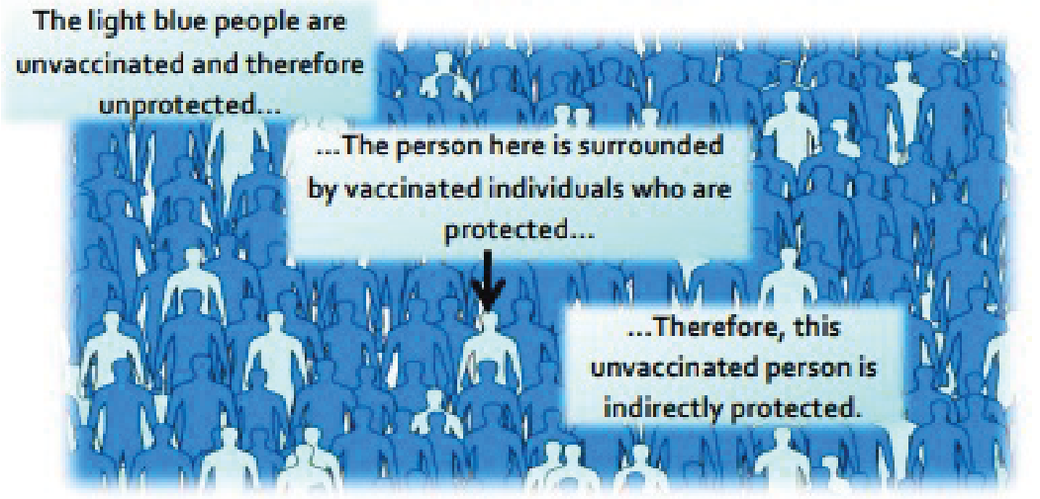

The light blue people are unvaccinated and therefore unprotected

The person here is surrounded by vaccinated individuals who are protected…

Therefore, this unvaccinated person is indirectly protected

What is herd immunity and why is it important?

A small proportion of people in every population do not respond to vaccines and remain unprotected despite vaccination. In addition, people who are severely immuno-compromised are unable to receive live vaccines. Therefore, these people are dependent on not being exposed to infection in the first place. If a sufficient number of people are vaccinated in the population vaccine preventable infections are not able to transmit successfully because most people are immune. Therefore, people who are susceptible are indirectly protected by the presence of these immune individuals. This is known as herd immunity. High levels of vaccine coverage must be maintained in the population to achieve and preserve herd immunity and to protect those who cannot be immunised.

**References**:

Gessner, B.D., Feikin, D.R. (2014) Vaccine preventable disease incidence as a complement to vaccine efficacy for setting vaccine policy. Vaccine 30;32(26):3133-8

Malech, H.L., Deleo, F.R., Quinn, M.T. (2014) The role of neutrophils in the immune system: an overview. Methods Mol Biol. 1124:3-10

McIntyre, W.J., Tami, J.A. (1992) Introduction to immunology. Pharmacotherapy 12(2 Pt 2):2S-10S Web link Pasupuleti, M., Schmidtchen, A., Malmsten, M. (2012) Antimicrobial peptides: key components of the innate immune system. Crit Rev Biotechnol. 32(2):143-71

Storey, M., Jordan, S. (2008) An overview of the immune system. Nurs Stand. 23(15-17):47-56