Food Hygiene & Safety

Food safety versus food quality

Background
These resources have been funded by the European Union’s SafeConsume project, which is an EU-wide project to reduce illness caused by foodborne pathogens. Find out more information at http://safeconsume.eu/.
These resources have been developed following research with students and teachers from across Europe and have been tested with schools during development.
Following research with consumers across Europe, several food related risk behaviours have been identified which we seek to improve education on. One of these behaviours is a misconception about date labels and wastage of foods which this activity covers.

National Curriculum:
- KS3: RSHE; Health and prevention.
- KS4: Food preparation and nutrition GCSE; Cooking and food preparation - The scientific principles underlying the preparation and cooking of food.

Lesson learning outcomes:
- To understand types of food labels and why these are important
- To understand the difference between food safety and food quality
- To understand how to store and use different types of food
- To understand consequences of not following food labels properly

Resources:
- Food Safety vs Food Quality activity PowerPoint
- Food Safety vs Food Quality student worksheet
- Optional student worksheet: Data analysis activity

Lesson plan
Designed for 11 - 14 year olds, but could be adapted for 15 – 18 year olds.

Introduction
Using the Food Safety vs Food Quality PowerPoint, introduce the importance of food labels with students. Focus primarily on food hygiene and safety labels and ask students what information these provide.

Quiz
Before starting the main lesson, ask the class to vote for what they think “use by” and “best before” labels mean. You can do a show of hands or use an interactive online system such as Kahoot.
A specific Kahoot quiz has been made at https://create.kahoot.it/share/food-quality-vs-food-safety-vote/25db61a7-6d24-40ce-95c1-1a078b7804d6
Follow the link and choose classic (player vs player). Ask students to join by going on their smart phone/tablet and visiting www.kahoot.it or the kahoot app and typing in the game PIN.
You will get answers in real time – it may prevent students from guessing the same as others
The voting options for the Kahoot quiz are:
Q. What does ‘best before’ mean?
- The food is safe to eat up to this date, but should not be eaten past it X
- The food can be consumed after this date, but may no longer be at its best
- It depends on the type of food X
- None of these X
Q. What does ‘use by’ mean?
- The food is safe to eat up to this date, but should not be eaten past it
- The food can be consumed after this date, but may no longer be at its best X
- It depends on the type of food X
- None of these X

Discussion
- What could happen if you eat food past the ‘use by’ date?
After this date, harmful microbes may have grown in the food and you risk the chance of foodborne illness
- What could happen if you eat food past ‘best before’?
You are unlikely to get a foodborne illness, but the food might not taste as nice.
- Explain to students that foods that smell or taste good are often mistakenly assumed to be safe. This was often the case when refrigerators were not available to preserve food. For some foods, e.g. raw meat, refrigeration will inhibit pathogens, but not spoilage bacteria (which break down food and give it an unpleasant taste). For other foods, removal of competing flora (bacteria) and refrigeration will allow growth of pathogens but spoilage bacteria to a lesser degree (e.g. cooked rice). Microbes may also be present on fresh foods, e.g. greens. It is important to remember that microbes are invisible, therefore food that smells nice may still have harmful microbes. Remind students to look at use by dates when making decisions about whether they should keep or throw away food, for the purposes of food safety.

- Ask students to vote by a show of hands if they would throw away food past its use by and best before dates.

- Should you throw away food that is past its ‘best before’ date?
If the food is unopened (e.g. a sealed tin) the food should still be safe to eat and might not need to be wasted.
- Should you throw away food that is past its ‘use by’ date?
Yes, as there is a risk of foodborne illness – you should not risk your health. You can prevent wasting food by only buying food with a ‘use by’ date if you are planning to eat it within a few days, or by freezing it on day of purchase.
- Show students the video on food waste by the Food Standards Agency and begin a discussion with students on what consumers can do to prevent waste of food.

- Use the slide on freezing to recap with students how freezing food can help to reduce waste with leftovers or food bought close to the use by date.

Group work (optional):
Arrange students in small groups (2- 4) and ask them to discuss and develop a poster or mind map to present to the class, either on:
- Things we can do to reduce food waste at home
- Things we can do to prevent foodborne illness*

*Can be done as a revision task to recap key food hygiene behaviours.

Optional activity
If you would like to revise student’s data analysis skills, there is an optional activity whereby students complete a pie chart based on the class vote mentioned above and then answer some questions on EU data.
- Show students the video on food date labels created by Food Standards Scotland.
- Provide students with the student worksheet and ask them to complete the questions following the video.
- In pairs, ask students to discuss the consequences of eating food that is past its ‘use by’ and ‘best before’. Get them to feed back to the class.
The main message you want students to go away with is that:
- foods with ‘use by’ dates have a risk of causing foodborne illness and should be treated carefully (i.e. eaten within date and stored correctly).
- foods with a best before date are usually a bit tougher (e.g. pasta and rice) and are still safe to eat after the date shown.

Suggestions to share with students:

Tackling food waste | Tackling foodborne illness
- Plan what food you need to buy and when you plan to eat it  - Freeze food on day of purchase if you do not plan on eating until later  - Be aware of what food you already have in the fridge or pantry  - Give unwanted food away or to a foodbank  - Store leftovers appropriately  - Find creative ways to use leftovers | - Use separate chopping boards and knives for raw meat, fish and vegetables.  - Wash hands and surfaces  - Do NOT wash raw chicken  - Before you serve pork, poultry and minced meat, make sure it is steaming hot and cooked all the way through ie. when you cut into the thickest part of the meat, check that none of the meat is pink and that any juices run clear. You could also use a temperature probe (if you have one) to check the temperature of the thickest part of the meat. The temperature needs to reach one of the following combinations to make sure it has been cooked properly:  - 60°C for 45 minutes  - 65°C for 10 minutes  - 70°C for 2 minutes  - 75°C for 30 seconds  - 80°C for 6 seconds

Food safety versus food quality Student Worksheet

- What does the ‘use by’ label mean?

- What types of food might have a ‘use by’ label?

- What does the ‘best before’ label mean?

- What types of food might have a ‘best before’ label?

- Define the term ‘food safety’, what label is associated with it?

- Define the term ‘food quality’, what label is associated with it?

Food safety versus food quality Student Answer Sheet

- What does the ‘use by’ label mean?

The food will be safe to eat up to this date but should not be eaten past this date. This label is about food safety. After this date, microbes may have grown to harmful levels in the food.

- What types of food might have a ‘use by’ label?

Usually seen on raw meat and fish, chilled or ready to eat foods, prepared vegetables, bagged salad.

- What does the ‘best before’ label mean?

The food can be consumed after this date but it may no longer be at its best quality. This label is about food quality not safety

- What types of food might have a ‘best before’ label?

Usually seen on food that can keep for a long time, e.g. tinned food, pasta, rice, frozen food.

- Define the term ‘food safety’, what label is associated with it?

Food safety is what we can do to prevent contamination of food by harmful microbes and prevent foodborne illnesses (food poisoning). Food safety is associated with the ‘use by’ label.

- Define the term ‘food quality’, what label is associated with it?

Food quality refers to characteristics of the food that make it acceptable to consumers, including: taste and flavour, appearance and texture. Food quality is associated with the ‘best before’ label.

Food quality vs food safety – optional activity

As a class you will vote for what different labels mean. Record the class voting in the following 2 tables:
- What does ‘Best before’ mean?
Definition | Number voted | Percentage of total*
- The food will be safe to eat up to this date, but should not be eaten past this date
- The food can be consumed after this date, but it may no longer be at its best quality
- It depends on the type of food
- None of these
- Don’t know

- What does ‘Use by’ mean?
Definition | Number voted | Percentage of total*
- The food will be safe to eat up to this date, but should not be eaten past this date
- The food can be consumed after this date but it may no longer be at its best quality
- It depends on the type of food
- None of these
- Don’t know
Number who voted for this option
Total number in class

X 100
*Work out the total percentage of each option:

Make a pie chart for each definition using the percentages you calculated

Label each pie chart and split it into 5 sections, the size of each section should reflect the size of the percentage of that section. Make sure you label each ‘slice’ of the pie! If any of the sections are 0% then do not include this in your chart

Describe your pie charts. Did most of you get the correct answer?

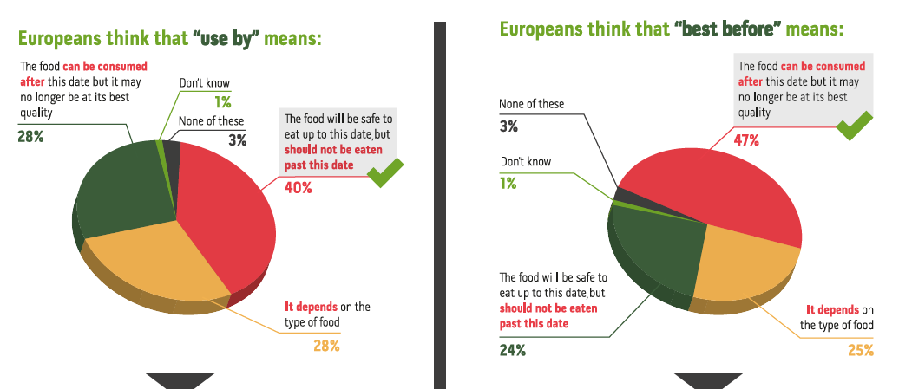
5. Describe the charts showing what the European population believe:

  - Describe what the European population understand by ‘use by’?

  - Describe what the European population understand by ‘best by’?

  - Compare and contrast the European charts with your class charts

  - How does the understanding of your class compare to the European population?

