## Super slimy snot

**Difficulty:2 | Ages: 5-11 | Scientific | Creative | Time: 10-15 mins**

### Learning objectives

* Our bodies have natural defences to protect us from infections
* Snot helps to protect us from infection by trapping harmful microbes
* If we sneeze we can spread these microbes to others, so it is important to use a tissue and then throw this away, or our sleeve if we have no tissue.

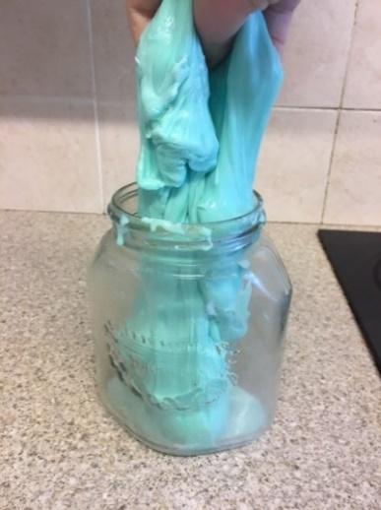 **Pictured: Example of the ‘super slimy snot’ in a jar**

### Equipment

* Laundry starch (or other slime activator such as borax powder) and warm water
* Polyvinyl acetate ­(PVA) glue
* Green food colouring
* Spoons and container for each child
* Optional: Green/red glitter (or eco alternative) or ultraviolet
* (UV) gel and torch

### Advanced preparation

1. To save time, mix up enough ‘slime activator’ for the group: depending on the size of the group, fill one container with warm water and add enough laundry starch to create a milk coloured solution when dissolved
2. The starch dissolves best in warm water and may need re-stirring every so often
3. If using a different slime activator, follow instructions provided on the label

### Activity instructions

* Explain that snot is special, it is our first defense against inhaling harmful microbes.
* Sneezing is a way in which our body tries to get rid of harmful microbes and dust.
* Our nose and throat are also home to beneficial microbes known as flora who live there naturally without harming us and can help to protect us from harmful microbes.
* Ask children how much snot they think our nose makes in one day. The answer is two pints – the same amount as a medium bottle of milk. The majority of this is swallowed without knowing! Ask children if they think this will increase when you are ill with a cold.
* Explain to children that they will be making their own slimy snot which they can take home with them.

To make snot:

1. Provide each child with a container, place two tablespoons of PVA glue in each container and one drop of green food colouring to each container and mix well
2. Add slime activator drop by drop while stirring the mixture. The slime will begin to form.
3. Stop adding activator when desired sliminess is reached!
4. Children can add green (friendly microbes) and red (harmful microbes) glitter to their slimy snot. Alternatively, you can add UV gel or powder and show how the snot fluoresces under UV torch.
5. Discuss with children why it is important to use a tissue, or our sleeve (not our hands) when we have a runny nose or sneeze and wash our hands if we touch snot as harmful microbes within the snot can pass to our friends and family and make them ill