**Foundation Stage**



# Spread of Infection: Hand Hygiene

# Lesson 1: Hand Hygiene

By taking part in a classroom experiment, children learn why it is important to wash hands properly and learn the best method and order for hand washing.

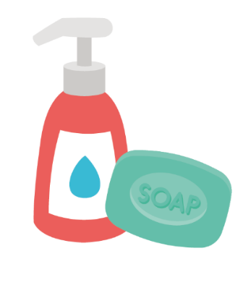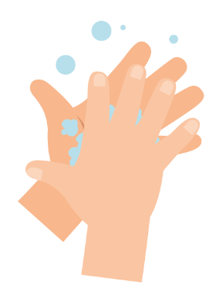

## Learning Intention

### All children will:

* Develop an understanding of how personal hygiene practices, such as handwashing and nose blowing, help to prevent the spread of germs and maintain health.

## Northern Ireland Curriculum Links

### Curriculum Key Elements

* Personal Health and Moral Character

### Curriculum Skills

* Communication
* Thinking
* Problem Solving and Decision Making

### Curriculum Areas of Learning

* Language and Literacy
* Personal Development and Mutual Understanding (PDMU)
* The World Around Us (TWAU)

 **Lesson 1: Hand Hygiene**

## Resources Required

### Activity: Balloon hands

#### Per child

* Disposable plastic/vinyl gloves

#### Per group or class

* Basin
* Water
* Hand soap
* Washable black marker

**Extension Activity: Hand Washing and Nose Blowing Flashcards**

#### Per class

* TS1 Hand Washing and Nose Blowing Flashcards

### Extension activity: Picture Sequencing Activity

#### Per child/ group

* SW1 Picture Sequencing Activity
* Glue sticks & paper or card

### Extension Activity: Hand Washing Chart

#### Per child

* SW2 e-Bug Healthy Hands Hand Washing Progress Chart

Supporting Materials

* TS1 Hand Washing and Nose Blowing Flashcards
* SW1 Picture Sequencing Activity - place hand washing in the correct order
* SW2 e-bug Healthy Hands Hand Washing Progress Chart

## Advanced Preparation

* Fill a basin with soapy water
* Inflate vinyl gloves with air and tie at the bottom to create hand balloons
* Draw circles and dots on the balloon hands with washable marker to resemble germs

**Lesson 1: Hand Hygiene**

## Key Words

Hygiene

Soap

Infection

## Health & Safety

Ensure that children have no soap allergies or sensitive skin conditions.

For safe microbiological practices in the classroom consult CLEAPPS

[www.cleapps.org.uk](http://www.cleapps.org.uk/)

## Weblinks

www.e-Bug.eu/eng/EYS/lesson/Hand-Hygiene

## Introduction

When introducing children to the concept of microbes, you can refer to the teacher refresher section for more information.

1. Begin the lesson by asking how many children have washed their hands today? Ask them why they washed their hands (to wash away any dirt or germs that might be on their hands) and what would happen if they didn’t wash their hands (they might get ill as they ingest harmful germs on their hands).
2. Talk to the children about how we use our hands all the time, and that they pick up millions of germs every day. Although many of these are harmless, some could be harmful. Explain that we spread our germs to our friends and others through touch, and that this is why we wash our hands.
3. Describe key times we should be washing our hands (especially after using the toilet and before eating).
4. Explain to the children that they are going to do an activity to demonstrate how germs are all over our hands and how best to wash them off.

## Activity

1. Demonstrate how to wash the marker off the balloon hands with soapy water.
2. Provide each child with a balloon hand covered in germs (washable marker).
3. The children should take turns thoroughly scrubbing the marker off the balloon hands in the basin of soapy water.
4. Have a conversation with the children about what they saw. How long did it take for all the germs to disappear? Why do you think it’s important to wash our hands? If we didn’t use soap would it have worked?

Children should notice that it is much easier to wash off the marker pen with soapy water.

Now visit e-bug.eu/eng/EYS/ lesson/Hand-Hygiene to find a NHS demonstration and the UKHSA hand washing song to help make the correct technique more memorable for little hands.

## Discussion

1. Discuss with the children where the germs on the balloon hands may have come from. Emphasise to children that not all the germs on their hands are harmful; there may also be useful germs there too.
2. Emphasise to the children that we also need to wash our hands properly. Highlight that germs like to hide in between fingers and under the nails. It is important to know both WHEN and HOW to wash our hands properly to prevent spreading germs and potentially infection. When you must sneeze and you can’t wash your hands, a solution may be to sneeze or cough onto your sleeve/elbow.

## Extension Activities

### Hand Washing and Nose Blowing Flashcards

TS1 is a useful way to support learning. Cards can be cut and laminated for future use or displayed on a whiteboard. Ask children to name the image, the correct word is shown on the card.

### Picture Sequencing Activity

Provide SW1 to a child or group. Supply paper, card and glue sticks and ask children to sort the cards into the correct order and stick them onto the paper or card with glue.

### Hand Washing Chart

SW2 is a hand washing chart that allows children to mark and keep track of how often they have washed their hands throughout one school-week. Print the sheet and distribute to each child. This could be a classroom or take-home activity to reinforce hand washing behaviours.

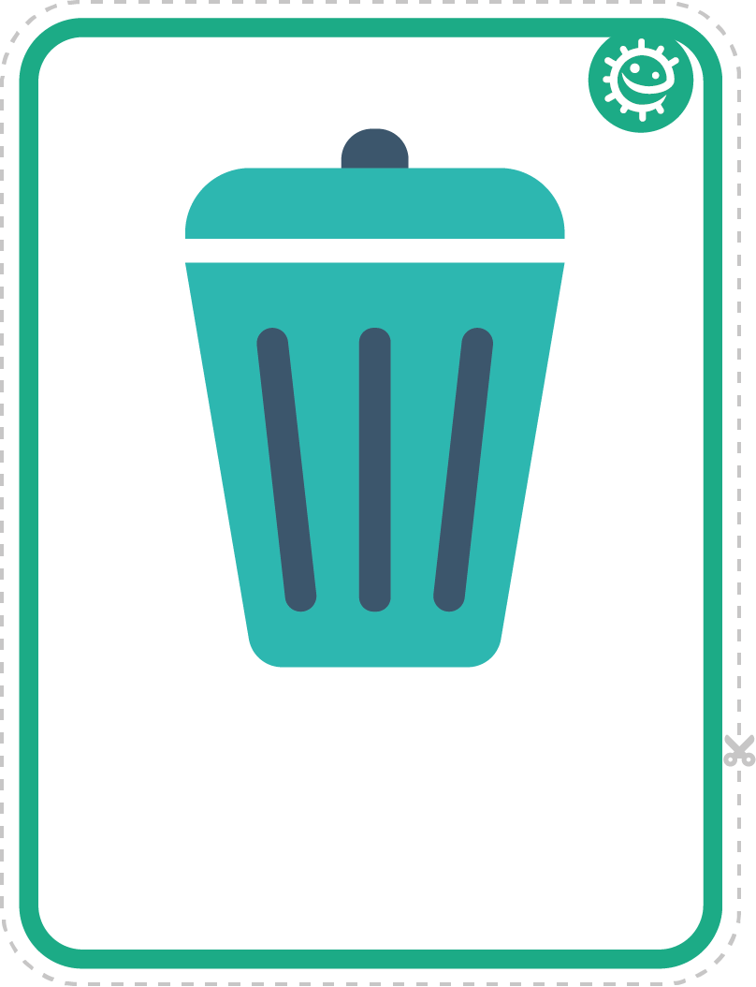 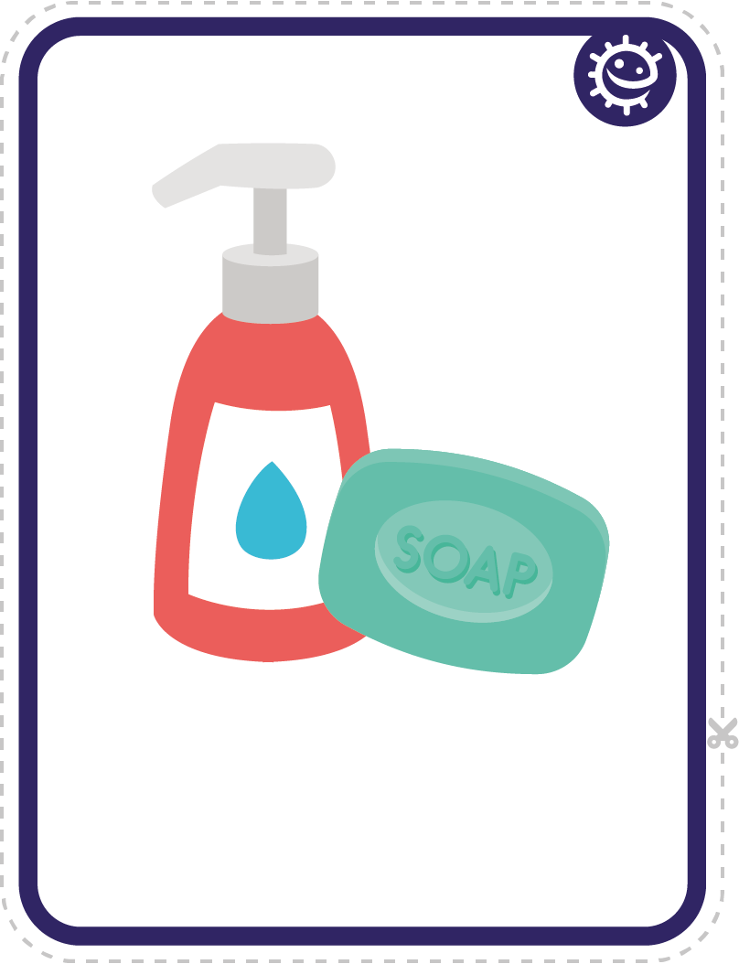

## TS1 - Hand Washing and Nose Blowing Flashcards

Bin

Soap

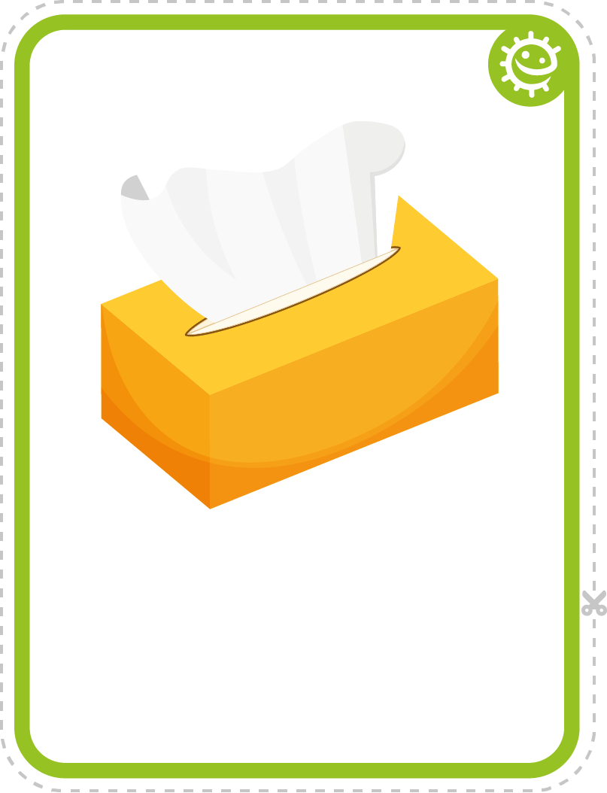 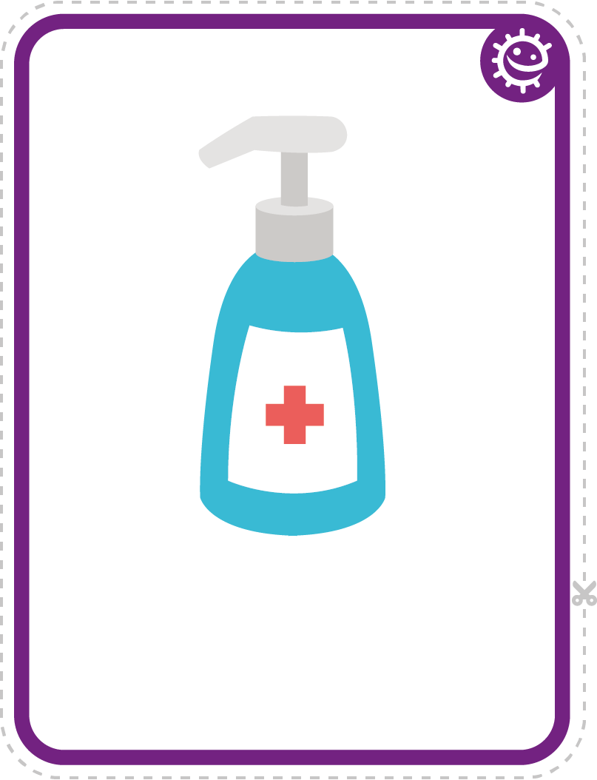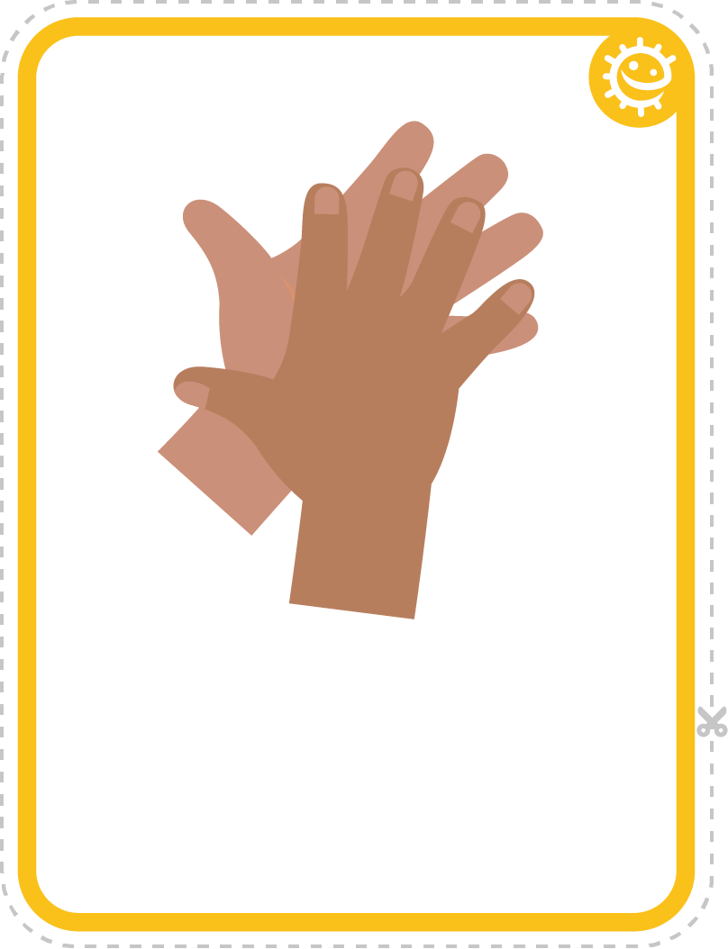 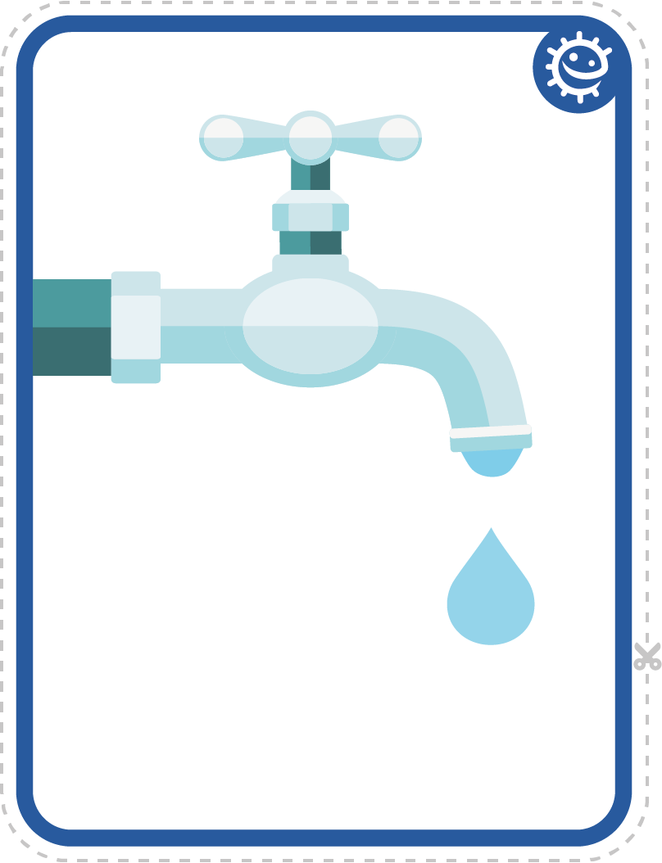

Hand sanitiser

Tissue

Hands

Tap

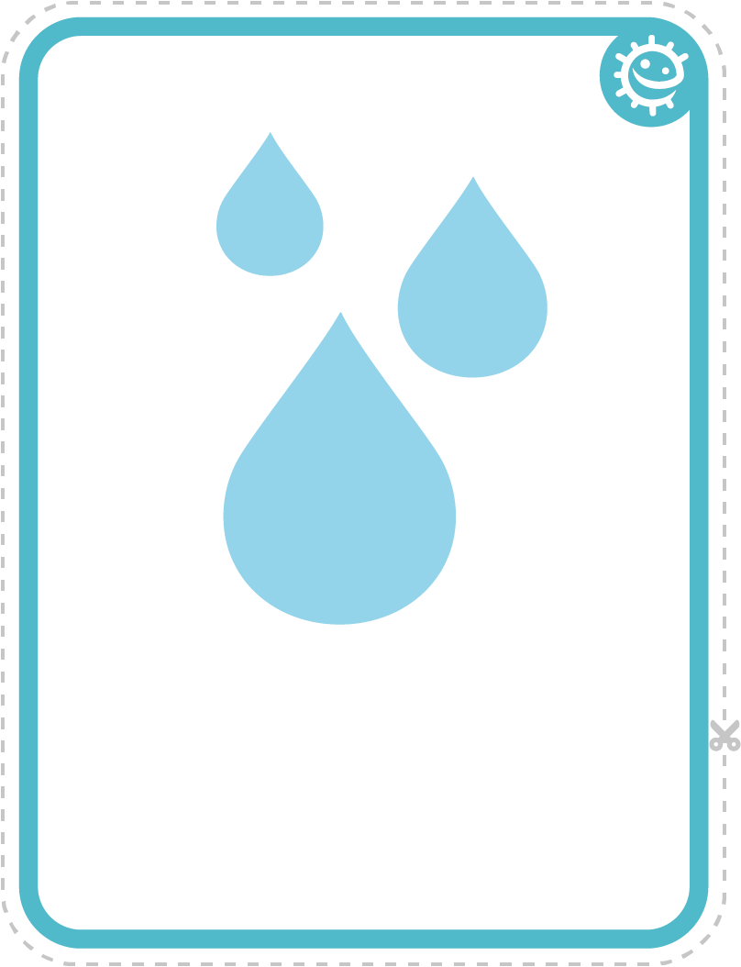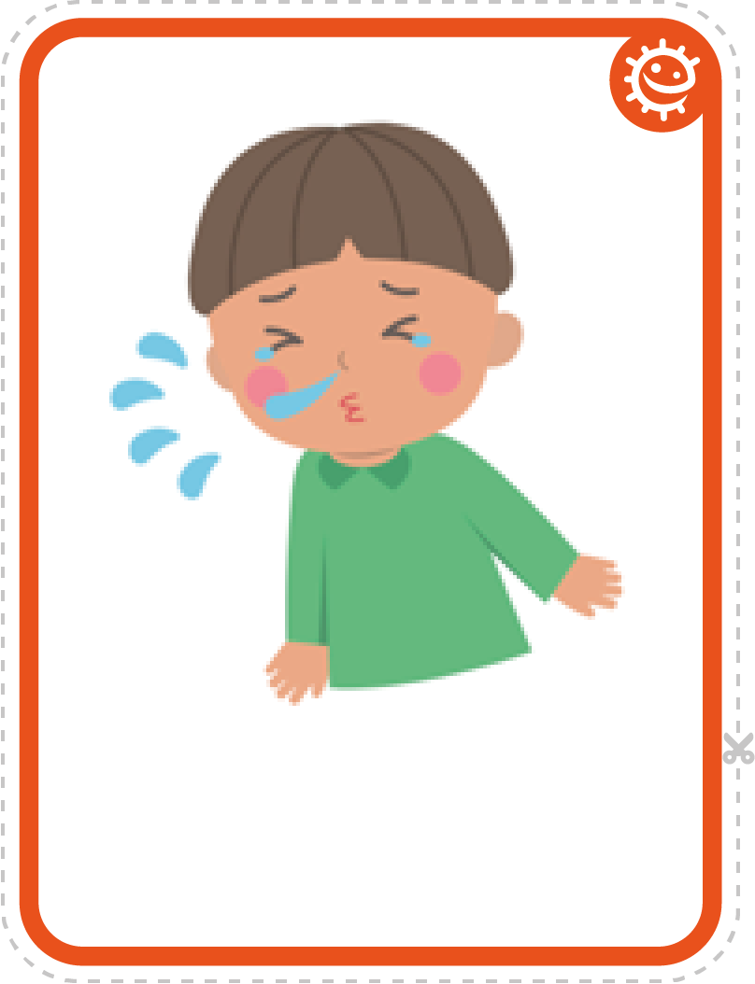

Water

Sneeze

Sneeze

## SW1 - Picture Sequencing Activity – place hand washing in the correct order

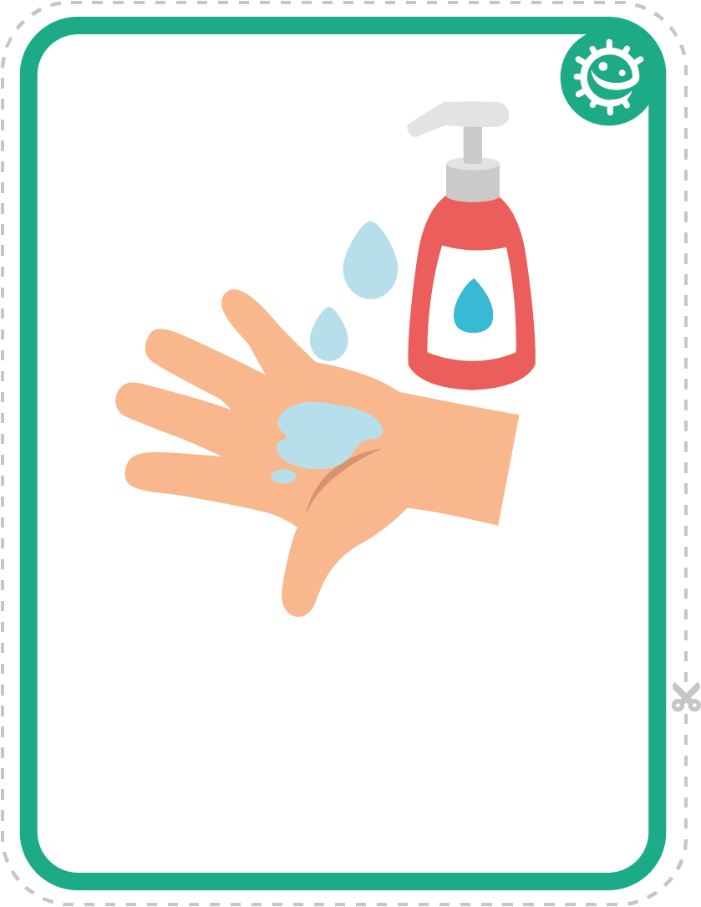 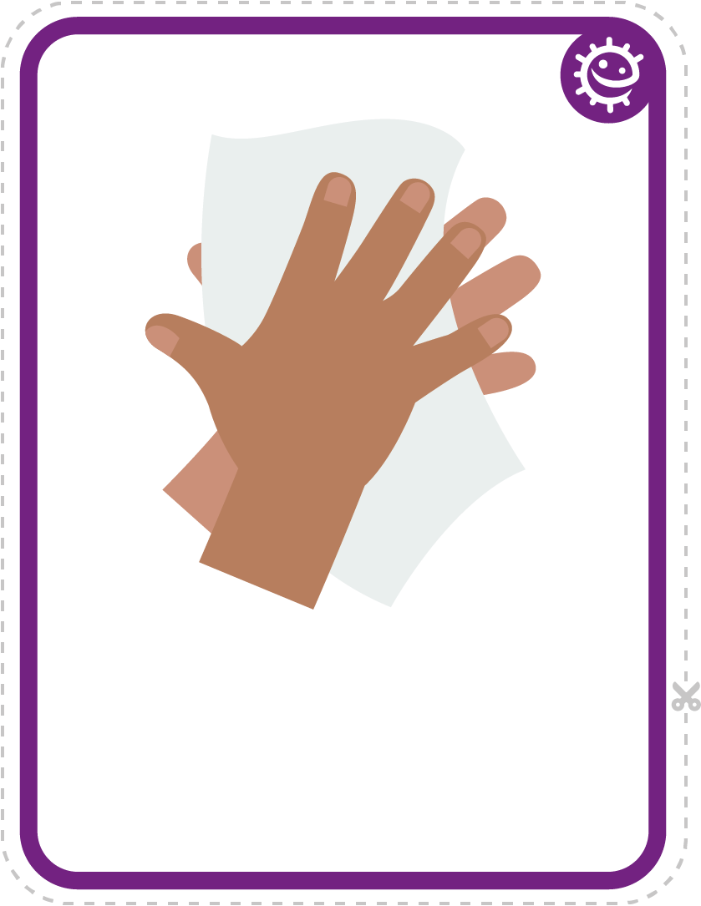

Soap

Dry hands

 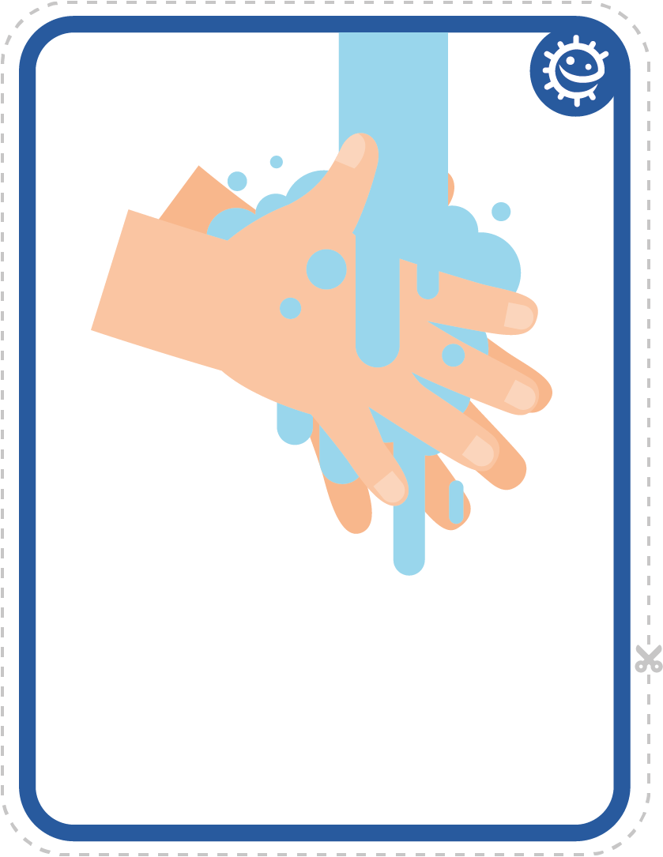

Turn on tap

Rinse hands

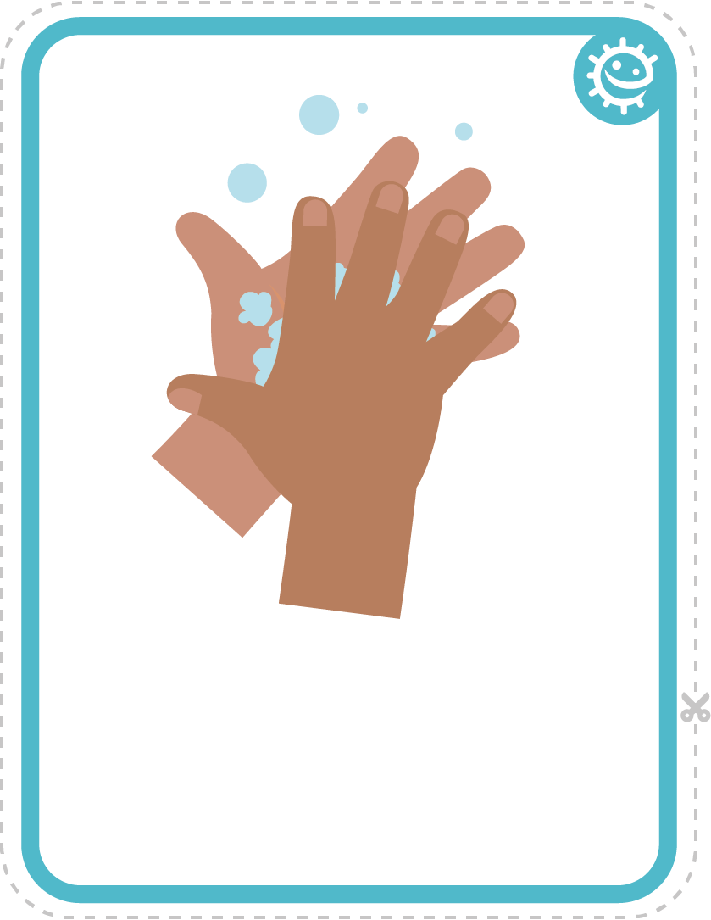

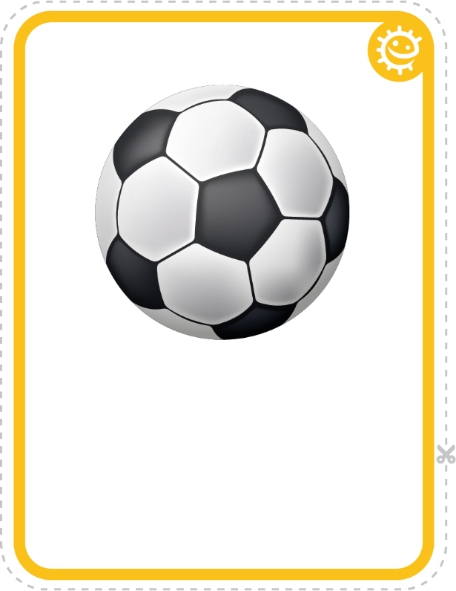

Play outside

Scrub hands



## SW2 - Healthy Hands Hand Washing Chart

FRI

I washed my hands before school

I washed my hands after breaktime

I washed my hands before lunch

THU

WED

TUE

Healthy Hands Handwashing Chart

Name

Class

MON