## SW3 - Microbe Mania Fill in the Blank Worksheet



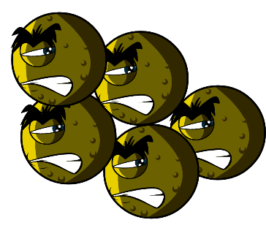 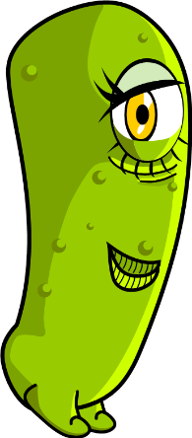 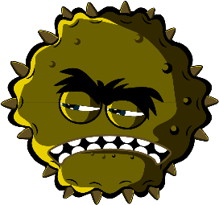

### Microbes Worksheet

What have you learnt about microbes?  
Complete the sentences below

Germs and bugs are also called _ _ _ _ _ _ _ _

and there are three main types.

The smallest microbe is a _ _ _ _ _ and they can make us poorly with a cough or a cold.

The largest microbe is a _ _ _ _ _ _. We use this to make bread.

Balls, rods and spirals are the three main

shapes of _ _ _ _ _ _ _ _.

Microbes are found _ _ _ _ _ _ _ _ _ _ and even in volcanoes!